REPUBLIC OF GHANA

ENVIRONMENTAL PROTECTION AGENCY/MINISTRY OF ENVIROMENT, SCIENCE, TECHNOLOGY AND INNOVATION

MINISTRY OF LANDS AND NATURAL RESOURCES

GHANA LANDSCAPE RESTORATION AND SMALL-SCALE MINING PROJECT
(P171933)

RESETTLEMENT POLICY FRAMEWORK AND PROCESS FRAMEWORK
(RPF&PF)

APRIL 2021

DECEMBER 2020

TABLE OF CONTENTS
LIST OF TABLES vii
LIST OF FIGURES vii
LIST OF ABBREVIATIONS AND ACRONYMS viii
DEFINITION OF TERMS xii
EXECUTIVE SUMMARY xv
PURPOSE OF RESETTLEMENT POLICY FRAMEWORK (RPF) AND PROCESS FRAMEWORK (RF) xvii
Relevant national policies, regulations and institutions described include the following: xix
1.0 INTRODUCTION 1
1.1 Background 1
1.2 Objectives and Principles of the RPF 2
1.3 Purpose of the Resettlement Policy Framework 3
1.4 Rationale for the Preparation of Resettlement Policy Framework 3
1.5 Purpose of the Process Framework 3
1.6 Methodology and Approach 4
1.6.1 Desk Review 4
1.6.2 Stakeholder Consultation 4
1.6.3 Analysis of Data and Content of Report 5
2.0 brief description of the glrssm project 6
2.1 Project Objectives 6
2.2 Project Components 6
2.3 Description of the Project Baseline Environment, Location, Population and Livelihood 7
2.3.1 Ashanti Region 8
2.3.1.1 Location and Size 9
2.3.1.2 Population 9
2.3.1.3 Transport 9
2.3.1.4 Districts 9
2.3.2 Central Region 10
2.3.2.1 Districts 10
2.3.3 Eastern Region 10
2.3.3.1 Districts 10
2.3.4 Western Region 10
2.3.4.1 Tourism 11
2.3.4.2 Education 11
2.3.4.3 Districts 11
2.3.5 North East Region 11
2.3.5.1 Location and Size 12
2.3.5.2 Cultural and Social Structures 12
2.3.5.3 Economy 12
2.3.5.4 Demographics 12
2.3.5.5 Religion 12
2.3.5.6 Districts 13
2.3.6 Savannah Region 13
2.3.6.1 Location and Size 13
2.3.6.2 Demographics 13
2.3.6.3 Religion 13
2.3.6.4 Districts 14
2.3.7 Upper East Region 14
2.3.7.1 Location and Size 14
2.3.7.2 Demographics 14
2.3.7.3 Transportation 15
2.3.7.4 Districts 15
2.3.8 Upper East Region 15
2.3.8.1 Location and Size 15
2.3.8.2 Tourism 16
2.3.8.3 Economy 16
2.3.8.4 Districts 16
2.4 Project Oversight and Responsibility 26
3.0 LEGAL AND INSTITUTIONAL FRAMEWORK FOR LAND ACQUISITION 31
3.1 The Constitution of Ghana 31
3.2 Ghana National Land Policy (1999) 31
3.3 Relevant National Laws 32
3.3.1 Administrative Lands Act, 1962 (Act, 123) 32
3.3.2 The State Lands Act, 1952 (Act 125) 32
3.3.3 The Lands Statutory Wayleaves Act, 1963, Act 186 32
3.3.4 Land Use and Spatial Planning Act, 2016 (925) 32
3.3.5 Lands Commission Act, 1994 (Act 483) 32
3.3.6 State Lands Act 1962, Act 125 32
3.3.6.1 Damage or Loss 33
3.3.6.2 Claiming Compensation 33
3.3.6.3 Valuation 33
3.3.7 Overview of Land Ownership in Ghana 33
3.3.7.1 Customary Ownership 33
3.3.7.2 State Lands 34
3.3.7.3 Vested Lands 34
3.3.8 Local Government Act, 1994, Act 480 34
3.3.9 Forestry Commission Act, 1999 Act 571 34
3.3.10 Minerals Commission Act, 1993 Act 450 34
3.4 World Bank Environment and Social Standards (ESS5) 34
3.5 Comparison of Ghanaian Laws with World Bank ESS 35
3.6 Institutional Framework 38
3.6.1 Ministry of Lands and Natural Resources 38
3.6.2 Ministry of Environment, Science, Technology and Innovation 38
3.6.3 Ministry of Finance 38
3.6.4 Environmental Protection Agency 39
3.6.5 The Ministry of Food and Agriculture (MOFA) 39
3.6.6 Forestry Commission 39
3.6.7 Minerals Commission 39
3.6.8 Water Resources Commission 40
3.6.9 Lands Commission 40
3.6.10 Ghana Geological Services Authority (GGSA) 40
3.6.11 Land Use and Spatial Planning Authority 41
3.6.12 The Municipal and District Assemblies (MDA’s) 41
3.6.13 Traditional Authorities and Community Elders 41
3.6.14 World Bank 42
3.6.15 Non-Governmental Organizations NGOs 42
4.0 DESCRIPTION OF Potential Risks and Impacts from GLRSSMP 43
4.1.1 Potential Positive Social Impacts 43
4.2 Potential Negative Social Impacts and Risks 43
4.2.1 Land Tenure and Ownership 43
4.2.2 Livelihood Issues 43
4.2.3 Forest Management Issues 44
5.0 ELIGIBILITY CRITERIA AND ENTITLEMENT MATRIX - RPF 55
5.1 Eligibility Criteria 55
5.1.1 General Eligibility 55
5.1.2 Proof of Eligibility 56
5.2 Entitlement Matrix 56
5.3 Principles and Procedures of Involuntary Resettlement 62
5.4 Avoiding or Minimizing Involuntary resettlement 62
5.5 Cut-Off Date 62
5.6 Resettlement Processes 62
5.6.1 Categorization of project activities with respect to land needs 62
5.6.2 Overview of the Resettlement Preparation Process 63
5.6.2.1 Resettlement Action Plan (RAP) 63
5.6.2.2 Abbreviated Resettlement Action Plan (ARAP) 63
5.6.2.3 Census of Affected Persons & Assets/ Socio-economic baseline census 63
5.6.2.4 Consultations during Resettlement Action Planning and Implementation 63
5.7 Vulnerable Groups 64
5.7.1 Identification and Assistance to Vulnerable Groups or Individuals 64
5.7.2 Impact of Vulnerability on Resettlement 64
5.8 Economic Displacement and Livelihood Restoration 65
5.9 Budgeting for Resettlement 65
6.0 METHODS OF VALUATION OF ENTITLEMENTS - RPF 66
6.1 Valuation Methods 66
6.1.1 Land 66
6.1.2 Structures 66
6.1.3 Crops/Economic Plants 66
6.1.4 Valuation Responsibility 67
6.1.5 Other considerations into the Compensation Package 67
6.1.5.1 Livelihood Assistance/Loss of Income 67
6.1.5.2 Resettlement/Relocation Assistance 67
6.1.5.3 Disturbance Allowance 67
6.2 Types of Compensation 68
6.3 Compensation Payments/ Claims 68
7.0 DESCRIPTION OF THE PROCESS FOR PREPARING AND APPROVING RAPS 70
7.1 Description of the Project 70
7.2 Potential Impacts 70
7.3 Objectives 70
7.4 Census Survey and Baseline Socioeconomic Studies 70
7.5 Legal Framework 71
7.6 Institutional Framework 71
7.7 Eligibility 72
7.8 Valuation of and Compensation of Losses 72
7.9 Community Participation 72
7.10 Implementation Schedule 72
7.11 Cost and Budget 72
7.12 Grievance Redress Mechanism 72
7.13 Monitoring and Evaluation 72
7.14 Arrangements for Adaptive Management 73
8.0 PROCESS Framework 75
8.1 Rationale for the development of the Process Framework 75
8.2 Objectives of the Process Framework 75
8.3 Potential Restrictions of Access to Protected Areas 75
The GLRSSMP actions in Protected Areas: 76
8.4 Consultation with Municipal, District Assemblies and Communities 88
8.4.1 Consultation with Municipal and District Assemblies on GLRSSMP 88
8.4.2 Consultation with Communities on GLRSSMP Activities with potential for restrictions 89
8.4.3 Views, Concerns and Suggestion from Communities and Traditional Authorities 89
8.4.4 Views, Concerns and Suggestion from Youth, PWDs, etc 90
8.4.5 Concerns and Suggestion from Municipal and District Assemblies 90
8.5 Framework for Activity Level Consultations During Project Implementation 91
8.6 Preliminary Eligibility Criteria and Proposed Measures to Assist Affected Persons and Communities 91
8.6.1 Description of Eligibility Criteria and Plan of Action 91
8.7 Livelihood Restoration Measures and Access to Alternative Resources 94
8.8 Administrative and Legal Procedures to Implement Proposed Measures to Assist Affected Persons and Communities 95
8.8.1 Procedures for Implementation of Alternative Livelihood Schemes 96
8.9 Grievance Processes to Addressing Issues Relevant to the Process Framework 96
8.10 Monitoring Arrangements for the Process Framework and Indicators 97
8.11 Monitoring Plans and Indicators of the Process Framework 97
9.0 STAKEHOLDER CONSULTATIONS and disclosure 99
9.1 Consultation Meetings 99
9.2 Summary of Consultation Views and Suggestions 100
9.2.1 Natural Resource Issues 100
9.2.2 Economic and Livelihood Issues 101
9.2.3 Socio-Cultural Issues 101
9.3 Disclosure Requirements for the Resettlement Policy Framework and Process Framework 102
10.0 IMPLEMENTATION ARRANGEMENTS 103
10.1 Roles and Responsibilities 103
10.2 Technical support and capacity building 104
11.0 Grievance REDRESS Mechanism 106
11.1 General Grievance/Disputes Anticipated 106
11.2 Objectives of the GRM 106
11.3 Proposed Grievance Management and Redress Mechanism 107
11.3.1 Dissatisfaction and Alternative Actions 108
11.3.2 Documentation and Tracing 108
11.3.3 Financing 108
11.3.4 Timeframe for Grievance Redress 108
12.0 MONITORING AND EVaLUATION of the RPF and process framework 110
12.1 Scope and Indicators for Monitoring 110
12.2 Reporting and Documenting 110
12.3 Evaluation of Resettlement Policy Framework and Process Framework 111
13.0 BUDGET AND FUNDING ARRANGEMENTs 113
13.1 Budgetary Provisions 113
14.0 REFERENCES 116
APPENDICES 116
Appendix 1: Screening Checklist for Identifying Cases of Involuntary Resettlement 117
Appendix 2A Stakeholder Consultations 119
Appendix 2B Stakeholder Consultation Pictures 133
Appendix 2C: Stakeholder Consultation Pictures 141
Appendix 3: Sample Asset Valuation Survey Form 157
ANNEX 4: Compensation Claim and Commitment Form 160
Appendix 5: Annotated Outline – Resettlement Action Plan (RAP) 161
14.1 Appendix 6: Outline – Abbreviated Resettlement Action Plans (ARAP) 163
Appendix 7: Model Complaint Registration & Resolution Form (GRM) 164

LIST OF TABLES
Table 2-1:GLRSSMP Target Project Areas 16
Table 2-2:Key Implementing Agencies, Mandates and Roles 26
Table 3-3-1:Comparison of Ghanaian Laws with World Bank Environmental and Social Standards (ESS5) 36
Table 4-4-1:Identified Project Activities and Related ESS5 Risks and Impacts 45
Table 5-5-1:Types of Project Affected Persons (PAPs) and Types of Compensation 54
Table 5-5-2: Eligibility Criteria and Entitlement Matrix 56
Table 6-6-1:Summary of Valuation Methods for Specific Items 63
Table 6-6-2: Summary of General Guidelines for Cost Preparation 66
Table 8-8-1 : Protected Areas Fringe Communities 73
Table 8-8-2:Selected Forest Reserves along the Pra Basin and the Transition Zones 81
Table 88-3:Savannah Landscape 82
Table 8-8-4:Municipal and District Assemblies Consulted on GLRSSMP 83
Table 8-8-5:Community Consultations in the Northern Savannah Region 84
Table 8-8-6:Summary of consultations held with EPA Regional Offices 85
Table 8-8-7: Preliminary Eligibility criteria 87
Table 8-8-8:Institutional Framework 92
Table 8-8-9:Monitoring indicators and verification means 96
Table 10-10-1:Summary of Implementation Institutions and Responsibilities 101
Table 1111-1:Suggested Time Frame for Grievance Redress 105
Table 12-1:Monitoring Indicators and Means of Verification 107
Table 13-13-1:Indicative Budget for Implementation 110
Table 13-13-2:Itemization of budget 111

LIST OF FIGURES
Figure 2-1: Districts in the Ashanti Region 8
Figure 2-2:Districts in the Central Region 9
Figure 2-3:Districts in the Eastern Region 9
Figure 2-4:Districts of the Western Region 10
Figure 2-5:Districts of the North East Region 12
Figure 2-6:Districts of the Savannah Region 13
Figure 2-7:Districts of the Upper East Region 14
Figure 2-8:Districts of the Upper West Region 15
Figure 2-9:GLRSSMP Districts in Ghana 17
Figure 11-11-1:Grievance Redress Mechanism 106

LIST OF ABBREVIATIONS AND ACRONYMS

AAP - Ambient Air Pollution
ADR - Alternative Dispute Resolution
AER - Annual Environmental Reports
AfDB - Africa Development Bank
AFRCD - Armed Forces Revolutionary Council Decree
ALPs - Alternative Livelihood Projects
AP - Affected Persons
ARAP - Abbreviated Resettlement Action Plan
ASGM - Artisanal and Small-scale Gold Mining
ASM - Artisanal Small-scale Mining
BBOP - Business and Biodiversity Offsets Program
CBO - Community Based Organisation
CERSGIS - Centre for Remote Sensing and Geographic Information Systems
CREMA - Community Resources Management Area
CRMC - Community Resources Management Committee
CS - Consultation Strategy
CSIR - Council for Scientific and Industrial Research
CSO - Civil Society Organisation
CSOs - Community Service Organizations
DCE - District Chief Executive
DMC - District Mining Communities
DPMU - District Project Management Unit
DRM - Dispute Resolution Mechanism
DPs - Displaced Persons
DSC - District Steering Committee
DVLA - Driver and Vehicle Licencing Authority
E&S - Environment and Safety
EA - Environmental Assessment
EEMC - Environ Engineering Management Consult
EHS - Environmental Health and Safety
EHSG - Environmental Health and Safety Guidelines
EIA - Environmental Impact Assessment
EITI - Extractive Industries Transparency Initiative
EMP - Environmental Management Plan
EP - Environmental Permit
EPA - Environmental Protection Agency
EPD - Environmental Permitting Decision
ESIA - Environmental and Social Impact Assessment
ESMF - Environmental and Social Management Framework
ESMP - Environmental and Social Management Plans
ESMS - Environmental and Social Management System
ESS - Environmental and Social Standards
FC - Forestry Commission
FGD - Focus Group Discussion
FIP - Forest Investment Programme
FRL - Forest Reference Level
FSD - Forest Services Division
GLRSSMP - Ghana Landscape Restoration and Small-Scale Mining Project
GBV - Gender-Based Violence
GDP - Gross Domestic Product
GFW - Global Forest Watch
GGSA - Ghana Geological Survey Authority
GHG - Green House Gases
GIS - Geographic Information System
GNASSM - Ghana National Association of Small-Scale Miners
GNI - Gross National Index
GoG - Government of Ghana
GRM - Grievance Redress Mechanisms
GSA - Geological Survey Authority
GSBA - Globally Significant Bird Area
GoG - Government of Ghana
GPRS - Ghana Poverty Reduction Strategy
GRA - Ghana Revenue Authority
GRM - Grievance Redress Mechanisms:
GHS - Ghana Cedis
GWCL - Ghana Water Company Limited
Ha - Hectares
HAP - Household Air Pollution
HAZID - Hazard Identification Study
HAZOP - Hazard and Operability Study
HFZ, - High Forest Zone
IAs - Implementing Agencies
IAPs - Interested and Affected Parties
ICMM - International Council on Mining and Metals
IESS - Institute for Environment and Sanitation Studies
IFC - International Finance Corporation
ILO - International Labour Organisation
IRMA - Initiative for Responsible Mining Assurance
ISDS - Integrated Safeguards Data Sheet
IUCN - International Union for the Conservation of Nature
IWMI - International Water management Institute
LC - Lands Commission
LECITA - Legislation, Enforcement, Civil, Integrated & Technological Adaptation
LI - Legislative Instrument
LVD - Land Valuation Division
M&E - Monitoring and Evaluation
MC - Minerals Commission
MDAs - Ministries Department and Agencies
MESTI - Ministries of Environment, Science, Technology & Innovation
MLGRD - Ministry of Local Government and Rural Development
MLNR - Ministry of Lands and Natural Resources
MMDAs - Metropolitan, Municipal and District Assemblies
MMDA - Metropolitan, Municipal and District Assemblies (s)
MMDCEs - Metropolitan, Municipal and District Chief Executives
MMSD - Mining, Minerals, and Sustainable Development
MMIP - Multi-sectoral Mining Integrated Project
MoF - Ministry of Finance
MOFA - Ministry of Food and Agriculture
MRCP - Mine Reclamation and Closure Plan
NBSAP - National Biodiversity Strategy Action Plan
NCCP - National Climate Change Policy
NDVI - Normalized Difference Vegetation Index
NEAP - National Environmental Action Plan
NGO - Non-Governmental Organisation
NNE - North North East
NPK - Nitrogen Phosphorous Potassium
NPMU - National Project Management Unit
NPP - Net Primary Productivity
NTFPs - Non-Timber Forest Products
OASL - Office of the Administrator of Stool Lands
OP - Operational Policy
PAD - Project Appraisal Document
PAH - Polycyclic Aromatic Hydrocarbons
PAD - Project Appraisal Document
PAPs - Project Affected Persons
PCR - Physical Cultural Resources
PCU - Project Coordination Unit
PEA - Preliminary Environmental Assessment
PER - Preliminary Environmental Report
PF - Policy Framework
PIM - Project Implementation Manual PM
PIU - Project Management Unit
PM - Particulate Matter
PMMC - Precious Minerals Marketing Company
PMU - Project Management Unit
PNDCL - Provisional National Defence Council Law
PPA - Project Preparation Advance
PPE - Personal Protective Equipment
PPP - Public Private Partnership
PS - Performance Standard
QRA - Quantitative Risk Assessment
RAP - Resettlement Action Plan
RCA - Replacement Cost Approach
RCC - Regional Coordinating Council
REDD - Reducing Emissions from Forest Deforestation and Forest Degradation
RF - Resettlement Framework
RPF - Resettlement Policy Framework
RMSC - Resource Management Support Centre
SC - Steering Committee
SDG - Sustainable Development Goals
SE - Supervising Engineer
SEA - Sexual Exploitation and Abuse
SESA - Strategic Environmental and Social Assessment
SLWMP - Sustainable Land and Water Management Project
SSW - South-South West
SZ - Savannah Zone
ToR, - Terms of Reference
TRC - Technical Review Committee
TWN - Third World Network-Africa
TZ - Transitional Zone
UMaT - University of Mines and Technology
UNESCO - United Nations Educational, Scientific and Cultural Organization
WB - World Bank
WD - Wildlife Department
WHO - World Health Organization
WRI - Water Research Institute
WRC - Water Resources Commission

DEFINITION OF TERMS

Admitted Farms
These are “farmers or cultivators who had their farms in forest reserve areas before their designation as reserves and they are entitled to continue to farm in designated areas” (Handbook for Paralegals in Ghana, CEPIL, 2009). Boundaries of these farms are well established and recorded in the Reserve Settlements Commissioner’s reports.
Census
A field survey carried out to identify and determine the number of Project Affected Persons (PAPs) or Displaced Persons (DPs) as a result of land acquisition and related impacts. The census provides the basic information necessary for determining eligibility for compensation, resettlement, and other measures emanating from consultations with affected communities and the local government institutions.
Compensation
The payment in kind, cash or other assets given in exchange for the acquisition of land including fixed assets, is called compensation. These include other impacts resulting from activities to rehabilitate or cushion the impacts from displacement.
Cut-off Date
The cut-off date is the date of commencement of the census of PAPs or DPs within the GLRSSMP project designated areas and boundaries. This is the date on and beyond which any person whose land is occupied for the GLRSSMP Project, will not be eligible for compensation. Similarly, fixed assets (such as built structures, crops, fruit trees, and woodlots) established after the agreed cut-of date, or an alternative mutually agreed on date, will not be compensated.
Entitlements
The benefits set out in the resettlement instrument (e.g. ARAP, RAP etc.), including financial compensation; the right to participate in livelihood restoration programs; housing, house sites and service provision; and transport and other short-term assistance required to resettle or relocate.
Involuntary Resettlement

Resettlement is considered involuntary when affected persons or communities do not have the right to refuse land acquisition or restrictions on land use that result in displacement. It also refers to project-related land acquisition or restrictions on land use that may cause physical displacement (relocation, loss of residential land or loss of shelter), economic displacement (loss of land, assets or access to assets, including those that lead to loss of income sources or other means of livelihood), or both.
Grievance Redress Mechanism
The RPF contains a grievance redress mechanism based on policies and procedures that are designed to ensure that the complaints or disputes about any aspect of the land acquisition, compensation, resettlement, and rehabilitation process, etc. are being addressed. This mechanism includes a procedure for filing of complaints and a process for dispute resolution within an acceptable time period.

Land
Land refers to all types of agricultural and/or non-agricultural land and any structures thereon whether temporary or permanent and which may be acquired by the project. Land includes anything growing on or permanently affixed to land, such as crops, buildings and other improvements, and appurtenant water bodies.
Land Acquisition
“Land acquisition” refers to all methods of obtaining land for project purposes, which may include outright purchase, expropriation of property, and acquisition of access rights, such as easements or rights of way. Land acquisition may also include: (a) acquisition of unoccupied or unutilized land whether or not the landholder relies upon such land for income or livelihood purposes; (b) repossession of public land that is used or occupied by individuals or households; and (c) project impacts that result in land being submerged or otherwise rendered unusable or inaccessible. “Land” includes anything growing on or permanently affixed to land, such as crops, buildings and other improvements, and appurtenant water bodies.
Livelihood Assistance
Livelihood assistance is the provision of development assistance in addition to compensation such as livelihood support, credit facilities, training, or job opportunities, needed to assist PAPs or DPs restore their livelihoods.
Project Affected Persons (PAPs)/Displaced Persons (DPs)
Project affected persons (PAPs) or Displaced Persons (DPs) are persons affected by land and other assets loss as a result of GLRSSMP activities. These persons(s) are affected because they may lose, be denied, or be restricted access to economic assets; lose shelter, income sources, or means of livelihood. These persons are affected whether or not they will move to another location. Most often, the term DPs applies to those who are physically relocated. These people may have their: standard of living adversely affected, whether or not the Displaced Person will move to another location; lose right, title, interest in any houses, land (including premises, agricultural and grazing land) or any other fixed or movable assets acquired or possessed, lose access to productive assets or any means of livelihood.
Process Framework
A process framework is prepared when Bank-supported projects may cause restrictions in access to natural resources in legally designated protected areas. The purpose of the process framework is to establish a process by which members of potentially affected communities participate in design of project components, determination of measures necessary to achieve the objectives of ESS5, and implementation and monitoring of relevant project activities.
Project Impacts
Impacts on the people living and working in the affected areas of the project, including the surrounding and host communities are assessed as part of the overall evaluation of the Project
Replacement Cost
Replacement cost refers to the amount sufficient to cover full recovery of lost assets and related transaction costs. The cost should be based on Market rate (commercial rate) according to Ghanaian laws for sale of land or property. It is normally calculated based on a willing buyer-willing seller basis, but also applies in Ghana to acceptable market valuation or from an assessment from the Land Commission and government valuer.
Resettlement Action Plan (RAP)
The RAP is a resettlement instrument (document) to be prepared when sub-project locations are identified. In such cases, land acquisition leads to physical displacement of persons, and/or loss of shelter, and /or loss of livelihoods and/or loss, denial or restriction of access to economic resources. RAPs are prepared by the implementing agency when more than 200 people are affected by subproject activities and contain specific and legal binding requirements to resettle and compensate the affected people before project implementation. Abbreviated Resettlement Action Plan are prepared when less than 200 people are affected by subproject activities.
Resettlement Assistance
Resettlement assistance refers to activities that are usually provided during, and immediately after, relocation, such as moving allowances, residential housing, or rentals or other assistance to make the transition smoother for affected households.
The purpose of the resettlement framework is to clarify resettlement principles, organizational arrangements, and design criteria to be applied to subprojects or project components to be prepared during project implementation.
Restrictions on land use

This refers to limitations or prohibitions on the use of agricultural, residential, commercial or other land that are directly introduced and put into effect as part of the project. These may include restrictions on access to legally designated parks and protected areas, restrictions on access to other common property resources, and restrictions on land use within utility easements or safety zones
Rights and Entitlements
Rights and entitlements are defined for PAPs and DPs (with the cut-off date) and cover those losing businesses, jobs, and income. These include options for land-for land or cash compensation. Options regarding community and individual resettlement, and provisions and entitlements to be provided for each affected community or household will be determined and explained, usually in an entitlement matrix.
Vulnerable Persons
Disadvantaged or vulnerable refers to those who may be more likely to be adversely affected by the project impacts and/or more limited than others in their ability to take advantage of a project’s benefits. Such an individual/group is also more likely to be excluded from/unable to participate fully in the mainstream consultation process and as such may require specific measures and/or assistance to do so. This will take into account considerations relating to age, including the elderly and minors, and including in circumstances where they may be separated from their family, the community, or other individuals upon which they depend.

EXECUTIVE SUMMARY

BACKGROUND

The Ghana Land Restoration and Small-Scale Mining Project (GLRSSM) is an integrated project being developed by the Ministry of Lands and Natural Resources (MLNR) and the Environmental Protection Agency (EPA). The funding for the GLRSSMP is being provided by the World Bank to the Government of Ghana through the Ministry of Lands and Natural Resources and the Ministry of Environment, Science, Technology and Innovation.

Project objectives and Components

The Objectives of the GLRSSMP are to strengthen integrated landscape management, formalization of artisanal and small-scale mining, and increase benefits to communities in the targeted degraded savannah and cocoa forest areas.

The GLRSSMP is financed through a blend of the World Bank IDA credit financing (US$75 million) and grant funding from the Global Environment Facility (US$12.76 million) and the PROGREEN Multi-Donor Trust Fund (US$15 million).
Specifically, the project will be implemented through the following components:
Component 1: Institutional Strengthening of Governance and Partnerships for Participatory Landscape Management - : The component aims to strengthen the planning and policy framework at the sub-national level by carrying out spatial planning and implementation, policy support and capacity-building, working with administrative and technical agencies within the regions and districts that are within the sub-basins in the project area. This component will also enhance multi-purpose land and water management models at central level through acquisition of remote sensing data and airborne geo-physics which will allow new layers of data to be added to modelling exercises. This component includes support for integrated landscape management planning and fostering partnerships to support adoption of sustainable landscape management approaches at scale within project areas.
It will also support effective monitoring of sustainable cocoa production through the use of this improved Forest Monitoring System to ensure compliance with the cocoa standards; this will include training of the COCOBOD and FC staff as well as decision-makers. This activity will help ensure that the footprint of forest loss and degradation due to cocoa development is being reduced and adequately monitored. This will address an existing need to harmonize efforts by diverse partners operating in the landscape and monitor compliance with agreed standards of sustainable cocoa production.
Component 2: Regulatory strengthening and formalization of sustainable ASM - This component aims to strengthen the regulatory framework for ASM, with a focus on modernizing regulatory instruments and building the capacity of key government agencies involved in ASM regulation and compliance monitoring (such as Minerals Commission (MC), Forestry Commission (FC), and Environmental Protection Agency (EPA) as well as District Mining Committees. It will also support ASM formalization through appropriate registration of ASM permits, streamlining ASM administration, mainstreaming ASM in sector reporting and enhancing district capacity to manage ASM.
Component 3: Sustainable Crop and Forest Landscape Management - The component aims to link improved food production and ecological integrity. The component activities will support sustainable production practices for key food crops; sustainable water and land management interventions supporting silvopastoral and riparian vegetation establishment activities; value chains for key commodity crops including cocoa and shea; value-addition for food crops; financial mobilization for sustainability of established interventions; and income generation and income diversification at community level with a view to integrated natural resource management in target cocoa, savannah and forest transition zone landscapes.
This component will also aim to establish and scale up forest landscape restoration activities in the target landscapes, focusing on enhancing forest cover and management and restoration of mined-out sites. This component will primarily focus on scaling up the interventions within forest landscapes based on the lessons learnt from SLWMP (in Northern Savannah region) and ongoing work in the Forest Investment Programme (FIP) the cocoa landscapes (in the Transition Zone). The target areas under this component will include forested landscapes within protected areas and their buffer zones, and off-reserve areas within the biological corridors, managed by the communities, including under the Community Resource Management Area (CREMA) arrangements.
Component 4. Monitoring and Project and Knowledge Management: - This component aims to support: robust project management and implementation (including financial, internal audit and procurement management, monitoring and evaluation, safeguards supervision, implementation and monitoring of the grievance redress mechanism, monitoring implementation of the gender action plan, etc.); better communication outreach and dissemination; appropriate stakeholder engagement; and adequate knowledge management.
Component 5. Contingency Emergency Response - A Contingency Emergency Response Component (CERC) with zero allocation will be created and made implementation-ready to allow the GoG to respond quickly in case of an eligible emergency. The mechanism will be defined in a specific CERC Operational Manual that will clearly outline the triggers, eligible expenditures, procurement thresholds, and procedures for using part of IDA resources of the project to respond quickly in the event of an eligible emergency.

PROJECT LOCATION
The proposed Project will be implemented in the Northern Savannah Zone and the Forest Transition Zone (in the central-south areas of the country). The project focus on scaling up the interventions within forest landscapes based on the lessons learnt from Sustainable Land and Water Management Project (SLWMP) (in the Northern Savannah region) and ongoing work in the FIP in the cocoa landscapes (in the Transition Zone). The SLWMP, forest restoration, and on-the-ground activities in support of ASM will be undertaken in converging landscapes. See Annex 4 for the map of the project area.

In the Northern Savannah Region, the Project area will fall mainly within the Guinea Savannah Zone and a small area of the Sudan Savannah. Project activities will focus on the sub-watersheds of two Volta River tributaries flowing into the country from Burkina-Faso in order to concentrate impacts and affect outcomes at the sub-watershed level. The Kulpawn-Sisilli and the Red Volta sub-watersheds have been prioritized due to SLWM needs, high poverty and presence of biodiversity corridors and newly established Community Resources Management Areas (CREMAs).

In the South-Central Region, Project area will be located within the Pra River Basin, one of the most intensively used basins in Ghana for settlement, agriculture, logging and mining. The total Basin area is approximately 23,200 km² and it extends through almost 55 percent of Ashanti, 23 percent of Eastern, 15 percent of Central, and 7 percent of Western Regions of Ghana. The Pra Basin falls within the Upper Guinean rainforest, which has been recognized as a global biodiversity hotspot due to a high presence of endemic species. Nationally, the Ashanti region, which covers more than half of the Basin, is the second largest producer of cocoa beans in Ghana and an area with substantial active ASM.

Project target areas include 28 rural districts (See Figures 2-1 to 2-8, below in Chapter 2, pages 8 to 16). These districts were selected based on their location within biological corridors and land degradation and illegal mining pressures. Districts in the Northern Savannah Zone have been prioritized based on their potential to intensify successful impacts achieved under the ongoing SLWMP. Districts in the Transitional Forest Zone have been prioritized based on results from ongoing initiatives.

Some specific designated project areas in relation to the formalization of Artisanal and Small-Scale Mining (ASM) under the GLRSSMP are in the Prestea-Huni Valley in the Western Region and Kyebi in the Eastern Region. Figure 2-9 below in Chapter 2, page 17 shows the Designated ASM Project Districts in Ghana.

PROJECT BENEFICIARIES

The main beneficiaries of the proposed project are small-scale crop farmers investing in improved practices for crop production and landscape planning and management and ASM operators who will benefit from enhanced productivity due to formalization, introduction of new technologies, and alternative livelihoods support. Also, communities living in areas impacted by ASM activities will benefit from better environmental and social stewardship. The target communities will enjoy multiple benefits due to participation in the planning and management of the resources, improved yields for subsistence and cash crops, higher incomes as a result of better value addition, and enhanced ecosystem services provided by the landscapes, such as watershed protection, better water availability and quality, and reduced soil erosion. Support to livelihoods activities will create gainful employment.

ENVIRONMENTAL AND SOCIAL RISK CLASSIFICATION

GLRSSMP anticipates a number of environmental and social impacts, and the World Bank’s Environmental and Social Risk Classification for the GLRSSMP is substantial. Eight out of the ten Environment and Social Standards (ESS) are applicable.

PURPOSE OF RESETTLEMENT POLICY FRAMEWORK (RPF) AND PROCESS FRAMEWORK (RF)

The proposed GLRSSM project components may involve land acquisition or restriction of land use with associated physical and/or economic displacements. However, given that the specific locations where project activities may lead to potential physical and/or economic displacement are unknown, the RPF component of this document set out the framework under which the project will assess, plan and manage potential involuntary resettlement and land acquisitions induced by project activities. It is also anticipated that some of the GLRSSM project components may cause restrictions of access to natural resources in legally designated parks and protected areas. Hence, this document includes a Process Framework component that layouts the arrangements that the project will follow to assess, plan, and manage potential restrictions in access to natural resources in legally designated parks and protected areas.

The purpose of the RPF is to clarify resettlement principles, organizational arrangements, and design criteria to be applied to subprojects or project components to be prepared during project implementation as required by ESS5, para. 25.

The purpose of the Process Framework is to establish a process by which groups or members of potentially affected communities participate in design of project components, determine measures necessary to achieve resettlement policy objectives, and implement and monitor relevant project activities.

This combined Resettlement Policy Framework (RPF) and Process Framework (PF) has been prepared to:

- To clarify resettlement principles, organizational arrangements, and design criteria to be applied to subprojects or project components to be prepared during project implementation (see ESS5, para. 25). Where the likely nature or magnitude of the land acquisition or restrictions on land use related to a project with potential to cause physical and/or economic displacement is unknown during project preparation, EPA and MLNR are required to develop a framework establishing general principles and procedures compatible with this ESS5; and

- In anticipation that the GLRSSMP project may result in restrictions in access to natural resources in legally designated parks and protected areas. The Framework establishes a process by which members of potentially affected communities participate in design of project components, determination of measures necessary to achieve resettlement policy objectives, and implementation and monitoring of relevant project activities. Specifically, the process framework describes participatory processes by which activities under the project will be accomplished

This RPF makes provisions for minimizing resettlement and identifying other project alternatives when possible and also minimizing impacts from land acquisition through involvement of landowners, traditional authorities, farmers and communities in executing some GLRSSM activities.
OBJECTIVES AND PRINCIPLES OF THE RPF AND RF

The objectives of the RPF are:
- Avoid involuntary resettlement or, when unavoidable, minimize involuntary resettlement by exploring project design alternatives.
- To avoid forced eviction
- To mitigate unavoidable adverse social and economic impacts from land acquisition or restrictions on land use by: (a) providing timely compensation for loss of assets at replacement cost and (b) assisting displaced persons in their efforts to improve, or at least restore, their livelihoods and living standards, in real terms, to pre-displacement levels or to levels prevailing prior to the beginning of project implementation, whichever is higher.
- To improve living conditions of poor or vulnerable persons who are physically displaced, through provision of adequate housing, access to services and facilities, and security of tenure.
- To conceive and execute resettlement activities as sustainable development programs, providing sufficient investment resources to enable displaced persons to benefit directly from the project, as the nature of the project may warrant; and
- To ensure that resettlement activities are planned and implemented with appropriate disclosure of information, meaningful consultation, and the informed participation of those affected.

It clarifies the principles, guidelines and procedures to mitigate potential risks related to land acquisition, restrictions on land use and involuntary resettlement, associated with the Ghana Landscape Restoration and Small-Scale Mining Project, arrangements for implementation and to design an action plan that would guide activities of Implementing Agencies (IAs).

LEGAL AND INSTITUTIONAL FRAMEWORK FOR LAND ACQUISITION
The RPF had considered the relevant laws, legislation, regulations, and local rules governing land acquisition, involuntary resettlement issues on land and other assets, and access restrictions in Ghana.

Relevant national policies, regulations and institutions described include the following:
- Forestry Commission Act, 1999 Act 571
- Minerals Commission Act, 1993, Act 450
- Timber Resource Management Act, 1997 - Act 547:
- Timber Resources Management Act 617 (Amendment) Act, 2002:
- The Constitution of the Republic of Ghana 1992

Some key institutions participating in the project will include:
- Ministry of Lands and Natural Resources;
- Ministry of Environment, Science and Technology, and Innovation;
- Ministry of Finance and Economic Planning;
- Forestry Commission;
- Minerals Commission;
- Environmental Protection Agency;
- Traditional Authority;
- NGOs/ CSOs.

ELIGIBILITY CATEGORIES AND VALUATION OF ENTITLEMENTS

Resettlement Policy Framework (RPF)

Eligibility is the definition of displaced persons and criteria for determining their eligibility for compensation and other resettlement assistance, including relevant cut-off date. The eligibility will be broadly classified as persons or communities with formal legal rights to land or assets; persons who do not have formal legal rights to land or assets, but have a claim to land or assets that is recognized or recognizable under Ghanaian laws; and persons who have no recognizable legal right or claim to the land or assets they occupy or use.

General eligibility is defined as, “people who stand to lose land, houses, structures, trees, crops, businesses, income and other assets as a consequence of the project will be considered as Project Affected Persons (PAPs)” in line with requirements from Environmental and Social Standards (ESS5).

Process Framework (PF)

A preliminary criterion for eligibility has been defined and an entitlement matrix developed under the process framework. GLRSSM project interventions that may cause restrictions of access to natural resources, the category of affected persons/communities, assets likely to be affected and the type of compensation/livelihood restoration measures (See Table 8-7, page 86). The eligibility criteria defined in this table broadly includes; communities with restrictions in access to forest resources; forest fringe communities; admitted settlements and farms; communities with no legal rights (squatters) to resources; persons with or without formal legal rights to resources but have claims to property recognized by community leaders;

This preliminary set of criteria provides guidance on eligible activities and recipients for livelihood restoration assistance. During the project implementation and prior to the introduction of restrictions, the implementing agency in collaboration with the local communities will identify the specific restrictions, measures to be undertaken to assist affected persons, eligibility criteria and arrangements for implementation and monitoring various aspects of implementation, particularly with respect to evaluating the success of livelihood restoration mitigation measures through site-specific community consultations with affected persons and communities.
COMPENSATION AND BENEFITS FOR AFFECTED PERSONS
Based on the eligibility criteria and the cut-off date, affected persons qualified for entitlements in the form of compensation at replacement cost, and other assistance as may be necessary to help them improve or at least restore their standards of living or livelihoods where there is physical displacement or economic displacement when the project is affecting livelihoods or income generation.
Categorization of project activities with respect to land needs:
As far as land needs and involuntary resettlement requirements are concerned, two different situations may be encountered during the implementation of the GLRSSMP:
- The project components occurring on government lands and road reservations. These affected persons fall under the eligibility category of persons who have no recognizable legal right or claim to the land or assets they occupy or use. Through a census the affected persons will be identified. This is consistent with the eligibility classification under WB ESS5. Furthermore, individuals that build structures or farm on road reservation should be considered under Involuntary Land Acquisition process and be part of the RAP.
- Components which may require additional land acquisition (e.g., involuntary land acquisition from those who have formal legal rights to the land and assets (including customary and traditional rights recognized under the laws of the Ghana).

Resettlement Preparation Process

Resettlement Preparation Process, which will begin with screening of community-based interventions to determine if there is need for the preparation of any resettlement instrument (ARAP or RAP) have been developed. A sample screening checklist for identifying cases of involuntary resettlement is provided in Appendix 1.

GRIEVANCE REDRESS MECHANISMS

The Dispute Resolution Mechanism (DRM), outlines the processes and procedures for addressing disputes and conflicts arising from resettlement/compensation related issues. The DRM proposes amicable settlement/mediation as a first option, which is in line with the stated above objectives under this Resettlement Policy Framework and Process Framework (RPF). The proposed DRM for the GLRSSMP is as provided in Figure 8-1 in chapter 8.
RPF IMPLEMENTATION ARRANGEMENTS
The GLRSSMP Implementation is aligned with existing government agencies and their mandates.

The Environmental Protection Agency (EPA) /Ministry of Lands and Natural Resources (MLNR) have the overall responsibility for preparing and implementing the RPF with regard to activities implemented by them, with World Bank approval. These two agencies will ensure that all the necessary instrument and implementation of resettlement impacts including compensation, restoration and rehabilitation activities are carried out satisfactorily.

The EPA/MLNR will organize the regional and district orientation and training for the various government departments likely to be involved in the process, to be ready to implement alternative livelihood schemes and the payment of compensation, and other activities in a timely manner. The EPA/MLNR will ensure that progress reports reach the head office regularly. The project administration and restoration planning will run concurrently.

Much of the work will be done at the district levels EPA/MLNR through the District Assembly, which is the local administrative authority, will ensure that:
- communities are properly and adequately informed (timely, and also their rights and options relating to their properties that may be affected by the project;
- coordinate activities between different communities implementing the restoration or compensation plans;
- ensure timely implementation of plans and provision of compensation, in cash and/ or kind;
- attend to any grievances submitted by the affected persons/ communities.
MONITORING
The project Results Framework will guide monitoring and evaluation, reporting at mid-term and completion of the project. The MLNR and EPA will have overall responsibility for coordinating M&E for ASM and Land Restoration activities, ensuring that data and information are produced on time and to the required quality. Project performance and results will be reported on a semi-annual basis to the World Bank consistent with the Financing Agreement. Implementing Agencies will produce regular activity reports to inform project-level monitoring and evaluation.

The scope of monitoring of the RPF and PF will comprise social and economic considerations as well as technical components, which may further look at any physical infrastructure provided for the affected persons/ community.

The monitoring indicators will cover areas such as: (1) basic information on affected persons’ households, (2) prompt compensation payment to project affected persons, (3) restoration of living standards and livelihoods, (4) levels of affected persons’ satisfaction determined by number of grievances registered, and 5) effectiveness of restoration planning. Some indicators are suggested in Table 10-9 below, which are also consistent with provisions within the ESMF for the project.
STAKEHOLDER CONSULTATIONS AND DISCLOSURE
The RPF preparation included stakeholder consultations. Key project stakeholders’ consultations included Government Ministries, State Agencies/ Organisations/ and Departments, Project offices, non-governmental organizations in Greater Accra, Northern Savannah Region (Kunfusi, Bujan, Sakalu, Tarkom, Adonsi, Konsogo, Sagadugu, Jankori, Naaha), Savannah Region (Bole), Eastern Region (Kyebi), Ashanti Region (Tonkokrom) and Western Region (Prestea) during the period April to July 2020.

Meetings were held with key officials and opinion leaders including women and vulnerable groups to gauge level of awareness and involvement with the project, concerns of project development, and to obtain relevant documents or baseline information. The consultations also served to gather information on the mandates and permitting requirements to inform the development of the Projects.

Key issues raised related to:
- views and concerns from communities and Traditional Authorities on the extent of destruction caused by sand winners was a great worry and queried whether they are issued environmental permit before they commenced the activity, how the project would handle inputs, e.g., fertilizers to ensure that they reach right beneficiaries, etc.;
- views, and concerns from Youths, PWDs, etc., on the need of the project to provide incentives to the youth to garner interest in project activities; and
- concerns from the Municipal and District Assemblies in requesting for more insight into project implementation procedures and the specific roles they will play in the project, requesting for more consultations before the commencement of the project.

The list of stakeholders consulted and the key issues discussed are summarized in Appendices 14.0 of the RPF. Pictures of Stakeholder Consultations are presented in Appendices 14.2B of the RPF.
RESETTLEMENT POLICY FRAMEWORK AND PROCESS FRAMEWORK DISCLOSURE
The Resettlement Policy Framework and Process Framework will be disclosed nationally and at the World Bank External Website. The country level disclosure will take the form of newspaper advert, notices in participating districts, at the Environmental Protection Agency website and at the Ministry of Lands and Natural Resources. Additionally, copies of the RPF will be made available to all implementing agencies under the project and all participating Municipal and District Assemblies (MDAs). Similar process will be followed to disclosed required instruments (RAP/ARAP/LRP) as required during implementation to ensure project affected persons and communities and other interested parties are well informed about the project impacts and mitigation measures as required by the ESF.
BUDGET AND FUNDING ARRANGEMENTs AND TIME
The implementation of the RPF and PF would have budget implications in terms of awareness creation, capacity building and enhancement, and training of PCU, IA’s staff, MDA’s staff and community representatives as well as dissemination of RPF information to key stakeholders. The estimated total budget of Two Hundred and Ninety-Five Thousand United States Dollars (USD295,000.00) and its breakdown for year one is shown in Table 13-1.

INTRODUCTION

Background

Ghana’s rural economy is highly dependent on the agriculture and forestry sectors, thus making land resources—including agricultural lands, forests, natural habitats, and water bodies—critical for growth. Forestry and agriculture sectors, including cocoa production, account for more than 53 percent of land use and employ about 60 percent of the population, including 53 percent of women. Cocoa has been the backbone of the economy for decades. An estimated 800,000 farmer households directly depend on cocoa production for their livelihoods.

Skilled agricultural, forestry and fishery workers constitute the largest occupational group; these sectors form the main occupation for people in the rural localities. Thus, there is a need to focus on reforms which promote labor-intensive sectors, such as agriculture and forestry which have the potential to be one of the leading sectors for a more diverse economy due to large multiplier effect for job creation. Nationally, the potential of the forest and land management sector to contribute to the economy and job creation is challenged by severe land degradation and competing land use due to expansion of agricultural activities into forest landscapes.

Unsustainable agricultural and mining practices contribute significantly to land degradation. Annual cost of land degradation is high. Recent published assessments show that the total annual cost of environmental degradation is estimated at US$6.29 billion — this is equal to 10.7 percent of the national GDP in 2017. A considerable share of this cost is attributed to agricultural land degradation which is estimated at average annual of US$0.54 billion —this is equal to 0.9 percent of country’s GDP. The total annual cost attributed to ASM-related mercury exposure is estimated at US$240 million, or 0.4 percent of 2017 GDP. A recent study estimates that US$250 million is required to restore lands and water bodies destroyed by illegal ASM (colloquially called “galamsey”) in the Western Region alone. The costs of action to address land degradation are often several times lower than those of inaction. Regardless, land degradation is persisting, due to inadequate levels of investments in sustainable land and water management.

Ghana’s artisanal and small-scale mining industry comprises both a formalized segment of licensed operators and an illegal segment of miners working without required permits. In parallel to the 15 large-scale mining operations, which produce about 60% of the national gold output, the Artisanal and Small-Scale Mining (ASM) subsector includes about 1,300 registered small operations. Illegal operators are estimated to account for the same or even a higher number of businesses. It is estimated that approximately one million people in Ghana are engaged in ASM on full or part-time basis, placing it as the second-most important source of job creation after agriculture. As of 2018, the ASM subsector generated approximately 30 percent of total revenue from mining. ASM accounts for the entire diamond production of Ghana and 43 percent of total gold production.

The Government of Ghana (GoG) with support of the World Bank (WB) under the proposed Ghana Landscape Restoration and Small-Scale Mining Project (GLRSSMP) will: (a) support restoration of degraded lands for agricultural productivity; (b) strengthen sustainable management of forest landscapes for biodiversity conservation and ecosystem services; (c) support formalization of illegal ASM for sustainable mining; and (d) support land use planning for integrated landscape management to optimize land use to land characteristics. Specifically, the project will be implemented through the following components: (1) Institutional Strengthening of Governance and Partnerships for Participatory Landscape Management (2) Regulatory strengthening and formalization of sustainable ASM, (3) Investments for Sustainable Crop Management and Production, (4) Forest Landscape Management and Restoration, (5) Landscape Monitoring and Project and Knowledge Management, and (6) Contingency Emergency Response.

The Project will be processed under the World Bank’s Environment and Social Framework (ESF). Based on the scope of project activities and risk and impacts, the project environmental and social risk is rated as Substantial. The ESS 5 requires that “Where the likely nature or magnitude of the land acquisition or restrictions on land use related to a project with potential to cause physical and/or economic displacement is unknown during project preparation, the Borrower will develop a framework establishing general principles and procedures compatible with this ESS. Once the individual project components are defined and the necessary information becomes available, such a framework will be expanded into one or more specific plans proportionate to potential risks and impacts. No physical and/or economic displacement will occur until plans required by this ESS have been finalized and approved by the Bank” ESS 5, para. 25.

Given that the proposed specific locations of project activities are unknown at this project preparation stage, but the proposed activities have the potential to lead to land acquisition, restrictions on land use and involuntary resettlement, the EPA and MLNR has prepared this Resettlement Policy Framework and Process Framework (RPF&PF) which sets out the framework under which the Project will assess, plan and mitigate potential social risks and impacts of project activities as required by the ESS5-Land Acquisition, Restrictions on Land Use and Involuntary Resettlement and relevant Ghana laws and regulations when activities’ locations are identified.

A process framework is prepared when Bank supported projects may cause restrictions in access to natural resources in legally designated parks and protected areas. The purpose of the process framework is to establish a process by which members of potentially affected communities participate in design of project components, determination of measures necessary to achieve the objectives of this ESS, and implementation and monitoring of relevant project activities. ESS5, para 32

An Environmental and Social Management Framework (ESMF) which include a screening tool has been prepared as separate report to guide environment and social risks and impact identification and mitigation planning. A Stakeholder Engagement Plan (SEP) has also been prepared to guide stakeholder consultations throughout the life cycle of the project.

Objectives and Principles of the RPF

The objectives of the RPF are:
- Avoid involuntary resettlement or, when unavoidable, minimize involuntary resettlement by exploring project design alternatives.
- To avoid forced eviction
- To mitigate unavoidable adverse social and economic impacts from land acquisition or restrictions on land use by: (a) providing timely compensation for loss of assets at replacement cost and (b) assisting displaced persons in their efforts to improve, or at least restore, their livelihoods and living standards, in real terms, to pre-displacement levels or to levels prevailing prior to the beginning of project implementation, whichever is higher.
- To improve living conditions of poor or vulnerable persons who are physically displaced, through provision of adequate housing, access to services and facilities, and security of tenure.
- To conceive and execute resettlement activities as sustainable development programs, providing sufficient investment resources to enable displaced persons to benefit directly from the project, as the nature of the project may warrant; and
- To ensure that resettlement activities are planned and implemented with appropriate disclosure of information, meaningful consultation, and the informed participation of those affected.

Purpose of the Resettlement Policy Framework

The purpose of the Resettlement Policy Framework is to clarify resettlement principles, organizational arrangements, and design criteria to be applied to subprojects or project components to be prepared during project implementation as required by ESS5, para. 25. The nature or magnitude of land acquisition or restrictions on land use related to subprojects with potential to cause physical and/or economic displacement is unknown during project preparation. The EPA and MLNR havedeveloped this framework establishing general principles and procedures compatible with this ESS. An Environment and Social Management Framework (ESMF), prepared as a separate document outlines the processes for screening of project environmental and social risks and impacts using the project Environmental and Social Safeguards Screening tool. This will allow both the Environmental Protection Agency (EPA)/Ministry of Lands and Natural Resources (MLNR) and the World Bank to agree on the required instruments to be prepared to mitigate impacts for sub-projects during implementation.

Rationale for the Preparation of Resettlement Policy Framework

It is recognized that project-related land acquisition and involuntary resettlement could cause physical or economic displacement or both which often leaves adverse impacts on communities and affected persons. GLRSSM intervention areas are not well defined to merit the preparation of specific Resettlement Action Plans (RAPs) or Abbreviated Resettlement Action Plans (RAPs), where appropriate. Once the subproject or individual project components are defined, their sites are selected, and the necessary information becomes available, RPF will guide the preparation of site-specific plans proportionate to potential risks and impacts. Project activities that will cause physical and/or economic displacement will not commence until such specific plans have been finalized and approved by the Bank.

Purpose of the Process Framework
A process framework is prepared when projects may cause restrictions in access to natural resources in legally designated parks and protected areas. The Process Framework is provided to establish a process by which groups or members of potentially affected communities participate in design of project components, determine measures necessary to achieve resettlement policy objectives, and implement and monitor relevant project activities. Specifically, the process framework describes participatory processes by which the following activities will be accomplished:
(a) Components will be prepared and implemented for activities that may involve new or more stringent restrictions on natural resource use. It describes the process by which potentially displaced persons will participate in the project design;

(b) Establishes the eligibility criteria of affected persons and how potentially affected communities will be involved in identifying any adverse impacts, assessing the significance of impacts, and establishing mitigating or compensating measures necessary;

(c) Measures to assist affected persons in their efforts to improve their livelihoods or restore them, in real terms, to pre-displacement levels, while maintaining the sustainability of the park or protected area. It describes methods and procedures by which communities will identify and choose potential mitigating or compensating measures to be provided to those adversely affected, and procedures by which adversely affected community members will decide among the options available to them; and
(d) how potential conflicts or grievances within or between affected communities will be resolved process for resolving disputes relating to resource use restrictions that may arise between or among affected communities, and grievances that may arise from members of communities who are dissatisfied with the eligibility criteria, community planning measures, or actual implementation.

Additionally, the process framework describes arrangements relating to Administrative and legal procedures as well as monitoring arrangements.

Methodology and Approach

The RPF is guided by the provisions in the WB Environmental and Social Standards (ESS5) on land acquisition, restrictions on land use and involuntary resettlement. Desk studies and literature review of project documents and national laws on resettlement and consultation of stakeholders from the Metropolitan, Municipal and District Assemblies (MMDAs) and select project communities who are likely to be beneficiaries of the project were conducted.

Desk Review

Desks studies and literature review of existing projects such as the project PAD, ESCP, SEP, SLWMP, FIP and MMIP project documents and relevant country laws and regulations (see chapter 7.0), as well as socioeconomic assessment of the project areas were conducted. Existing reports on social concerns associated with the proposed investments under the project were also analyzed to obtain relevant information to guide the preparation of the RPF.

Stakeholder Consultation

Relevant stakeholders that may affect or be affected by the project interventions were consulted throughout the preparation of the RPF. They include relevant government ministries and agencies, local communities including women and the vulnerable, and individuals, who have or may have interest or concerns about the project and/or are impacted by it. The project team conducted several field visits, both separate and during Bank missions, to selected project districts and communities prior to the COVID-19 pandemic and national lockdowns to discuss some of the proposed activities and potential environment and social risk and impacts on their lives and the environment. Other stakeholder consultations for preparation of the RPF took place during the national lockdowns particularly when restrictions were relaxed from April to July 2020. These consultations were guided by the government mandated national prevention protocols and international best practices including the World Bank’s Technical Note on Public Consultations and Stakeholder Engagement in World Bank-supported operations when there are constraints on conducting public meetings. Since the COVID-19 pandemic did not permit frequent face-to-face meetings with the various stakeholder groups. Hence, the meetings were held via zoom, phone calls, WhatsApp messages, and email correspondence to collect the needed information for the preparation of the RPF. Concerns and feedback from these consultations were incorporated in the design of the project and the RPF.

Analysis of Data and Content of Report

The information gathered through literature reviews and stakeholder consultation were pulled together to generate this document through thematic analysis and with the aid of the World Bank guiding notes for RPF preparation. The framework describes the (i) project activities and locations, (ii) potential social risks and impacts of subproject interventions (iii) applicable World Bank ESS, (iv) national laws and regulations on compulsory land acquisition, involuntary resettlement and restrictions on land use, (v) basic processes and procedures for stakeholder consultations and grievance redress mechanisms (vi) basic elements and procedures for preparation of a RAP among others. Overall, the RPF is consistent with the World Bank ESS5 and the relevant land acquisition and compensation laws and regulations of Ghana.

brief description of the glrssm project

Project Objectives

The Project Development Objective is to strengthen integrated natural resource management and increase benefits to communities in targeted savannah and cocoa forest landscapes.

Achievement of the PDO will be measured through the following outcome indicators:

To strengthen integrated natural resource management
- Areas for which appropriate land use planning has been undertaken under spatial sub-basin plans (ha)
- Land area under sustainable landscape management practices (as an aggregation of the following practices) (ha)
- Area under conservation agriculture
- Trees in production landscapes outside of forests / agroforestry
- Area under collaborative, integrated and innovative management and with improved climate resilience (CREMAs)
- Area under improved catchment management
- Area under sustainable forest management
- Abandoned mine areas restored
- Licenses issued for ASM operations (number)
- Environmental and social management system for ASM established and operational (yes/ no)

To increase benefits to communities
- People in targeted areas with increased benefits as a result of the project (disaggregated by (1) sustainable land management practices and (2) alternative livelihoods (number), including female (number) and youth (number).

Project Components

The GLRSSMP is financed through a blend of the World Bank IDA credit financing (US$75 million) and grant funding from the Global Environment Facility (US$12.76 million) and the PROGREEN Multi-Donor Trust Fund (US$15 million).

The GLRSSMP has the following components:

Component 1: Institutional Strengthening for Participatory Landscape Management - : The component aims to strengthen the planning and policy framework at the sub-national level by carrying out spatial planning and implementation, policy support and capacity-building, working with administrative and technical agencies within the regions and districts that are within the sub-basins in the project area. This component will also enhance multi-purpose land and water management models at central level through acquisition of remote sensing data and airborne geo-physics which will allow new layers of data to be added to modelling exercises. This component includes support for integrated landscape management planning and fostering partnerships to support adoption of sustainable landscape management approaches at scale within project areas.
It will also support effective monitoring of sustainable cocoa production through the use of this improved Forest Monitoring System to ensure compliance with the cocoa standards; this will include training of the COCOBOD and FC staff as well as decision-makers. This activity will help ensure that the footprint of forest loss and degradation due to cocoa development is being reduced and adequately monitored. This will address an existing need to harmonize efforts by diverse partners operating in the landscape and monitor compliance with agreed standards of sustainable cocoa production.
Component 2: Enhanced governance in support of sustainable ASM - This component aims to strengthen the regulatory framework for ASM, with a focus on modernizing regulatory instruments and building the capacity of key government agencies involved in ASM regulation and compliance monitoring (such as Minerals Commission (MC), Forestry Commission (FC), and Environmental Protection Agency (EPA) as well as District Mining Committees. It will also support ASM formalization through appropriate registration of ASM permits, streamlining ASM administration, mainstreaming ASM in sector reporting and enhancing district capacity to manage ASM.
Component 3: Sustainable Crop and Forest Landscape Management - The component aims to link improved food production and ecological integrity. The component activities will support sustainable production practices for key food crops; sustainable water and land management interventions supporting silvopastoral and riparian vegetation establishment activities; value chains for key commodity crops including cocoa and shea; value-addition for food crops; financial mobilization for sustainability of established interventions; and income generation and income diversification at community level with a view to integrated natural resource management in target cocoa, savannah and forest transition zone landscapes.
This component will also aim to establish and scale up forest landscape restoration activities in the target landscapes, focusing on enhancing forest cover and management and restoration of mined-out sites. This component will primarily focus on scaling up the interventions within forest landscapes based on the lessons learnt from SLWMP (in Northern Savannah region) and ongoing work in the Forest Investment Programme (FIP) the cocoa landscapes (in the Transition Zone). The target areas under this component will include forested landscapes within protected areas and their buffer zones, and off-reserve areas within the biological corridors, managed by the communities, including under the Community Resource Management Area (CREMA) arrangements.
Component 4. Monitoring and Project and Knowledge Management: - This component aims to support: robust project management and implementation (including financial, internal audit and procurement management, monitoring and evaluation, safeguards supervision, implementation and monitoring of the grievance redress mechanism, monitoring implementation of the gender action plan, etc.); better communication outreach and dissemination; appropriate stakeholder engagement; and adequate knowledge management.
Component 5. Contingent Emergency Response - A Contingent Emergency Response Component (CERC) with zero allocation will be created and made implementation-ready to allow the GoG to respond quickly in case of an eligible emergency. The mechanism will be defined in a specific CERC Operational Manual that will clearly outline the triggers, eligible expenditures, procurement thresholds, and procedures for using part of IDA resources of the project to respond quickly in the event of an eligible emergency.

Description of the Project Baseline Environment, Location, Population and Livelihood

The GLRSSM Project will be implemented in the Northern Savannah Zone and the Forest Transition Zone (in the central-south areas of the country; and in the South-Central Region within the Pra River Basin, one of the most intensively used basins in Ghana for settlement, agriculture, logging and mining.

In the Northern Savannah Zone and the Forest Transition Zone (in the central-south areas of the country), the project focuses on scaling up the interventions within forest landscapes based on the lessons learnt from SLWMP (in Northern Savannah region) and ongoing work in the Forest Investment Project (FIP) cocoa landscapes (in the Transition Zone). The SLWM, forest restoration, and on-the-ground activities in support of ASM will be undertaken in converging landscapes.

In the Northern Savannah Region, Project area will fall mainly within the Guinea Savannah Zone and a small area of Sudan Savannah. Project activities will focus on the sub-watersheds of two Volta River tributaries flowing into the country from Burkina-Faso in order to concentrate impacts and affect outcomes at the sub-watershed level. The Kulpawn-Sisilli and the Red Volta sub-watersheds have been prioritized due to Sustainable Land and Water Management (SLWM) needs, high poverty and presence of biodiversity corridors and newly established CREMAs. Project field activities will focus on an estimated 100 communities: roughly 80 for SLWM activities in agricultural land and up to 28 for CREMA activities across eight Districts included in these two sub-watersheds.

In the South-Central Region, Project area will be located within the Pra River Basin, one of the most intensively used basins in Ghana for settlement, agriculture, logging and mining. The total Basin area is approximately 23,200 km² and it extends through almost 55 percent of Ashanti, 23 percent of Eastern, 15 percent of Central, and 7 percent Western Regions of Ghana. The Pra Basin falls within the Upper Guinean rainforest, which has been recognized as a global biodiversity hotspot due to a high presence of endemic species. Nationally, the Ashanti region, which covers more than half of the Basin, is the second largest producer of cocoa beans in Ghana and an area with substantial active ASM.

Project target areas include 28 rural districts as per below – the target districts were selected based on their location within biological corridors and land degradation and illegal mining pressures. Districts in the Northern Savannah Zone have been prioritized due to the success of the ongoing SLWMP and the need for more work to be done as an added momentum to reverse land degradation in northern Ghana in order to unlock the development potential of the areas and speed-up the socio-economic development of the country. Districts in the Transitional Forest Zone have been prioritized as broader landscape project to include the mining and tourism sectors towards transforming Ghana’s rural landscapes based on results from ongoing initiatives. Specific intervention areas for implementation of project activities within these districts will be selected using criteria developed during project preparation and included in the Project Implementation Manual. The target areas for capacity building of sustainable mining practices will be determined on the basis of baseline assessments and preparatory studies in the early stages of project implementation. Table 2-1 and figure 2-1 presents the target project districts.
    - Ashanti Region

The Ashanti Region is located in south Ghana and is third largest of 16 administrative regions (formerly 10), occupying a total land surface of 24,389 km2 (9,417 sq. mi.) or 10.2 per cent of the total land area of Ghana. In terms of population, however, it is the most populated region with a population of 4,780,380 according to the 2011 census, accounting for 19.4% of Ghana's total population. The Ashanti Region is known for its major gold bar and cocoa production. The largest city and regional capital is Kumasi.
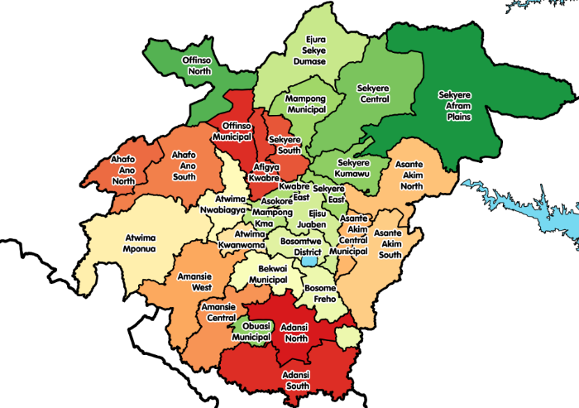
      - Location and Size
Figure 2-1: Districts in the Ashanti Region

The Ashanti Region is centrally located in the middle belt of Ghana. It lies between longitudes 0.15W and 2.25W, and latitudes 5.50N and 7.46N. The region shares boundaries with six of the sixteen political regions, Bono, Bono East and Ahafo Regions in the north, Eastern region in the east, Central region in the south and Western region in the South west. The region is divided into 27 districts, each headed by a District Chief Executive.
      - Population

The center of population of the Ashanti Region is located in the Kumasi Metropolitan District. According to the 2000 census, the region had a population of 3,612,950, making it the most populous region; however, its density (148.1 per square km) is lower than that of Central (162.2/km2) Region.[5] Majority of Ashanti region's population are Ethnic Akans and citizens by birth (94.2%) with five per cent naturalized Ghanaians. A smaller proportion (5.8%) of the population originate from outside Ashanti and Akanland or Ghana, made up of 3.7 per cent mainly from the five English-speaking countries of ECOWAS and 2.1 per cent from other African countries. The non-African population living in the region is 1.8 per cent of the total population. Akans are the predominant ethnic group in the region, representing 94.2% of citizens by birth. A high proportion (82.9%) of the Akan population is Ashanti.

Transport

The Ashanti region is served by the Kumasi Airport, which handles domestic flights. Five national highways – N4, N6, N8, N10 and N6 – and a few regional highways such as the R52 and R106 serve the region.

The N6 connects Kumasi via Kwame Nkrumah Circle and through Nsawam and N4 to Accra. The region is also connected to the Central Region by the N8 and N10, both of which originate from Yemoransa in the Central Region. The N10, however, connects the regional capital of Kumasi.
      - Districts
The political administration of the region is through the local government system. Under this administration system, the region is divided into 30 districts made up of 1 Metropolitan, 7 Municipal and 22 Ordinary districts. Each District, Municipal or Metropolitan Area, is administered by a Chief Executive, representing the central government but deriving authority from an Assembly headed by a presiding member elected from among the members themselves.

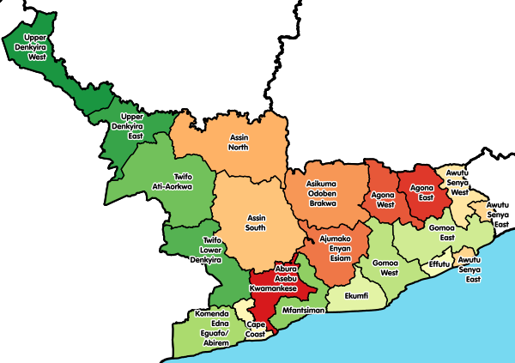
    - Central Region
Figure 2-2:Districts in the Central Region
The Central Region is one of the sixteen administrative regions of Ghana. It is bordered by Ashanti and Eastern regions to the north, Western region to the west, Greater Accra region to the east, and to the south by the Gulf of Guinea. The Central region is renowned for its many elite higher education institutions and an economy based on an abundance of industrial minerals and tourism. The Central region attains many tourist attractions such as castles, forts and beaches stretched along the Central region's coastline.

Districts
The Central Region comprises 20 districts.

Eastern Region
The Eastern Region is located in south Ghana and is one of the sixteen (formerly ten) administrative regions of Ghana. Eastern region is bordered to the east by the Lake Volta, to the north by Bono East Region and Ashanti region, to the west by Ashanti region, to the south by Central region and Greater Accra Region. Akans are the dominant inhabitants and natives of Eastern region and Akan, Ewe, Krobo, Hausa and English are the main spoken languages. The capital town of Eastern Region is Koforidua. The Eastern region is the location of the Akosombo dam and the economy of the Eastern region is dominated by its high-capacity electricity generation. Eastern region covers an area of 19,323 square kilometres, which is about 8.1% of Ghana's total landform.

Districts

The region is divided into administrative districts. The total number of districts were increased from 21 districts to 26.

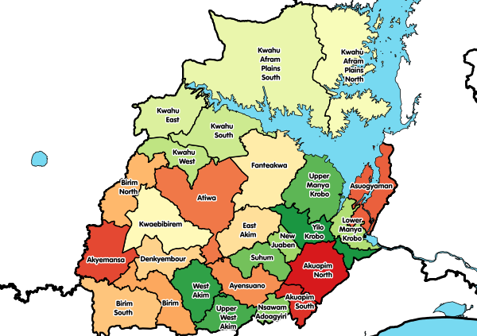
Achiase District was carved out of the existing Birim South District and inaugurated on 22 February 2019. The Afram Plains District has since been split into two and renamed as Kwahu Afram Plains North District with its capital being Donkorkrom and Kwahu Afram Plains South District with its capital also being Tease. The Akuapim South District, East Akim District and Kwahu West Districts have been upgraded to Municipal status with the addition of Birim Central Municipal District which is entirely new. Other new districts include Akyemansa District and Kwahu East District. The Manya Krobo District has been split into Lower Manya Krobo District and Upper Manya Krobo District.
Figure 2-3:Districts in the Eastern Region

Western Region

The Western Region is located in south Ghana, spreads from the Ivory Coast (Comoé District) in the west to the Central region in the east, includes the capital and large twin city of Sekondi-Takoradi on the coast, coastal Axim, and a hilly inland area including Elubo. It includes Ghana's southernmost location, Cape Three Points, where crude oil was discovered in commercial quantities in June 2007. The region covers an area of 23,921 sq. km, and had a population of 2,376,021 at the 2010 Census; the latest official projected population (as at 2019) is 3,093,201.

The Western Region enjoys a long coastline that stretches from South Ghana's border with Ivory Coast to the Western region's boundary with the Central Region on the east.

The Western Region has the highest rainfall in Ghana, lush green hills, and fertile soils. There are numerous small and large-scale gold mines along with offshore oil platforms dominate the Western Region economy.

The culture is dominated by the Akans; the main languages are Akan, French and English.

Tourism
The largest rivers are the Ankobra River, the Bia River, and the Pra River in the east, with the Tano River partly forming the western national border. The area is known for the UNESCO World Heritage Site and village of Nzulezo, built entirely on stilts and platforms over water, and the Ankasa Protected Area. There is a series of imposing Portuguese, Dutch, British, and Brandenburgian forts along the coast, built from 1512 on.

Education
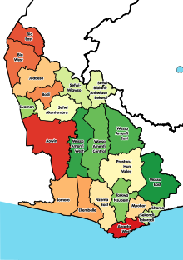
Figure 2-4:Districts of the Western Region
The Western region has many post-secondary schools, including teachers' and nursing colleges, and two universities one at Tarkwa, UMaT and Takoradi Technical University formerly known as Takoradi Polythecnic.

Districts
The original Western Region of Ghana contained 1 Metropolitan Assembly and, 22 Municipalities,
However, following a reorganisation of Regions in 2018, the existing ten Regions were replaced by a new structure of sixteen Regions; as part of this reorganisation, nine districts (those asterisked below) were removed from the Western Region and formed into a new Western North Region with its new capital at Wiawso. The present Western Region is left with 14 districts.

North East Region
The North East Region is one of the sixteen regions of Ghana. It is located in the north of the country and was created in December 2018 after a referendum was voted upon to break it off of the Northern region. The region's capital is Nalerigu.

The North East Region of Ghana was a proposed new region to be carved out of the existing Northern Region of Ghana. The creation of this new region was in fulfilment of a promise made by the New Patriotic Party prior to the 2016 Ghana general election. Upon winning the elections, the President, Nana Akuffo Addo created the Ministry of Regional Reorganization to oversee policy formulation and implementation, and Hon. Solomon Namliit Boar, MP for Bunkpurugu Constituency and former Deputy Northern Regional Minister was appointed as the first Regional Minister for the newly created North East Region. In all six new regions were to be created from the existing ten regions of Ghana. The other regions are Western North, Bono, Bono East, Ahafo, Savannah and Oti regions.

A referendum vote held on December 27, 2018 was successful with 81% voter turnout in the proposed region voting 99.8% in favor of the creation of the North East Region. The region's proposed capital is the town of Nalerigu in the East Mamprusi Municipal Assembly.

Location and Size
The North East Region is bordered on the north by the Upper East region, on the east by the eastern Ghana-Togo international border, on the south by the Northern region, and on the west by the Upper West region. North East region is made up of 6 districts.

Cultural and Social Structures

The Nayiri is the King (overlord) of Mamprugu traditional area of which the entire region is a part. He has a traditional council of elders who advise him. The Nayiri is supported by paramount chiefs, divisional and other sub-chiefs under him. His paramountcies extend beyond the boundaries of the North East Region and even the nation. Notable among the chiefs are the Wulugu Naaba, Wungu Naaba, Soo Naaba, Kulgu Naaba, Yunyoorana and Bunkpurugu Naaba and Zuarungu Naaba, Tongu Naaba, Sakuti (all in Upper East Region).

Mamprusi people are the major ethnic group in the Municipality. However, there are also Dagombas, Bimobas, Konkombas, Talensis, Tampulma, Bissa, Mossis, Chakosis and Hausas who have settled in the area. Two traditional festivals are celebrated annually, Damba Festival, Bugum (Fire) Festival. The District is a multi-religious one with the dominant religions being Christianity, Islam and Traditional African Religion.

Economy

More than 85% of the economically active population are agricultural. The low population density is partly caused by emigration, in addition to geography and climate.

Demographics

The North East Region has a low population density, and, along with the official language of English, most inhabitants speak a language of the Gur subfamily in the Niger–Congo language family, such as Mampruli, Tampulma, Bimoba, Kusaal, Dagbani, or Konkomba. The Mamprusi Kingdom is located in the region.

Religion

Most residents in the North East region are affiliated with Christianity, Islam, and/or Traditional African Religion.

Districts

The North East Region of Ghana contains 6 districts. 4 are ordinary districts in addition to 2 municipal districts.
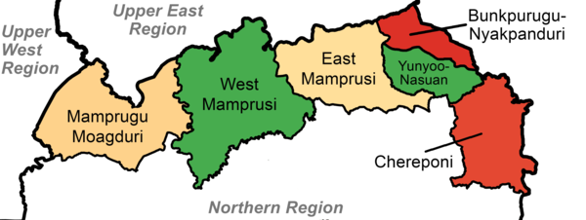
Figure 2-5:Districts of the North East Region

Savannah Region

The Savannah Region is one of the newest regions of Ghana and yet the largest region in the country. The creation of the Region follows presentation of a petition by the Gonja Traditional Council, led by the Yagbonwura Tumtumba Boresa Jakpa I. Upon receiving favourable responses from all stakeholders in the Northern Region (the region it was broken off from), the Brobbey Commission (the Commission tasked with the creation of the new regions), a referendum was conducted on the 27th December 2018. The result was a resounding yes of 99.7%. The President of the Republic of Ghana signed and presented the Constitutional Instrument (CI) 115 to the Yagbonwura in the Jubilee House, Accra on 12 February 2019. The launch was well attended by sons and daughters of Gonjaland including all current and past MPs, MDCEs and all appointees with Gonjaland descent. Damongo was declared the capital of the new Savannah Region. It is located in the north of the country. The Savannah Region is divided into 7 districts; Bole, Central Gonja, North Gonja, East Gonja, Sawla/Tuna/Kalba, West Gonja, North East Gonja and 7 Constituencies; Bole/Bamboi, Damongo, Daboya/Mankarigu, Salaga North, Salaga South, Sawla/Tuna/Kalba and Yapei/Kusawgu.

Location and Size

The Savannah Region is bordered on the north by the Upper West region, on the west by the Ghana-Côte d'Ivoire international border, on the south by the Bono and Bono East regions, and on the west by the North East and Northern regions. Savannah region is made up of 7 districts.

Demographics

The Savannah Region has a low population density, and, along with the official language of English, most inhabitants speak a language of the Oti–Volta subfamily in the Niger–Congo language family, such as Gonja, Dagbani, Mamprusi, or Tamprusi.

Religion

A majority of residents in the Savanna Region identify as Muslim.

Districts
The Savannah Region of Ghana contains 7 districts.
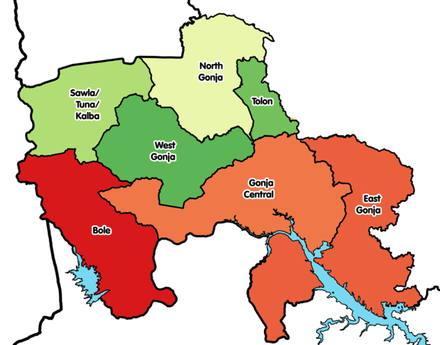
Figure 2-6:Districts of the Savannah Region

Upper East Region

The Upper East Region is located in north Ghana and is the second smallest of 10 now 16 administrative regions in Ghana, occupying a total land surface of 8,842 square kilometers or 2.7 per cent of the total land area of Ghana. The Upper East regional capital is Bolgatanga, sometimes referred to as Bolga. Other major towns in the region include Navrongo, Paga, Bawku and Zebilla.

Location and Size

The Upper East region is located in the north-eastern corner of Ghana, precisely located in the Kingdom of Dagbon, and bordered by Burkina Faso to the north and Togo to the east. It lies between longitude 0° and 1° West, and latitudes 10° 30′N and 11°N. The region shares boundaries with Burkina Faso to the north, Togo to the east, Upper West Region to the west, and the Northern Region to the south. The Upper East region is divided into 15 districts, each headed by a district chief executive.

Demographics

Population

The center of population of the Upper East Region is located in its capital of Bolgatanga. The population is primarily rural (79%) and scattered in dispersed settlements. The rural population was 87.1 percent in 1984 and 84.3% in 2000. There was, thus, a 2.8 percentage point reduction in the rural share of the population between 1984 and 2000 and a further 5.3 percent reduction between 2000 and 2010.

With only 21 per cent of the population living in urban areas, the region is the least urbanized in Ghana. In fact, together with Upper West, they are the two regions with a less than 20 per cent urban population.

Ghanaian citizen by birth, childhood or parenthood constitute 92.5 percent of the population of the Upper East region. Naturalized Ghanaian citizen constitute 5.3 percent.

Transportation

Three national highways – N2, N10, and N11 – and a few Regional highways such as the R113, R114, R116 and R181, serve the region.

The N10 originates from Yemoransa in the Central Region and connects through Kumasi in the Ashanti Region and terminates at Paga in the Upper East Region. The national capital of Accra is also connected to the region by the N2 which terminates in Kulungugu in the Upper East Region. Both these national routes are connected by the N11 which links the regional capital of Bolgatanga to Bimpiela, also in the region.

Districts
The Upper East Region of Ghana contains 15 districts made up of 2 municipal and 13 ordinary districts as follows:

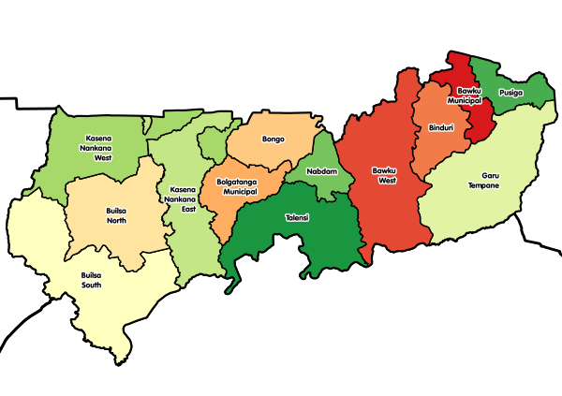
Figure 2-7:Districts of the Upper East Region
Old Map of the Districts of the Upper East Region (2016)

Upper East Region

The Upper West Region of Ghana is located in the north-western corner of Ghana and is bordered by Upper East region to the east, Northern region to the south, and Burkina Faso to the west and north. The Upper West regional capital and largest settlement is Wa. Upper West is the youngest region, created in Ghana by the then Head of State, Flight-Lieutenant Jerry Rawlings in 1983 under the Provisional National Defence Council (PNDC). The area was carved out of the former Upper Region, which is now the Upper East Region.

Location and Size

The Upper West Region is one of the 16 regions of Ghana. It is located at the North Western corner of Ghana with latitude 9.8°- 11.0° North and longitude 1.6°- 3.0 West, bounded to Burkina Faso to the North. It covers a geographical area of 18,476 square kilometres, representing 12.7% of the total land area of Ghana. The northern Ghana-Burkina Faso is bordered on the east by the Upper East region and Northern regions, on the south by the Northern region, on the west by western Ghana-Burkina Faso, and the Upper West region on the north. It is the seventh largest region in Ghana in total area, and it is made up of 11 districts. By virtue of its location, the Upper West Region has the potential for international and inter-regional trade and other bi-lateral relations, but the overspill of criminal activities and disaster, such as bush fires, diseases and pestilence, armed robbery etc., from the region's neighbours also pose a threat.

Tourism

The Wechiau Hippopotamus Sanctuary is located southwest of Wa, along the Black Volta River in the Wa West District. The Gwollu Wall in the Sissala District serves as the hometown of one of Ghana's past presidents - Dr. Hilla Limann.

Economy

The major economic activity of the Upper West Region is agriculture. Crops grown include corn, millet, peanuts, okra, shea tree and rice. Sheep, goats, chickens, pigs and guinea fowl are raised for meat and eggs. Because the region's dry season is long, extending roughly from October to May, many people leave the region to work in the southern part of Ghana for at least part of the year.

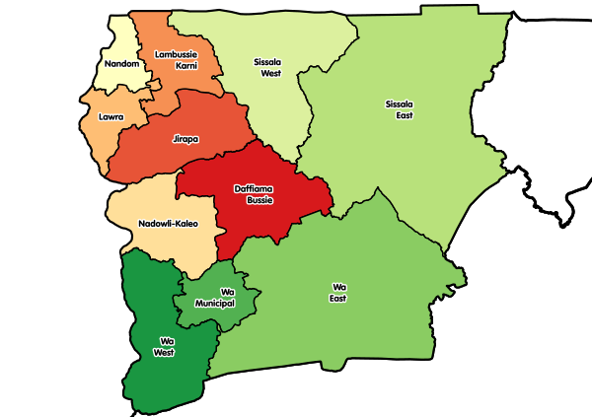
Districts
Figure 2-8:Districts of the Upper West Region
The Upper West Region of Ghana contains 11 districts consisting of 1 municipal and 10 ordinary districts as follows:

Table 2-1:GLRSSMP Target Project Areas

Project Regions | Project Districts
Ashanti | - Adansi South (Pra River Basin)
 | - Asante Akim South (Pra River Basin)
 | - Atwima Mponua (Tano River Basin)
 | - Bosome Freho (Pra River Basin)
 | - Juaben Municipal (Pra River Basin)
 | - Sekyere Afram Plains North (Afram River Basin)
Bono East | - Sene West (Sene River Basin)
Central | - Assin North (Pra River Basin)
 | - Twifo Ati Morkwa (Pra River Basin)
Eastern | - East Akim (Pra River Basin) (ASM)
 | - Kwahu Afram Plains North (Afram River Basin)
 | - Kwahu South (Pra River Basin)
 | - Kwahu East (Pra River Basin)
 | - Kwahu West (Pra River Basin)
 | - Kwahu Afram Plains South (Obosum River Basin / Afram River Basin)
North East | - Mamprugu Moagduri (Nasia River Basin)
 | - West Mamprusi (Nasia River Basin)
Savannah | - Sawla-Tuna-Kalba (Black Volta River Basin)
 | - West Gonja (Black Volta River Basin)
Upper East | - Builsa South (Sisili River Basin)
 | - Bawku West (Red Volta River Basin)
 | - Kassena-Nankana (Sisili River Basin)
 | - Talensi (Red Volta River Basin)
Upper West | - Daffiama-Bussie-Issa (Kulpawn River Basin)
 | - Sissala East (Sisili River Basin)
 | - Sissala West (Kulpawn River Basin)
 | - Wa East (Kulpawn River Basin)
Western | - Prestea-Huni Valley (Pra River Basin) (ASM)

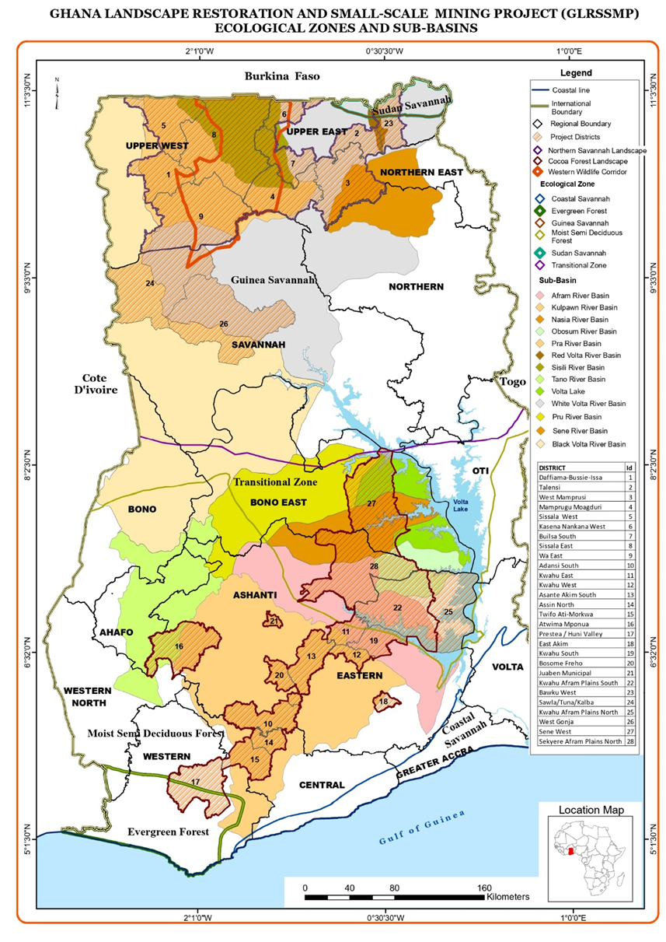
Figure 2-9:GLRSSMP Districts in Ghana

Table 2-2: Regional and District Profile

Region | District | Population | Age  Structure |  |  | Sex  Structure |  | Landuse  Pattern | Economic  Activity | Income | Agriculture |  | Main Ethnicities | Religious  Group | Social  Cohesion | Festivals | Conflicts | Resolution  System | Housing |  | Migration |  | Poverty | Covid-19
 |  |  | Below  15 | 15-65 | Above  65 | M | F |  |  |  | Cash  Crop | Food  Crop |  |  |  |  |  |  | House  Hold Size | Structure | Immi | Emmi
Upper East Region | Talensi | 94, 793 | 41.5% | 52% | 6.5% | 46,556 | 48,237 | Agriculture Lands | Livestock rearing and Agriculture | - | Shea | Maize, Millet, Sorghum, groundnut, vegetables | Frafra | African traditional, Christians and Muslims | Strong | Gologo | No |  | 80.612 (1.) |  |  |  | High poverty among rural farmers
 | Bawku West | 94, 043 | 45.2% | 47.9% | 6.9% | 45,114 | 48, 920 | Agriculture Lands | Trade and Agriculture  Livestock | - | Shea and Dawadawa | Maize, Sorghum, Millet, soyabean, yam, groundnut | Kusasis | African traditional, Christians and Muslims | Strong | Samanpiid | No |  | 15,169 (6.1 per household) | Mud/ Earth and Concrete | 5,033 |  | High poverty among rural farmers
Upper West Region | DBI | 38,008 | 42% | 51.2% | 6.5% | 18671 | 19337 | Agriculture Lands | Trade and Agriculture | - | Shea, Dawadawa | Maize, Sorghum, Millet, yam groundnut and vegetable | Dagaaba, Sissala | African traditional, Christians and Muslims | strong | Jimbenti and Dunyee | No |  | 5030 (6.4 per household) | Mud/ Earth and Concrete | 5,319 |  | High poverty among rural farmers
 | Sissala East | 56,528 | 32.7% | 61.1%) | 6.2% | 27,529 | 28,999 | Agriculture Lands | Agriculture, Livestock |  | Shea, Dawadawa, cowpea | Maize, Sorghum, Millet, groundnut and Cassava | Sissala, Kasena, Moshie | African Traditional Religion, Christianity and Islam | Strong | Paragbielle | No |  | 8,652 (6.4 per household) | Concrete and Mud Brick | 45,335 |  | High poverty among rural farmers
 | Wa East | 72,074 | 45% | 47.7% | 9.8% | 36,397 | 35,677 | Agriculture Lands | Agriculture, Industry and services |  | Shea | Maize, Sorghum, millet, groundnut, Yam | Funsi, Sissala, Gwolla | African Traditional Religion, Christianity and Islam | Strong | Tenghana | No |  | 10,768 (6.6 per household ) | Concrete and Mud Brick | 15,065 | - | High poverty among rural farmers
North East Region | West Mamprusi | 121, 117 | 45% | 48.1% | 6.9% | 59,590 | 61,527 | Agriculture lands | Trade and Agriculture | - | Shea | Maize, groundnut, sorghum,millet, Rice, Yam, vegetables | Mampusi, Kantosis and Comas | African Traditional Religion, Christianity and Islam | Strong | Damba | No |  | 14 432 (8.4 per household), | Mud/ Earth and Concrete | 6,038 |  | High poverty among rural farmers
Eastern Region | Kwahu West | 93,584 | 37.8% | 63.1%) | 5.2% | 44,875 | 48,709 | Agriculture Lands | Trade, Manufacturing, Fishing and Agriculture |  | Cocoa | Maize, Cassava, Plantain, Rice, Yam | Kwahu  Ewes | African Traditional Religion, Christianity and Islam | Strong | Kwahu Easter Festival | no |  | 23,296 (3.9 per household) | Concrete and Mud Brick | 21,858 | 15,873 | High poverty among rural farmers
Ashanti | Adansi  South | 69,593 | 15.60% | 78.80% | 4.60% | 34,563 | 35,029 | Agriculture,  settlement | Farming,  Fishing,  Livestock |  | Cocoa | Maize |  | African Traditional Religion, Christianity and Islam | strong | Akwasidayea | No |  |  |  |  |  | High poverty among rural farmers
Ashanti | Asante Akim South | 145,349 | 60,550 | 76,248 | 8,551 | 72,939 | 72,410 | Agriculture,  settlement | Farming,  Small-scale  Mining, Manufacturing, |  | Cocoa, oil palm, cola, orange | plantain,  cassava,  rice,  vegetables, yam, cocoyam | Akan,  Kusaasi,  Ewes | African Traditional Religion, Christianity and Islam | weak | Kwadutown, ogyeman | No |  |  |  | 90,492) |  | High poverty among rural farmers
Ashanti | Atwima  Mponua | 147,829 | 63,272 | 77,902 | 6,655 | 76,890 | 70,939 | Agriculture,  settlement | Farming  Livestock  fishing  Metal works  Building  Lumber/sawn milling  Carpentry  Footworks  Gari processing  Bakery |  | Cocoa,  Oil Palm  citrus | Maize,  Cassava,  Cocoyam,  Plantain,  Rice | Akans (60.2%)  Dagbani (19.1%)  Gurma (7.9%)  Ewe (4.6%)  Mande (3.9%) | African Traditional Religion, Christianity and Islam | strong | Amanano Asuabo,  Akwasidae,  Awukudae | No |  |  | most houses in the District are built with either landcrete or swish walls and also roofed with either roofing sheet or thatch | 48,949 |  | High poverty among rural farmers, particularly migrants
Eastern | Kwahu  Afram  Plains  South | 146,  026 | 62,  139 | 79,  068 | 4, 819 | 62,  450 | 53, 362 | Agricultural and  Settlement  Land scape | Farming  Forestry,  Fishing,  Agro-forestry,  livestock  Oil palm  Extraction,  Sawmilling,  Wood  carving,  carpentry |  | Cashew  Orange  Oil palm | Maize  Yam  Plantain  Cocoyam  Groundnut | Ewes,  Kwahus,  Ashantis,  Northerners | Christians’  Islam,  Traditional,  Pagans | Strong | Akwasidae ,  Fetu  Afahye,  and  Easter  festivals | No |  | 25,007 | Mud bricks  with  concrete  floors and  metal  sheets | 37,636 | 16,509 | High poverty among rural farmers
Eastern | Kwahu  south | 87,  912 | 34,  655 | 46,  802 | 6,  455 | 41,  876 | 46,  036 | Agriculture,  Settlements | Crop  Farming, f  Fishing,  livestock  Pottery,  trading ‘  Gari-  Processing |  | Cocoa, citrus, | Plantain  Cassava  Cocoyam  Yam  maize | Kwahus  Ewes  Dangme  Ashantis | Christianity  Islam  Traditional | strong | Easter,  Akwasi-  daekese,  And  Afahye  festivals | No |  |  |  | 11,881
Eastern | Kwahu  East | 97,206 | 38,  395 | 50,  905 | 7,  904 | 48.  8% | 51.  2% | settlement | Farming,  Livestock  rearing,  fish  processing |  | Cocoa, citrus | Maize,  Cassava,  Plantain,  Yam,  Vegetables  Cocoyam | Akans,  Ewes,  Ga-  Adangbe,  Fulani | Christianity’,  Islam,  Traditional’  Pagans | strong | Akwasid-  aekese,  Afahye  and  E-aster  festivals | No |  |  |  |  |  | high level  of poverty  of 38%
Central | Assin  north | 80,  534 | 35,  206 | 41,  673 | 3,  655 | 41,  907 | 38,  627 | Agriculture,  settlement | Forestry,  Fishing,  Farming,  livestock  Illegal  Mining,  Oil extraction,  Cassava  processing |  | Oil palm,  Cocoa,  Rubber  Citrus | Maize,  Cassava,  Rice, plantain | Akans,  Ewes | Christianity,  Islam | Strong | Tutu  Festival | No |  | 36,317 | Mud bricks,  and cement  with metal  sheets as  roof. | 44.  6%
 | Twifo Atti Morkwa | 61,743 | 41.8% | 54.5% | 3.7% | 30,254 | 31,489 | Agriculture, Wetlands | Agriculture and fishing |  | Cocoa, oil palm | Maize, Cassava, Plantain, Rice, Yam | Akans | African Traditional Religion, Christianity and Islam | Strong | - | No |  | 59,284 (2.1 per household) | Concrete | 26,179 |  | High poverty among rural farmers

Project Oversight and Responsibility
Table 2.2 describes the Key Project Implementing Agencies and Beneficiary Agencies, their mandate, and role in the project.
Table 2.2.: Key Implementing and Beneficiary Agencies, Mandates and Roles
Implementing Agencies | Institutional Mandate and Activities | Role in the Project
Landscape restoration
IMPLEMENTING AGENCY  Environmental Protection Agency (EPA) | EPA is the lead implementing agency for the landscape restoration activities under the project and will provide a coordination and monitoring role in the implementation. EPA is the principal institution established for environmental protection in Ghana, created under the Environmental Protection Agency Act, 1994 (Act490). The EPA's policy direction is articulated by the Environmental Assessment Regulations, 1999 (LI1652). These two pieces of legislation mandate the EPA to manage, control and monitor compliance of environmental regulations by specific industries. The EPA has an important role in the project implementation as the lead environmental regulator, which oversees compliance with environmental assessment requirements, facilitate public participation and disclosure and issue environmental permits for the project. The EPA has the mandate to decide on project screening, guide the conduct of the environmental assessment studies and to grant environmental approval for the project to commence. Its mandate also covers monitoring of implementation phase of the project to confirm compliance with approval conditions, mitigation measures, and other environmental commitments and quality standards. | The Project Coordinating Unit – Landscape Restoration (PCU-LR) will be housed within the EPA Headquarters with a full-time coordinator, and other relevant staff, and will amongst others, to manage and coordinate operations of implementing agencies, preparation of workplans and reporting. EPA will lead activities on integrated landscape management planning, demonstration of policy measures and incentives for innovation to enable upscaling of restoration activities, and sustainable production and value chains within the landscape and incentives for watershed services provision.
BENEFICIARY AGENCIES
Ministry of Environment, Science, Technology and Innovation (MESTI) | The ministry is mandated to have oversight responsibility to provide leadership and guidance for Environment, Science, Technology and Innovation within the broad sector of the economy through sound policy formulation and implementation. It ensures the establishment of the regulatory framework and setting of standards to govern the activities of science and technology and the management of the environment for sustainable development. MESTI also has the responsibility to analyze and coordinate all planned programs in the environment, science, technology and innovation sector of the economy for purposes of achieving a single integrated management system. MESTI is the lead implementing agency for the Sustainable Land and Water Management Project (P098538) and will ensure effective coordination and continuity of activities in the Savannah landscape. MESTI is the sector Ministry to which the Environmental Protection Agency reports to. | MESTI will have oversight responsibility for the coordination and implementation of landscape restoration activities.
Ministry of Food and Agriculture (MOFA) | MOFA promotes sustainable agriculture and thriving agribusiness through research and technology development, effective extension and other support services to farmers, processors and traders for improved livelihood. Its primary roles are the formulation of appropriate agricultural policies, planning & co-ordination, monitoring and evaluation within the overall national economic development. | Under the project, MOFA will lead and support DAs on activities relating to the development and implementation of participatory micro watershed / community level plans, Community subprojects: silvopastoral, rangelands, and water management investments.
Forestry Commission (FC) (Forest Service Division and Wildlife Division) | FC is the implementation arm of MLNR responsible for regulation, control and management of forest and wildlife resources, the conservation and management of those resources and the coordination of policies related to them. The Commission embodies the various public bodies and agencies that were individually implementing the functions of protection, management, the regulation of forest and wildlife resources. The FC has the following divisions:  - Forest Services Division (FSD);  - Wildlife Division (WD);  - Timber Industry Development Division (TIDD);  - Wood Industries Training Centre (Forestry Commission Training School);  - Resource Management Support Centre (RMSC) | Under the project, activities on forest management planning and investments in and around forest reserves will be implemented by the FSD while activities on management of wildlife protected areas and biological corridors will be implemented by the WD.
Ghana Cocoa Board (COCOBOD) | COCOBOD is responsible for the production, research, extension, internal and external marketing and quality control of cocoa, coffee, and shea nut. The functions are classified into two main sectors; Pre-harvest and Post-harvest. The Pre-harvest Sector functions are performed by the Cocoa Research Institute of Ghana (CRIG), the Seed Production Unit (SPU) and the Cocoa Swollen Shoot Virus Disease Control Unit (CSSVDCU) deal with fundamental issues on actual cocoa production at the farm gate level. The Post-Harvest Sector functions are undertaken by the Quality Control Division (QCD) and the Cocoa Marketing Company (CMC) Limited. The post-harvest activities of COCOBOD start with quality control measures of QCD which farmers must observe to facilitate the acceptance of their produce at the buying centers by the licensed buying companies engaged in internal marketing of cocoa at the time. | Under the project, COCOBOD will undertake activities to ensure improved cocoa production on moribund farms. As part of the community planning exercise of the project, COCOBOD will collate data for the cocoa management and farmer database system. This is to ensure and promote effective policy-making and delivery of interventions in the cocoa sector. This will assist in the building a strong biodata for cocoa farmers and a platform for effective management of cocoa beans and inputs sales and the deployment of subsidies to cocoa farmers.
Mining
IMPLEMENTING AGENCY  Ministry of Lands and Natural Resources (MLNR) | MLNR has the oversight responsibility for the land and natural resources sector and its functions include policy formulation, coordination, monitoring and evaluation, validation of policies, programmes and project, supervision of sector departments and agencies; and negotiations with development partners. The ministry is thus responsible for the management of Ghana's land, forests, wildlife and mineral resources.  MLNR is the lead implementing agency for the Ghana Forest Investment Program (FIP) - Enhancing Natural Forest and Agroforest Landscapes Project (P148183) and will ensure will ensure effective coordination between this project and the FIP. MLNR is the sector Ministry to which the Forestry Commission and Minerals Commission reports. | Under the project, the Project Coordinating Unit on Mining (PCU-Mining) will fall under the leadership of MLNR and will be responsible for project coordination, fiduciary management, and supervision of implementation, as appropriate. The PCU-Mining will coordinate closely with all Implementing Agencies of mining-specific project components.
BENEFICIARY AGENCIES
Minerals Commission (MC) | Minerals Commission has the responsibility to oversee regulation and management of the utilization of the mineral resources of Ghana, and to co-ordinate the policies in relation to them. The main functions of the MC include the following:  - formulate recommendations of national mining policies and monitor their implementation;  - monitor the operations of all bodies or establishments with responsibility for minerals and report to the Minister;  - receive and assess development agreements relating to minerals and report to Parliament;  - secure comprehensive data collection on national mineral resources; and  - perform such other functions as the Minister may assign to it.  A foremost responsibility of the MC is the administration of minerals rights. For this purpose, the MC maintains a cadastral system and a register of mineral rights. The various mining and mineral permits include reconnaissance license, prospecting license, and mining lease. Actual decisions in matters of mineral rights are taken by the Minister of Mining, but only after recommendation of the MC. | Under the project, MC will lead activities under the formalization of ASM sector and together with the EPA and FC, will lead activities on reclamation of mined out sites and waterways and alternative livelihoods.
Precious Minerals and Marketing Corporation (PMMC) | PMMC is mandated to purchase gold produced by small-scale miners through its licensed buyers; it has a network of 800 licensed merchants. | Under the project, PMMC will support activities on establishment and strengthening of ASM mining cooperatives, supply chains and marketing and operation of the assay center.
The EPA and FSD will be also implementing activities under the ASM components.

LEGAL AND INSTITUTIONAL FRAMEWORK FOR LAND ACQUISITION

The Resettlement Policy Framework and Process Framework have considered the following laws, legislation, regulations, and local rules governing land acquisition and involuntary resettlement issues on land and other assets in Ghana.
- The 1992 Constitution of the Republic of Ghana
- Ghana National land Policy (1999)
- Administration of Lands Act, 1962 (Act 123);
- The State Lands Acts, 1962 (Act 125);
- The State Lands Regulations 1962 (LI 230)
- The Lands Statutory Wayleaves Act, 1963, Act 1866. Lands (Statutory Way Leaves) Act, 1963 (Act 186);
- Land Use and Spatial Planning Act, 2016, Act (925)
- Lands Commission Act, 1994 Act (483)
- State Lands Act, 1962, (Act 125)
- Forest and Wildlife Policy (2011)
- Minerals Commission Act 1993, (Act 550)
- Forestry Commission Act 1999, (Act 571)
- The State Lands (Amendment) (No.2) Regulations 1963 (LI285);
- State Lands (amendment) Act 2000 (Act 586)
- Minerals and Mining Regulation (compensation and resettlement) 2012 (LI2175)
- Land Title Registration Law of 1986
- The Lands Commission Act 2008, Act 767
- Local Governance Act of 2016, Act 936; Timber Resource Management Act, 1997 - Act 547:
- Timber Resources Management Act 617 (Amendment) Act, 2002:
- Labour Act 2003, Act 651

The Constitution of Ghana

The Constitution of Ghana (1992) upholds the rights of citizens to own property and receive adequate reparation from the state when lands are compulsorily acquired by the state. The Constitution provides for individual property rights, the protection of those rights, and appropriate compensation from the government if it compulsorily acquires a private person’s property.

Ghana National Land Policy (1999)

The Government of Ghana in 1999 put in place the above policy to serve as a broad framework and policy guidelines for land administration and utilization. The main objective is to provide guidelines aimed at enhancing land management systems, land use, conservation of land resource and enhancing environmental quality. All these are intended to ensure coordinated and orderly use of land, a vital resource, by present and future generations.

Relevant National Laws

Administrative Lands Act, 1962 (Act, 123)

Act 123 of 1962 was enacted to facilitate the management and administration of stool lands (and other lands). The Act empowers the Minister responsible for lands to manage stool lands in accordance with the provision of the law. If Presidential Assent is provided before approval of this document, the document will be modified to reflect the provisions in the new Land Act.

The State Lands Act, 1952 (Act 125)

This is the principal law under which private lands could be compulsorily acquired. The Law empowers the President to acquire any land for the public benefit. The Act and its Regulation, (the State Lands Regulation 1962, L1 230) detail out the mechanism and procedure for compulsorily acquiring lands. It is a mandatory requirement that a copy of the instrument of acquisition be served on any person having an interest in or possession such lands or be affixed at a convenient place on the land and be published thrice in a newspaper circulating in the district where the land is situated.

The Lands Statutory Wayleaves Act, 1963, Act 186

The Lands Statutory Wayleaves Act 1963, Act 186 was enacted to facilitate the entry on any land for the purposes of construction, installation and maintenance of public utility works and creation of right of ways and other similar right for such works.

Land Use and Spatial Planning Act, 2016 (925)

The Land Use and Spatial Planning Law seeks to provide sustainable development of land and human settlements through a decentralized planning system and ensures judicious use of land. This is to improve the quality of life, promote health and safety in respect of human settlements. It further regulates national, regional, district and local spatial planning and generally provides for spatial aspects of socio-economic development and related matters.

Lands Commission Act, 1994 (Act 483)

The Act 483 provides for the management of public and vested lands and the certification of stool lands transactions. It is a requirement of the 1992 Constitution that there shall be no disposition or development of any stool land unless the Lands Commission of the region in which the land is situated has certified that the disposition or development is consistent with the development plan drawn up or approved by the planning authority for the area concerned.

State Lands Act 1962, Act 125

The State Lands Act 1962 (Act 125) has vested authority in the President of the Republic of Ghana to acquire land for the public interest via an executive instrument. On publication of an instrument made for the acquisition, the land shall vest in the President on behalf of the Republic (sect. 1). The Minister may pay compensation or may offer land of equivalent value. Disputes that arise may be referred by the Minister to the Tribunal established under section.

Damage or Loss

The State Lands Act also makes provision for compensation for any person who suffers any loss or damage due to “the carrying out of any survey, as a result of installation, construction, inspection, maintenance, replacement, or removal of any specified work.” The Minister will base the amount of compensation on any loss or damage and may consider how much the person’s land has increased in value as a result of the installation or construction of the works.

Claiming Compensation

The State Lands Act states that the affected person or group is responsible for registering a claim against land acquisition (State Lands Act, Act 125). Any claim for compensation must be made to the Minister no more than three months after the date of declaration made by the President under Act 186, Section 1. No person shall be entitled to any compensation for loss or damage if, in the opinion Ghana Economic Transformation Project Resettlement Policy Framework (RPF) Ministry of Finance, Accra, Ghana 18 of the Minister; (1) any alleged damage to the land has been sufficiently addressed, and the land has been reinstated, (2) any alleged loss arising out of the deprivation of the use of any land, (3) the person alleging the loss has been offered other land of equivalent value, (4) the alleged damage is to movable property, and the property has been sufficiently restored or replaced, or (5) the works constructed do not substantially interfere with the enjoyment of land.

Valuation

The State Lands Act also defines market value as the amount the land would sell for on the open market at the time the wayleave is declared, using the principle of willing buyer – willing seller. Replacement value is used for compensation if there is no demand or market for the land due to the situation of the land or the purpose for which the land was used when the declaration of intent to acquire the land was made. The replacement value is the amount required for “reasonable reinstatement equivalent to the condition of the land at the date of said declaration”. Cost of Disturbance is defined as the reasonable expenses incidental to any necessary change of residence of place of business by any person having a right or interest in the land.

Overview of Land Ownership in Ghana

The section provides a brief overview of the land ownership regimes in Ghana. The land ownership system in Ghana is governed by a complex operation of both customary, statute, and common law resulting in a rather uniquely complicated land ownership structure. There are three principal land ownership patterns in Ghana namely:
- Customary-owned;
- State-owned;
- Customary-owned but state-managed lands also known as vested lands.

The Land Title Registration Law of 1986 recognizes these types of interests in land.

Customary Ownership

Customary ownership occurs where the right to use or to dispose of use-rights over land is governed purely by customary laws of the land-owning community. Customary laws in Ghana vary from one community to another, and the Ghanaian society is made up of various ethnic communities with their varying social structures, customary practices, and norms. These customary laws and norms rest neither on the exercise of brute force, nor on the evidence of rights guaranteed by government statute, but on the fact that they are recognized as legitimate by the community, the rules governing the acquisition and transmission of these rights being usually explicitly and generally known, though not normally recorded in writing (Bower, 1993)

State Lands

State lands are those specifically acquired by government under an appropriate enactment using the state powers of eminent domain. Currently the principal acquiring legislation is the State Lands Act of 1962, Act (122) for public purposes or in the public interest. Under such ownership the Allodial rights become vested in the government which can then proceed to dispose of the lands by way of leases, certificate of allocations, licenses, etc. to relevant beneficiary state institutions as well as private individuals and organizations. The boundaries of these lands are cadastral surveyed but are scattered throughout the country.

Vested Lands

The third category of land in Ghana is the generally referred to as vested lands and they are lands owned by a Stool but managed by the state on behalf of the land-owning Stool. Under such ownership, the legal rights to sell, lease, manage, and collect rent is taken away from the customary landowners by the application of specific law to that land and vested in the state. The landowners retain the equitable interest in the land (i.e., the right to enjoy the benefits from the land). This category of land is managed in the same way as state lands. Unlike state lands, however, the boundaries are not cadastral surveyed, and they are usually larger in size, covering wide areas.

Local Government Act, 1994, Act 480

Under the Local Government Act, Act 480, 1994, MMDAs are mandated to assist, support and coordinate the establishment of educational infrastructure within their areas of geographical jurisdiction. Their involvement and support have therefore been sought under the project to facilitate the execution of the project.

The Lands Commission is responsible for handling compensation claims flowing out of State acquisitions. The Land Valuation Division of the Lands Commission establishes compensation levels, using market value for lands, and generally replacement values for structures. Ghanaian law does not give illegal squatters or settlers the right to compensation, unless they can claim a right to the property under the Limitation Decree.

Forestry Commission Act, 1999 Act 571

An Act to re-establish the Forestry Commission in order to bring under the Commission the main public bodies and agencies implementing the functions of protection, development, management and regulation of forests and wildlife resources and to provide for related matters.

Minerals Commission Act, 1993 Act 450

An Act to establish the Minerals Commission to be responsible for the regulation and management of the utilization of the mineral resources of Ghana and the co-ordination of the policies in relation to them.

World Bank Environment and Social Standards (ESS5)

The World Bank Environmental and Social Standard (ESS5) recognizes that project-related acquisition and restrictions on land can have adverse impacts on communities and persons. Project-related land acquisition or restrictions on land use may cause physical displacement (relocation, loss or residential land or shelter), economic displacement (loss of land, assets or access to assets, leading to loss of income sources or other means of livelihood) or both. The term “involuntary resettlements” refers to these impacts. Resettlement is considered involuntary when affected persons or communities do not have the right to refuse land acquisition or restrictions on land use that result in displacement.

The Environment and Social Standard (ESS 5) applies to physical and/or economic displacement resulting from the following types of land-related transactions:
- Land rights or land use rights acquired through expropriation or other compulsory procedures in accordance with the legal system of the host country;
- Land rights or land use rights acquired through negotiated settlements with property owners or those with legal rights to the land if failure to reach settlement would have resulted in expropriation or other compulsory procedures
- Project situations where involuntary restrictions on land use and access to natural resources cause a community or groups within a community to lose access to resource usage where they have traditional or recognizable usage rights
- Certain project situations requiring evictions of people occupying land without formal, traditional, or recognizable usage rights
- Restriction on access to land or use of other natural resources that cause a community or groups within a community to lose access to resource usage where they have traditional or customary tenure, or recognizable usage rights. This may include situations where legally designated protected areas, forests, biodiversity areas or buffer zones are established in connection with the project including communal property and natural resources such as marine and aquatic resources, timber and non-timber forest products, freshwater, medicinal plants, hunting and gathering grounds and grazing and cropping areas.

Involuntary resettlement would be avoided as far as feasible. Where avoidance is not possible, Involuntary Resettlement should be minimized by exploring all viable alternative project designs, providing compensation for loss of assets at replacement cost, ensure that resettlement activities are implemented with appropriate disclosure of information, consultation, and the informed participation of those affected, improve, or restore, the livelihoods and standards of living of displaced persons, improve living conditions among physically displaced persons through the provision of adequate housing with security of tenure at resettlement sites.

There are significant gaps between Ghana regulations and World Bank Environment and Social Standard. The main differences lie within the terms and conditions of compensation, treatment of illegal settlers “squatters” and accommodation for vulnerability in resettlement. For instance, the Ghana statutes makes provision for compensation to be paid to only persons who have suffered any loss and can produce any form of title that is legal in the form of deeds, leaseholds, or legally binding tenancy agreement to the land in question. However, ESS 5 expects all forms of losses without exception to be catered to – and since this is a World Bank financed project, provisions of ESS5 prevail and shall be applied.

Comparison of Ghanaian Laws with World Bank ESS

Under the Ghana Landscape Restoration and Small-scale Mining Project, some temporary or permanent land acquisition or restriction of access during the implementation phase may occur, thereby triggering ESS5. There is therefore the need to apply provisions of ESS5. However, there are significant gaps between Ghanaian laws and regulations and the requirements for resettlement and restriction of access as outlined in the World Bank Environmental and Social Standards (ESS5). These gaps and actions to fill them applying the World Band ESF have been identified in Table 7.1 below.

Table 3-3-1:Comparison of Ghanaian Laws with World Bank Environmental and Social Standards (ESS5)
Topic | Ghana Legislation Requirements | World Bank Policy Requirement (ESS5) | Comparison/Gaps | Gap Bridging Actions
Land Tenants/ Squatter | No constitutionally or legislatively recognized resettlement rights or assistance for those without recognized (formal) legal rights to land. | For those without formal legal rights to lands or claims to such land that could be recognized under the laws of the country, the government should provide resettlement assistance in lieu of compensation for land, to help livelihoods improve or at least restore those affected persons’ | Bank policies provide for compensation for squatters; Ghanaian laws do not. Bank policies make provisions for supporting vulnerable groups among the displaced; the Ghanaian laws have no provisions for special support for vulnerable. | Provision are made for compensation to support squatters and the vulnerable
Timing of compensation payments | There are no relevant constitutional or legislative provisions that specify the timing of completion of resettlement and compensation. | Implement all relevant resettlement plans before project completion and provide resettlement entitlements before displacement or restriction of access. | There is no equivalence on implementing all relevant resettlement plans before project completion or on providing resettlement entitlements before displacement or restriction of access. Even if these requirements are met, they would be applicable only to communities with proprietary rights or interests in affected lands. | Compensation payments are done prior to displacement.
Calculation of compensation and valuation | Fair and adequate | Full replacement cost and livelihood restorations | There are no equivalent provisions on relocation assistance, transitional support, or the provision of civic infrastructure. | The Replacement Cost Approach (RCA) will be adopted for the calculation of compensation, and livelihood restoration
Relocation and Resettlement | In the event where inhabitants have to be physically displaced, the State is to resettle them on “suitable land with due regard for their economic well-being and social and cultural values”. | Affected people who are physically displaced are to be provided with residential housing, or housing sites, or, as required, agricultural sites at least equivalent to the old site. Preference to be given to land-based resettlement for displaced persons whose livelihoods are land based. | Ghanaian laws do not appear to make provisions for avoidance or minimizing of involuntary resettlement | Physically displaced PAPs are to be provided with housing sites at least equivalent to the old site. Preference to be given to land-based resettlement for displaced persons whose livelihoods are land-based (i.e. farmers, etc.)
Restriction on access to land or use of other natural resources | There are no relevant specific legislative provisions that addresses issues of restriction on access to land or use of other natural resources | For projects that may impose changes in land use that restrict access to resources in legally designated parks or protected areas or other common property resources on which local people may depend for livelihood purposes, the project/plan will establish a participatory process for determining appropriate restrictions on use and set out the mitigation measures to address adverse impacts on livelihoods that may result from such restrictions. | Ghanaian laws do not appear to make provisions for restriction on access to land or use of other natural resources | Where there are issues of restriction on access to land or other natural resources the project/plan will establish a participatory process for determining appropriate restrictions on use and set out the mitigation measures to address adverse impacts on livelihoods that may result from such restrictions.
Resettlement Assistance | No specific provision with respect to additional assistance and monitoring | Resettlement assistance may consist of land, other assets, cash, employment, and so on, as appropriate. | Ghanaian policy and legislation would need to be reviewed to aligned with this Bank policy | Affected people are to be offered resettlement support to cover a transition period.
Completion of resettlement and compensation | There are no relevant constitutional or legislative provisions that specifically state that resettlement and compensation need to be completed. | Implement all relevant resettlement plans before project completion and provide resettlement entitlements before displacement or restriction of access. | There is no similarity between Ghanaian law and World Bank policies on implementing relevant resettlement plans before project completion or on providing resettlement entitlements before displacement or restriction of access. | The implementation of relevant resettlement plans before project completion or on providing resettlement entitlements before displacement or restriction of access should be made in compliance with the eligibility classification in Para. 10 of ESS5 and in line with Section 5.1.1 of this RPF..
Vulnerable Groups | No specific provision | Particular attention to be paid to vulnerable groups, especially those below the poverty line, the landless, the elderly, physically challenged, women and children. | Ghanaian policy and legislation would need to be reviewed to aligned with this Bank policy | Particular attention to be paid to vulnerable groups, especially those below the poverty line, the landless, the elderly, women and children.  Ensure women’s perspectives are factored into all aspects of resettlement planning and implementation. Enable women to share equitably in compensation from resettlement of male-headed households when land is in one person’s name.
Livelihood restoration and assistance | There are no specific laws or regulations specifying support for livelihood restoration and transition and moving allowances | Livelihoods and living standards are to be restored in real terms to pre- displacement levels or better. | Ghanaian policy and legislation would need to be aligned with Bank policy to effectively guarantee rights of all affected persons of involuntary resettlement | Steps to be taken to restore livelihoods and living standards in real terms to pre- displacement levels or better
Consultation and disclosure | The owner or occupier of the land must be formally notified at least a week in advance of the intent to enter, and be given at least 24 hours’ notice before actual entry. | Displaced persons and their communities are provided timely and relevant information, consulted on resettlement options, (including being involved in site selection of where they are being relocated) and offered opportunities to participate in planning, implementing, and monitoring resettlement | While the consultation requirement is inherent in the EIA, it contains a number of differences with the requirements of Bank policy, noted above also. In LI 1652 (Regulation 17), similar considerations apply, and the same differences are identifiable: There is no requirement to disclose the preliminary report under Regulation 9. Practice has been that where a mitigation plan affects local communities, proceedings are conducted in the local language. This is significant considering the composition of those most likely to be excluded from the remit of Ghanaian legislative and constitutional protection for involuntary resettlement (i.e., squatters). | Displaced persons and their communities are provided timely and relevant information, consulted on resettlement options, and offered opportunities to participate in planning, implementing, and monitoring resettlement.
Grievance Redress Mechanism and Dispute Resolution | Access to Court of Law | Appropriate and accessible grievance mechanisms to be established | The Local Governance Act 2016 Act 936 section 26 makes provision for the establishment of Public Relations and Complaint Committee to address grievances. Section 89 also makes provision for grievance procedures. | Appropriate and functional GRM to be established.  Ensure that a project grievance mechanism is in place as early as possible in project development to address concerns about compensation, relocation or livelihood restoration.

Institutional Framework

The GLRSSMP encompasses multiple stakeholders in dealing with the integrated landscape management, formalization of artisanal and small-scale mining.
The following institutions will play various roles in the implementation of the resettlement and livelihood restoration related activities of the GLRSSMP:

- Ministry of Lands and Natural Resources (MLNR)
- Ministry of Environment, Science, Technology and Innovation (MESTI)
- Environmental Protection Agency (EPA)
- Ministry of Food and Agriculture (MoFA)
- Ministry of Finance (MoF)
- Lands Commission (LC)
- Forestry Commission (FC)
- Minerals Commission (MC)
- Ghana Geological Survey Authority (GGSA)
- Municipal and District Assemblies (MDAs)
- Regional Coordinating Councils (RCCs)
- Traditional Authorities (TAs)
- Non-Governmental Organizations (NGOs)

Ministry of Lands and Natural Resources

The Ministry has the oversight responsibility for the land and natural resources sector and its functions include: Policy formulation, Co-ordination, Monitoring and Evaluation, Validation of Policies, Programmes and Projects, Supervision of Sector Departments and Agencies; and Negotiations with Development Partners.

MLNR is the sector Ministry to which the Forestry Commission, Minerals Commission and Lands Commission reports. It is also responsible for Ghana Landscape Restoration and Small-Scale Mining Project (GLRSSMP). MLNR will serve on the Program’s Coordination and Management Committee and will ensure liaison with the Ministry of Finance for the release of funds for compensation payment to affected parties relating to the ASM activities. .

Ministry of Environment, Science, Technology and Innovation

With respect to resettlement activities, the Ministry of Environment, Science, Technology and Innovation (MESTI) together with the Ministry of Lands and Natural Resources (MLNR) are the lead coordinating Ministries for the project, including hosting the PCUs. The PCUs will have key staff including Social and Environmental Safeguards Specialists who will lead and coordinate social impact assessments, resettlement planning and implementation in close coordination with safeguards focal persons of the other participating ministries and agencies. The Ministry will liaise with the Ministry of Finance for the release of funds for compensation payment to affected parties relating to the forest landscape activities. The Ministry may enter into special arrangements with participating Municipal and District Assemblies (MDAs) regarding implementation of provisions in the RAPs especially with reference to payments of compensations.

Ministry of Finance

Ministry is responsible for:
- Mobilization of external and internal resources necessary to pay compensation to project affected persons in the case of resettlement of restriction of access to economic resources.
- Ensures the timely releases of funds for payment of compensation to project affected persons.

Environmental Protection Agency

As the law stipulates, the EPA is statutorily mandated to ensure that the implementation of all undertakings do not harm the environment. It is expected that sub-projects that will require the preparation of EIA will abide by statutory requirements and the implementing institutions will liaise sufficiently with the Agency to ensure compliance.

The Ministry of Food and Agriculture (MOFA)

The Ministry of Food and Agriculture (MOFA) promotes sustainable agriculture and thriving agribusiness through research and technology development, effective extension and other support services to farmers, processors and traders for improved livelihood.

Forestry Commission

The Forestry Commission of Ghana is responsible for the regulation of utilization of forest and wildlife resources, the conservation and management of those resources and the coordination of policies related to them. The Commission embodies the various public bodies and agencies that were individually implementing the functions of protection, management, the regulation of forest and wildlife resources. These agencies currently form the divisions of the Commission:
- Forest Services Division (FSD)
- Wildlife Division
- Timber Industry Development Division (TIDD)
- Wood Industries Training Centre (Forestry Commission Training School)
- Resource Management Support Centre (RMSC)

The Climate Change Unit, established in 2007 as a unit of the Commission has a mandate to manage forestry-sector initiatives related to climate change mitigation, including Reducing Emissions from Deforestation and Forest Degradation (REDD+). It hosts the National REDD+ Secretariat and serves as the National REDD+ focal point.

Among the aims of the Commission is the sustainable utilization of Ghana's forest and wildlife resources meeting both national and global standards for forest and wildlife resource conservation and development.

Minerals Commission

In broad terms, the responsibility vested with the Mineral Commission is to oversee regulation and management of the utilization of the mineral resources of Ghana, and to co-ordinate the policies in relation to them.

A foremost responsibility of the MC is the administration of minerals rights. For this purpose, the MC maintains a cadastral system and a register of mineral rights. The various mining and mineral permits include reconnaissance license, prospecting license, and mining lease. Actual decisions in matters of mineral rights are taken by the Minister responsible for Mining, but only after recommendation of the MC.

For the promotion and administration of Small-Scale Mining, the MC maintains District Offices. The MC has been overwhelmed by the activities of illegal small-scale mining popularly known as galamsey and the Commission has not been able to bring it under control or get rid of it even with the recent introduction of the Presidential Task Force.

Water Resources Commission

The Water Resources Commission (WRC) was established by an Act of Parliament (Act 522 of 1996) with the mandate to regulate and manage Ghana's Water Resources and co-ordinate government policies in relation to them. The Act stipulates that ownership and control of all water resources are vested in the President on behalf of the people. The functions of the WRC as established under Act 522 among other things are to:
- Formulate and enforce policies in water resources conservation, development and management in the country;
- Coordinate the activities of the various agencies (public and private) in the development and conservation of water resources;
- Enforce, in collaboration with relevant agencies, measures to control water pollution; and
- Be responsible for appraising water resources development project proposals, both public and private, before implementation.

Lands Commission

This is the state agency charged primarily with the management and administration of state and vested lands. It is responsible for advising on policy framework for development of particular areas so as to ensure that development of such areas is coordinated. The functions of the Lands Commission are spelt out in Article 256 of the 1992 Constitution and the Lands Commission Act (Act 483) 1994. The Commission’s role in the compulsory acquisition is that it serves as a member/secretary to the Site Selection Committee, a technical committee that considers request for compulsory acquisition by the state agencies and recommends its acceptance or otherwise. The proprietary plan covering the site to be acquired is plotted by the Commission in the government records. Also, recommendation on the acquisition is processed by the Commission for the approval by the Minister responsible for lands, before an executive instrument would be issued and gazette. The Lands Commission comprises of four Divisions:
- Lands Registration Division
- Land Valuation Division
- Survey and Mapping Division; and
- Public and Vested Lands Management Division

Ghana Geological Services Authority (GGSA)

The Ghana Geological Survey Authority (GGSA), formerly named the Geological Survey Department (GSD), was established in 1913 by the colonial administration under the directorship of Sir Albert Kitson to, among other, investigate and establish the extent and quality of both existing and yet undeveloped areas of mining activity in the Republic of Ghana and to prepare for their exploitation. According to the GGSA Act 928 of 2016, some of the objectives of the GGSA are to:
- carry out systematic geological mapping, assess, monitor and evaluate geological hazards and risks, collect geoscientific data, manage and disseminate geoscientific information;
- promote the search for, and exploitation of minerals in the Republic of Ghana, undertake research in the field of geoscience and furnish specialised geoscientific services; and
- conduct research into matters of importance for the exploration, exploitation and protection of the nation’s geological and geoscientific natural resources.

Land Use and Spatial Planning Authority

The Authority prepares planning layouts for towns and cities and defines Safety Zones/Rights of Way. It also vets and approves layouts prepared by prospective developers and specifies all reservations based on forecasted land-use plans. The Authority is required to approve developments and grant permits in conformity with the already prepared layout of the area. Land Use and Spatial Planning Authority has responsibility to revise and consolidate the laws on land use and spatial planning, provide for sustainable development of land and human settlements through a decentralized planning system, ensure judicious use of land in order to improve quality of life, promote health and safety in respect of human settlements, regulate national, regional, district and local spatial planning, and generally provide for spatial aspects of socio economic development and other related matters. The Authority is mandated to undertake the following services:
- Preparation of Spatial Plans (Spatial Development Frameworks; Structure Plans and Local Plans);
- Rezoning and Change of Use
- Plan Revision and Amendments
- Layout Extracts
- Sub-division
- Site Selection
- Processing Development and Building Permit Applications
- Provision of Certified True Copies of Planning Documents and Permits

Provision of Planning Advisory Services LUSPA is positioned to operationalize the component activities along with the other participating MDAs. As indicated in the PCU structure, LUPSA is expected to have dedicated staff who will take direct responsibility for ensuring judicious use of selected land in order to improve quality of life, promote health and safety of the people.

The Municipal and District Assemblies (MDA’s)

The Municipal and District Assemblies (MDAs) are planning authorities as stated in the Local Governance Act 2016 (Act 936). They have jurisdiction over the project corridors and sites. They grant permits and licenses for development and operation of infrastructure and any other commercial activities. Land demarcation and general development plans of communities lie with the assemblies as well as the communities in consultations with the Traditional Authorities who are custodians of lands in most part of Ghana. The MDAs will be acquiring lands for sub-projects in their MTDPs and where resettlement and compensations are triggered; they will be responsible for the implementation of the provisions of the RAP for the GLRSSMP.

Traditional Authorities and Community Elders

In the 1992 Constitution, chieftaincy together with its traditional councils is guaranteed and protected as an important institution in the country. Article 267 (1) of the 1992 Constitution avers that all stool lands in the country shall vest in the appropriate stool on behalf of, and in trust of the subjects of the stool in accordance with customary law and usage. In Ghana, people of common descent owe allegiance to a symbol of collective authority, such as the ‘stool’ for the Akans of Southern Ghana or the ‘skin’ for the people of Northern Ghana. Traditional Authorities play a key role in the administration of the area and in customary land control. At the village level, family and land disputes and development issues are also traditionally dealt with by the village chief and elders. In addition to providing an important leadership role, especially in the more rural areas, chiefs act as custodians of stool/skin land, can mobilize their people for developmental efforts and arbitrate in the resolution of local disputes. Although chiefs have no direct political authority, some are appointed by the Government on District Assemblies. For the purpose of this project, community elders and chiefs will play a key role in identifying Project Affected Persons for compensation purposes.

World Bank

- Review and give No Objection to the RPF/RAP/ARAP;
- Disclose the approved report on World Bank External Website
- Conduct periodic site visits/monitoring and audits as needed to check compliance

Non-Governmental Organizations NGOs

NGOs are independent bodies who serve as the voice of the local people. They participate in public hearings of ESIAs and RAPs and in addressing the concerns of the communities. With regards to the implementation of the GLRSSMP where resettlements and compensations are triggered, they will serve as independent advocacy bodies to validate compensations and resettlement schemes, help with sensitization and awareness programs, facilitation of transparency and grievance redress. As part of the broader project consultation, the GLRSSMP will engage relevant NGOs in project activities. The NGOs will serve as bridge for community mobilization and support for the project.

DESCRIPTION OF Potential Risks and Impacts from GLRSSMP

It is acknowledged that the proposed Ghana Landscape Restoration and Small-Scale Mining Project and its activities could give rise to permanent or temporary physical and economic displacement resulting from land acquisition or restrictions on land use undertaken or imposed in connection with the project implementation. The project may also cause restrictions in access to natural resources in legally designated parks or protected areas. This chapter deals with the potentials risks and impacts associated with the project. As per the requirements of ESS5, it is recognized that GLRSSM project-related land acquisition and restrictions on land use can have adverse impacts on communities and persons. It is for this reason that this description of potential risks and impacts have been identified for the development of the appropriate mitigation measures.

Potential Positive Social Impacts

The positive impacts which may be associated with reclamation of degraded lands include:
- creation of opportunities for marginalized groups to access land;
- delineation of potential mining deposit/areas
- creation of available lands for social activities (recliamed lands close to settlements which can no longer be used for any viable economic activity can be designed for revreational purposes
- creation of employment for women and vulnearable groups;
- increasing the skills and capacity of youths to find employment;
- protection of traditional activities such as indigenous medicines;
- improvement of the aesthetic beauty of the land;

Potential Negative Social Impacts and Risks

Land Tenure and Ownership

Land tenure and ownership
- Conflicts in land claims
- Increased values in land prices leading to economic displacement of poor land tenants
- Lack of transparency in rules for benefit sharing of between landowner and farmer tenants
- Rules and agreements in place for traditional chiefs’ revenue sharing with locals and other stakeholders
- Discrimination
- Lack of grievance mechanisms for all land users and tenants
- Restrictions on reclaimed lands

Livelihood Issues

Maintaining Livelihoods
- Potential expansion of negative activities by admitted settlements and farms that result in biodiversity loss, ecosystem changes, depletion of natural resources
- Increasing demand for forest lands for farming/ settlements by fringe communities because productive lands not available;
- Lost opportunity to earn income through illegal gold mining to maintain families
- Farmers have little say in the harvesting of matured shade trees and restrictions on farm and settlement expansions;
- No financial benefit to farmers for planting and nurturing shade trees;
- Difficulties in registering shade trees;
- Unreliable supply of seedlings;
- Long gestation period of native species.

Forest Management Issues

Forest Management
- Lack of rights to use forest resources due to access restrictions
- Restricted access to non-timber forest products (NTFPs)

Table 4-1 below presents project activities that may have potential displacement / livelihoods impacts on affected persons as they may restrict access and use of land. The table identifies types of impacts relating to assets (land, crops, structures, cultural heritage resources) and livelihoods and economic displacement that may arise from the project activities, as applicable under ESS5.

ESS5 does not apply to the following project activities where the community using resources collectively decides to restrict access to these resources:
- subcomponent 3.1 related to implementation of SLWM subprojects in target micro-watersheds. Community decision-making and planning for such activities will start with preparation of the Community Watershed Management Plans through a consultative process that involves all households in the community. Implementation of the Community Watershed Management Plans is led by the elected Community Watershed Management Teams. The Community-Based Participatory Watershed Development Planning Manual, originally developed under the Ghana Sustainable Land and Water Management Project and successfully used by this project, provides detailed guidance on the preparation such plans and the engagement process throughout it.

- subcomponent 3.4 related to establishment of Community Resources Management Area( CREMAs )and implementation of their management plans. Formation of CREMAs follows the CREMA Manual prepared by the Wildlife Division of the Forestry Commission. CREMAs have been successfully promoted in Ghana, including with support of the World Bank financed projects such as the Northern Savannah Biodiversity Conservation Project, the Ghana Sustainable Land and Water Management Project, and the Ghana Forest Investment Program.
To ensure that adequate venues for addressing potential grievances exist, the Community Watershed Management teams and CREMA Executive Committees will provide for operation of the appropriate dispute / grievance redress mechanism in accordance with respective provisions in the Community Watershed Management Plans and CREMA management plans.
CREMA concept
The CREMA mechanism is an innovative natural resource management and landscape-level planning tool for community initiatives. It was developed by Ghana's Wildlife Division, an arm of the Forestry Commission, together with its partners, to support community resource management in off-reserve (un-gazetted) lands. The CREMA concept is grounded in Ghana’s Wildlife Policy. CREMAs fill a critical gap by giving communities the right to manage and benefit economically from their natural resources. While Ghana's Constitution vests ownership of the land in the Stool or Skin (the traditional or customary leadership structures that preside over a particular ethnic group, clan or tribe and the associated land and resources) it gives the Government the right to manage the naturally occurring resources for economic gain. This has resulted in a series of perverse incentives that, over the decades, have tended to drive ‘illegal’ resource use and degradation or deforestation of the forest resources. The CREMA represents a profound policy shift by permitting communities, land owners, and land users an opportunity to govern and manage forest and wildlife resources within the boundaries of the CREMA, and to benefit financially or in kind.
In Ghana, the CREMA process has followed a nearly 20-year evolution from an intellectual concept to an approved pilot initiative and finally to an authorized mechanism. As originally conceived, the CREMA approach provided a mechanism by which the Wildlife Division could transfer authority and responsibilities for wildlife to rural communities. It denoted a geographically defined area endowed with sufficient resources where the people had organized themselves for the purpose of sustainable management of their natural resources. The aim was to encourage local people to integrate wildlife management into their farming and land management systems as a legitimate land-use option.
CREMAs are gazetted through legal instruments issued by respective districts. They are governed by the CREMA Executive Committees composed of elected community representatives.

Table 4-1:Identified Project Activities and Related ESS5 Risks and Impacts
Treatment of cultural heritage is included here only as it pertains to locations affected by the activities with ESS5 risks. Comprehensive treatment of ESS8 Cultural Heritage is included in the Project ESMF.

Project activities | Potential risks and Impacts on Land, Structures, and Livelihoods |  |  |  |  | Proposed Mitigation plan(s)
 | Land | Crops/economic plants | Structures | Livelihoods | Cultural heritage resources
Component 1: Institutional Strengthening of governance and partnerships for participatory landscape management
Subcomponent 1.3: Airborne geo-physics and geological surveys
Activity 1.3 (a): Airborne geo-physics and geological surveys | Geological investigations will be on Minerals Commission’s blocked out areas deemed “virgin lands”. However, there could be compensation issues if the land is encroached; Temporary disruption of access to structures and Conflicts in land claims may occur | Pitting, trenching may cause temporary disruption to farming activities of community members. | Resource Access and Possible Restriction | Impacts on livelihoods or income generation of PAPs  This activity may temporarily disrupt the economic and livelihood activities of the community members | Cultural artefacts may be uncovered during excavation.  Compensation may be required | Establish eligibility criteria for affected persons (due to potential temporary impacts), set out procedures and standards for compensation (cash compensation and/or livelihood assistance) and incorporate arrangements for consultations, monitoring and addressing grievances in RAP/ARAP
Component 2. Enhanced governance in support of sustainable ASM
Subcomponent 2.1: Regulatory strengthening and formalization of ASM
Update of the mineral cadastre to include ASM | Permanent or temporary restrictions of identified mineable sites | Permanent or temporary disruption to farming activities of community members on identified mineable sites may occur | Not expected | Impacts on livelihoods or income generation of PAPs.  This activity may temporarily or permanently disrupt the economic and livelihood activities of the community members | Not expected | Establish eligibility criteria for affected persons, set out procedures and standards for compensation (cash compensation and/or livelihood assistance) and incorporate arrangements for consultations, monitoring and addressing grievances in RAP/ARAP
Subcomponent 2.2: Training and technology transfer
Establishment and operation of one ASM incubation and one demonstration centre | Facilities will be located on existing campuses of Minerals Commission’s premises. There may be physical or economic displacement if the sites are in use (encroachment) by community members. | If the sites are used for farming, construction of incubation centres may cause permanent or temporary disruption of crops | If the sites have structures on them (belonging to community members/ encroached), construction of incubation centres may cause permanent or temporary disruption of crops | This activity may temporarily disrupt the economic and livelihood activities of community members if sites are used by community people | Cultural artefacts may be uncovered during excavation | RAP/ARAP to be prepared for specific areas where the ASM demonstration centre and incubation center will be located to mitigate identified impacts
Component 3: Sustainable Crop and Forest Landscape Management
Subcomponent 3.1: Planning, capacity and implementation of SLWM in target micro-watersheds
Improved cocoa production on moribund farms  (support to revitalization of moribund cocoa farms affected by diseases) | Risk of expansion of farms beyond established boundaries | Not applicable | Not applicable | Not applicable | Not applicable | Verify plot boundaries at the start of implementation of activities; ensure that project GRM is accessible in case complaints arise
Subcomponent 3.3. Forest Management Planning and Investments in and around Forest Reserves
Improved management of target forest reserves | Not applicable | Not applicable | Not applicable | Access restriction in the gazetted protected areas. Uncontrolled harvesting of timber and trees for charcoal, fuel wood, etc., will be restricted.  Access to non-timber forest products may also be restricted. | Restrictions could affect access to cultural resources | - Apply provisions of the Process Framework  - establish rules and agreements for community access  - include appropriate mitigation measures in the management plans of respective Forest Reserves  Project design already includes provision for livelihoods activities targeting boundary communities
Engagement with Admitted Settlements and Admitted Farm Owners to limit their illegal expansion in FRs | Existing gazetted boundaries of admitted farms will be pillared / demarcated with trees to prevent (illegal) expansion beyond the farm boundaries | Not applicable | Not applicable | Harvesting of trees for charcoal, fuel wood, etc., will also be restricted | Not applicable | Establish an engagement process for determining appropriate restrictions on use and set out the mitigation measures to address adverse impacts on livelihoods that may result from these restrictions.  -Ensure that project support is provided based on needs of the farmers  -Established grievance redress options
Subcomponent 3.4: Management of Wildlife Protected Areas and Biological Corridors
Improved management of target wildlife protected area | Not applicable | Not applicable | Not applicable | Access restriction in the gazetted protected areas. Uncontrolled harvesting of timber and trees for charcoal, fuel wood, etc., will be restricted.  Access to non-timber forest products may also be restricted. | Restrictions could affect access to cultural resources | - Apply provisions of the Process Framework  - establish rules and agreements for community access  - include appropriate mitigation measures in the management plans of respective Forest Reserves  Project design already includes provision for livelihoods activities targeting boundary communities
Construction of CREMA community facilities (mini processing facilities for shea nut grinding, etc) | Site selection for such facilities will be undertaken as part of the preparation of the CREMA management plan. Care will be taken by the community during this exercise to identify locations that have no competing land uses.
Engagement with Admitted Settlements and Farm Owners to limit their illegal expansion in PAs | Existing gazetted boundaries of admitted farms will be pillared / demarcated with trees to prevent (illegal) expansion beyond the farm boundaries | Not applicable | Not applicable | Harvesting of trees for charcoal, fuel wood, etc., will also be restricted | Not applicable | Establish an engagement process for determining appropriate restrictions on use and set out the mitigation measures to address adverse impacts on livelihoods that may result from these restrictions.  -Conduct a livelihood Needs Assessment during project implementation to ensure that project support is provided based on needs of the farmers  -Established grievance redress options
Subcomponent 3.5: Reclamation of mined out sites and alternative livelihoods
Mapping, feasibility studies, and monitoring of abandoned mine sites with potential for restoration  Reclamation of abandoned ASM sites | Land Tenure and Ownership issues  -Conflicts in land claims may occur  -Tree planting on abandoned sites requiring consent from landowners but no transfer of title to the State or resettlement of tenants. | Not applicable | Demolition of temporary or permanent structures of miners at sites to be restored/ reclaimed | Loss of livelihoods or income generation activities of PAPs as a result of enforcement of restrictions on land access and use (e.g. buffer zones restrictions) | Cultural artefacts may be uncovered during restoration/ reclamation activities | Conduct comprehensive assessment of baseline uses and land ownership of sites proposed for restoration.  Establish eligibility criteria for affected persons, set out procedures and standards for compensation (cash compensation and/or alternative livelihood assistance) where applicable and incorporate arrangements for consultations, monitoring and addressing grievances in RAP/ARAP  -Implement recommendations of the land reclamation and alternative livelihood baseline studies conducted during the PPA.  -Affidavit signed by landlords and tenants; and witnessing or evidence by recognized traditional authority

ELIGIBILITY CRITERIA AND ENTITLEMENT MATRIX - RPF

Eligibility Criteria

This section sets out eligibility criteria, which are necessary to determine who will be eligible for resettlement and benefits, and to discourage claims of ineligible persons.

General Eligibility

General eligibility is defined as, “people who stand to lose land, houses, structures, trees, crops, businesses, income and other assets as a consequence of the project as of the formally recognized cutoff date will be considered as Project Affected Persons (PAPs)”. In line with requirements from WB ESS5 the following three categories of affected people will be eligible to Project resettlement assistance:

- Those who have formal legal rights to land and assets (including customary and traditional rights recognized under the laws of the Ghana);
- Those who do not have formal legal rights to land at the time the census begins but have a claim to such land or assets – provided that such claims are recognized under the laws of the country or become recognized through a process identified in the resettlement plan;
- Those who have no recognizable legal rights or claim to the land or asset they occupy or use.

Table 6-1 below presents the type of PAPs and types of compensation. The census to be conducted in accordance with the process described in this RPF will establish the status of the affected persons.

Table 5-1:Types of Project Affected Persons (PAPs) and Types of Compensation
Category of PAPs | Types of compensation
Affected persons with formal legal rights to land including customary leaders who hold land in trust for community members. | - Payment in Cash, kind, or land  - Compensation for land lost at full market price.  - Compensation to be granted to communities where customary leaders hold the land in trust for the community members.
Affected persons with customary claims of ownership or use of property recognized by community leaders (including the landless and migrants) | - To be provided compensation for land lost and other assistance.  - Users to be provided with alternative lands to use.
Affected persons with no recognizable legal right or claim to land they are occupying, e.g. squatters, illegal farmers/illegal settlers. | - To be provided resettlement or livelihood assistance for loss of farming or grazing activities. And full compensation for other improvements made to the land such as structures.

The above PAPs eligibility criteria meet World Bank ESS5 requirements on Involuntary Resettlement and State Lands Act 1963 section 6(1) of the Government of Ghana which provides that ‘any person whose property is affected by public projects shall be entitled to compensation’. The Act also provides avenues for people who are not satisfied with compensation to seek redress.

The social impact assessment to be informed by the scoping issues, will take into account all relevant social risks and impacts of the GLRSSMP including the following:
- threats to human security through the escalation of personal, communal or inter-state conflict, crime or violence;
- risks that project impacts fall disproportionately on individuals and groups who, because of their particular circumstances, may be disadvantaged or vulnerable;
- any prejudice or discrimination toward individuals or groups in providing access to development resources and project benefits, particularly in the case of those who may be disadvantaged or vulnerable;
- negative economic and social impacts relating to the involuntary taking of land or restrictions on land use;
- risks or impacts associated with land

Proof of Eligibility

The implementing agencies will consider various forms of evidence as proof of eligibility to cover:
- Affected persons with formal legal rights, documented in the form of land title registration certificates, leasehold indentures, tenancy agreements, rent receipts, building and planning permits, business operating licenses, utility bills among others. Unprocessed/unregistered formal legal documents will not bar eligibility and procedures for confirming authenticity of such documents will be established in the RAP.
- Affected persons with no formal or recognized legal rights.
- Criteria for establishing non-formal, undocumented or unrecognized claims to eligibility shall be established paying particular attention to each situation and its peculiarities.

Alternative means of proof of eligibility will include:
- Affidavit signed by landlords and tenants;
- Witnessing or evidence by recognized traditional authority,

Entitlement Matrix

Table 5-2 below presents the matrix of entitlements for the different categories of impacts, likely to be encountered. The entitlement could be in the form of replacement of assets if possible; land replacement, cash compensation, temporary loss of income for moveable structures; livelihood restoration and assistance; relocation assistance or as agreed between the parties involved.

Table 5-2: Eligibility Criteria and Entitlement Matrix
ASSETS | TYPE OF IMPACT | AFFECTED PERSONS/ENTITY | ELIGIBILITY CRITERIA | ENTITLEMENTS
NATURAL RESOURCES AND COMMUNAL PROPERTY | Land acquisition (permanent or temporary) | User of such resources (can be individuals or communities) | Use communal resources as an element of livelihood | -land-based compensation in the form of suitable replacement land, or assistance identifying and accessing similar resources in other areas of natural resources to address the loss of such resources.  -in-kind provision of resources, or, as a last resort, cash compensation intended to compensate those affected for loss of access for some reasonable period of time.  -Provide livelihood assistance (e.g. access to finance, training etc.)
AGRICULTURAL LAND (FARMLANDS) | Land acquisition (permanent or temporary) | Landowner (individual, family, stool) Person with formal legal right to land /without formal legal right to land but have claims to property (including customary and traditional rights)  Community land – compensation to be granted to communities | Owns the affected plot of land under state and customary in Ghana | Replacement with an equivalent piece of land at suitable location comparable to the previous land or better and cost of taxes, title fees will be paid to the PAPs. If land is not available, then cash compensation at full replacement cost as well as 10% disturbance allowance where there is satisfactory demonstration of lack of adequate land or strong preference by the PAP, livelihood restorations, will also be provided where required.  -Land replacement for communal farmlands or if unavailable, compensation be paid to the community with their full consultation and participation.  cash compensation covering all administrative, land registration and transfer fees  for temporary occupation, compensation (in cash or kind) for the period of occupation as agreed among the parties via negotiation.
 | Destruction/removal of crops | Owner or farmer | Have grown the affected crop (regardless of related land/plot ownership) | Cash compensation for crops not ready for harvesting counted at valuation date and based on updated current Land Valuation Division (LVD) prevailing rates  Cash compensation equivalent to average of last 3 years market value for the mature and harvested crop.); Disturbance allowance of 10% of cash compensation amount or at a rate determined by LVD and where feasible, allow for farmers to harvest crops before start of project interventions.
RESIDENTIAL LAND | Land used for residence partially affected, limited loss or Remaining land viable for present use | Title holder | Owns affected land | Cash compensation for affected land
 |  | Rental/lease holder | Rent/have leasehold with unexpired rent agreement
 | Land and assets used for residence severely affected or remaining area insufficient for continued use or becomes smaller than minimally accepted under zoning laws | Rental/lease holder | -Owns affected land or Rent/ have leasehold with evidence of unexpired term | Cash compensation for affected land to owner and cost of unexpired lease,  Refund of any unexpired rental fees
LAND USED FOR BUSINESSES OR OTHER PURPOSES | Land used for business or other purpose partially affected, Limited loss | Title holder/business owner | Owns business on affected land | Cash compensation for affected land
 |  | Business owner is lease holder | have leasehold with evidence of unexpired term | Cash compensation for affected land
STRUCTURE | 1. Destruction of immovable structure | owner | Owns affected structure | -Relocation to a similar dwelling in a similar location,  -Cost of moving (e.g. persons/ goods in similar dwelling provided or structure belonging to owner) or  -Compensation at full replacement cost of structure  -Disturbance allowance of 10% of cash compensation for full replacement
 |  | occupier (with evidence) | Live in or use the affected structure on rental basis (Occupant different from owner) | -Cost of renting similar structure (e.g. for 6 months’ duration)  -Cost of moving out to new place  Disturbance allowance of 10% of cost of renting similar structure or at a rate determined by the LVD.
 |  | Squatter | Live in or use the affected structure as at time of census | -Cost of moving/relocation assistance and disturbance allowance
 | 2. Movable structures | Owner/occupant | Owns/Use or occupies the affected structure | Cost of moving and disturbance allowance (e.g. 3 months’ rent or as agreed or negotiated)
 | 3. Cultural heritage sites | Community/traditional ruler or authority | Community/traditional ruler or authority who pay homage to cultural heritage resource/ sacred site | - The project will preserve cultural heritage. If restriction of access is inevitable, then negotiate limited access conditions for the affected community. If access is completely impossible, then proceed to current step 2.  - Relocation to new sites proposed by community or traditional authority and performance of necessary pacification rites
Livelihoods | Agriculture | User of affected land for agriculture or related purposes irrespective of ownership situation | Use communal resources as an element of livelihood | -Assistance in identifying and accessing similar resources elsewhere possible  -Cash compensation of any loss of income  -Assistance to alternative livelihood or livelihood restoration assistance (access to finance training etc.)
 | Business | Business owner (may be distinct from owner of structure where business takes place) | Operate a business on Project affected land, regardless of the land ownership situation (includes squatters) | Cash compensation for loss of income  Assistance to livelihood restoration

Principles and Procedures of Involuntary Resettlement
The WB principles regarding involuntary resettlement to avoid, minimize, or mitigate negative impacts of involuntary resettlement are the basic fundamental requirements that underpin the preparation and implementation of the resettlement instrument. Any impact of the project on land and/or people (land acquisition, resettlement, and livelihood restoration of affected people) will be addressed in compliance with the ESS 5 and relevant laws of Ghana on involuntary resettlement. Where there are gaps or inconsistencies between Ghanaian laws and the ESF, the requirements of the World Bank ESS 5 will apply.

Avoiding or Minimizing Involuntary resettlement
In line with the World Bank ESS 5, the design and implementation of subprojects under this project will consider design options for avoiding resettlement first, failing alternative measures will be deployed to minimize and/or mitigate the displacement impacts of the projects.

Cut-Off Date

When a site is selected for an activity under this project, the PCU will consult with the Project Affected Persons to agree on a cut-off date along with planning and commissioning of census. The determinants of the cut-off date will be consistent with the requisite laws and policies and provide reasonable time to allow for adequate capture of all eligible PAPs. The objective of the cut-off date is to establish a deadline for which Project Affected Persons qualify for entitlement to compensation. The cut-off date will be publicly disclosed to affected persons and communities through radio announcements, posted bills, phone calls, local information vans, and other means. Persons who enter or undertake developments in the Project Area after the Cut-Off Date are not eligible for compensation and/or resettlement assistance.

In accordance with ESS5 and for each activity under the GLRSSMP, a cut-off date will be determined, considering the likely implementation schedule of the sub-project. To ensure consistency between Ghanaian legal requirements and WB ESS 5. This cut-off date jointly agreed between the project and interested parties to be the date of inventory of assets/properties which will then inform preparation, consultation, and implementation of appropriate Resettlement Action Plans, Livelihood Assistance Plans, and other forms of social support.

In line with ESS5, the following three categories of affected people will be eligible to Project
resettlement assistance: Affected persons may be classified as persons:
- Who have formal legal rights to land or assets;
- Who do not have formal legal rights to land or assets, but have a claim to land or assets that is recognized or recognizable under national law; or
- Who have no recognizable legal right or claim to the land or assets they occupy or use.

Resettlement Processes

Categorization of project activities with respect to land needs

As far as land needs and resettlement requirements are concerned, two different situations may be encountered during the implementation of the GLRSSMP:
- The project components occurring on existing publicly-owned lands (e.g. vested stool lands; road reservations).
- Projects relating to GLRSSMP Components 1, 2, 3 and 4 as analyzed in Table 5-1 above could trigger ESS5 which this process framework is intended to address.
- The proposed Forest Landscape Management and Restoration project interventions may cause restrictions to access to legally protected reserves and parks. In such a case potentially, affected communities will be involved in identifying any adverse impacts, assess the significance of impacts and establishing criteria for eligibility for any mitigating or compensating measures necessary.

In situation a) above, the fact that there is no land acquisition involved means that procedures required by the Ghana Law do not need to be triggered. Proposed processes will therefore be consistent with WB requirements only.

Situation b) is more complex because it implies that both the Ghana Law and WB requirements are to be followed. However, where there is a clash between the Ghana Law and the World Bank policy, the Bank’s policy will prevail.

Situation c) fully requires ESS5. In such cases, potentially affected communities will be involved in identifying any adverse impacts, assessing the significance of impacts, and establishing the criteria for eligibility for any mitigating or compensating measures necessary based on the ESS5 and this process framework.

Overview of the Resettlement Preparation Process

Resettlement Preparation Process will begin with screening of activities to determine if there is need for the preparation of any resettlement instrument (ARAP or RAP). A sample screening checklist for identifying cases of involuntary resettlement is provided in Appendix 1. The results of the screening and the number of people that would be affected will determine whether the process is to include the preparation of a full RAP or of an ARAP. The PCU will use the MDA’s project teams to determine, through the screening and census, the number of affected persons/assets under any GLRSSMP activity that is likely to generate resettlement related or compensation issue.

Resettlement Action Plan (RAP)

The RAP will be prepared where more than 200 individuals are displaced. The tasks/ToR and content for the preparation of the RAP are provided in Appendix 5. All RAPs will need World Bank approval prior to commencing resettlement activities. Resettlement activities will be completed before commencing the activity.

Abbreviated Resettlement Action Plan (ARAP)

The ARAP will be prepared where less than 200 individuals are displaced. The tasks/ToR and content for the preparation of the ARAP are given in Appendix 6. All ARAPs will need World Bank approval prior to commencing resettlement activities. Resettlement activities must be completed before commencing GLRSSMP activities on the fields.

Census of Affected Persons & Assets/ Socio-economic baseline census
Upon identification of the need for involuntary resettlement in a sub-project, the project will carry out a census to identify the persons/assets/livelihood that will be affected by the sub-project. This will help to determine who will be eligible for assistance early enough in the project cycle. It will also help to prevent an inflow of ineligible people living outside the sub-project area of impact who might want to take advantage and claim for assistance. The start of the census will mark the cut off-date for eligibility for compensation.

Consultations during Resettlement Action Planning and Implementation

Consultations with stakeholders including PAPs will be an integral part in the ARAP or RAP preparation, implementation and monitoring processes at all stages and stakeholders should have access to the ARAP/ RAP. Consultations should happen in local language where possible; women should be consulted separately if that is more appropriate. The consultation process should ensure sizeable participation of women, youth, and groups at risk of exclusion, and also ensure prior distribution of project information in a form that is accessible to community members, etc. Consultations should be informed, inclusive of all groups and gender and a two-way mechanism with feedback received from the participants. These, including the Project’s response to the issues raised, should be documented. Prior to the initial consultation, a stakeholder analysis will be conducted to identify all project stakeholders along with their stakes/interest in the project.

Vulnerable Groups

Vulnerable groups are those people that are more severely at risk due to involuntary resettlement than other segments of the population. They are often more susceptible to hardship and less able than other groups to reconstruct their lives after resettlement. Vulnerable persons need to be identified during the census and specifically considered during the preparation and implementation of the Resettlement Action Plan (RAP) or Abbreviated Resettlement Plan (RAP or ARAP). Vulnerable people may include but not limited to:
- The elderly, usually from 60 years and above;
- Widows and widowers;
- Women and children;
- Physically challenged persons;
- Mentally challenged/highly depressed persons;
- Female heads of households; and Migrant/settler farmers without proper land documents.

Identification and Assistance to Vulnerable Groups or Individuals

Assistance to vulnerable persons may take various forms and may also depend upon vulnerable persons’ requests and needs. Assistance to vulnerable people may include but not limited to the following:
- Assistance in financial literacy training especially for women and assistance in compensation payment procedures (e.g., going to the bank with them to cash the compensation cheques);
- Assistance in the post payment period to secure the compensation money and reduce risks of misuse/robbery;
- Assistance in moving: providing vehicle, driver and assistance at the moving stage;
- Assistance in locating and growing of fodder banks for herdsmen for cattle grazing;
- Assistance to migrant/settler, subsistence farmers without proper land documents in finding alternative sites for farming, with some form of tenure security;
- Assistance in building: providing materials, workforce, or building
- Health care if required at critical periods: moving and transition period.

Provisions will be made in Community Plans, RAPs/ARPs where vulnerable people will be identified at census stage to enable the development of appropriate mitigation measures with the involvement of affected communities.

Impact of Vulnerability on Resettlement

Vulnerable people will be identified at census stage. Each RAP or RAP/ARAP developed under the GLRSSMP will make precise provisions with respect to assistance to vulnerable groups. Identification of vulnerable people and identification of the cause and impacts of their vulnerability, either through direct interviews by the RAP/ARAP consultant or national safeguards focal person based at the EPA or through the community at the RAP/ARAP stage is critical because often vulnerable people do not participate in community meetings, and their disability/vulnerability may remain unknown.

Identification of required assistance at the various stages of the process: negotiation, compensation, moving; Implementation of the measures necessary to assist the vulnerable person; and monitoring and continuation of assistance after resettlement and/or compensation, if required will be discussed with vulnerable people during the preparation of RAP/ARAP.

Economic Displacement and Livelihood Restoration

In instances where the projects affect livelihoods or income generation, measures to allow affected persons to improve, or at least restore, their incomes or livelihoods will be put in place. Under the GLRSSMP, there is a dedicated livelihood programme that is being developed. It is expected that the livelihood programme being developed will establish the entitlements of the affected persons and/or communities, paying particular attention to gender aspects and the needs of vulnerable segments of communities, and will ensure that these are provided in a transparent, consistent and equitable manner. The plan will incorporate arrangements to monitor the effectives of livelihood measures during implementation, as well as evaluation once implementation is completed.

The mitigation of economic displacement will be considered complete when the completion audit concludes that affected persons or communities have received all assistance for which they are eligible and have been provided with adequate opportunity to re-establish their livelihoods.

Budgeting for Resettlement

As part of the Resettlement Process, costs and budgets for the resettlement activities in a tabular format clearly showing categories of cost estimates for all resettlement activities, including allowances for inflation, population growth, and other contingencies; timetables for expenditures; sources of funds; and arrangements for timely flow of funds; and funding of resettlement, which is the responsibility of the Government of Ghana. Table 6-2 shows general guidelines and methods for cost preparation.

METHODS OF VALUATION OF ENTITLEMENTS - RPF

The basis of the valuation is derived from the States Lands Act 1962; and the Constitution of Ghana as well as WB Environment and Social Standard (ESS5) on land acquisition, restriction and restrictions to access and use of assets.

Valuation Methods

Land

The Land Valuation Division of the Ghana Lands Commission is responsible for the computation of compensation on the basis of market value in the case of land and replacement value for houses and other properties damaged or destroyed as a result of the acquisition. The State Lands Act defines market value as “the amount the land would sell for on the open market at the time the wayleave is declared, using the principle of willing buyer – willing seller”. Replacement value is used for compensation if there is no demand or market for the land due to the situation of the land or the purpose for which the land was used when the declaration of intent to acquire the land was made. The replacement value is the amount required for “reasonable reinstatement equivalent to the condition of the land at the date of said declaration”. Cost of Disturbance is defined as the reasonable expenses incidental to any necessary change of residence of place of business by any person having a right or interest in the land.

Structures

The full Replacement Cost Approach (RCA) will be adopted for the valuation of the structures. The RCA involves finding the estimate of the real replacement cost of a structure which is the estimated cost of constructing a substitute structure, having the same size and features as that existing, at prices current at the relevant date. For the purpose of this valuation, the affected assets/structures and development will not be depreciated in line with the World Bank requirements.

Crops/Economic Plants

The Enumeration Approach will be adopted for the crops affected by the project. The Enumeration Approach involves taking inventory of the affected crops (either by counting or area) and applying updated Land Valuation Division crop rates (updated to reflect market rates at the time of compensation). The existing approved Land Valuation Division crop rates available is that of 2014. Methods used by the Land Valuation Division (LVD) to calculate rates are not disclosed and are kept confidential. Updated/ realistic valuation rates to be applied under the GLRSSMP sub-projects will meet the “full replacement cost” requirements under the World Bank standards. Updated/Realistic valuation rates for the crops will be derived by applying appropriate depreciation, inflationary, labour and production cost factors to the prevailing LVD rates to ensure that the rates are in harmony with the full replacement cost/value requirements. The summary of valuation methods to be adopted for specific items are presented in Table 6-1 below.

Table 6-1:Summary of Valuation Methods for Specific Items
Item | Types | Method
Land | Customary lands, private lands | 1. Prevailing market value of the land to be acquired if there is a vibrant and free land market. Otherwise a negotiated price will be agreed.  2. Additional compensation for disturbance to the landowner (estimated at 10% of (1))  3. Supplementary assistance representing loss of income where applicable
Building structure | Any type of structure, e.g. mud houses with thatch roofing/ sand-crate block houses. | Full Replacement Cost method. No depreciation will be applied.
Farm Crops | Economic plants/food crops (cocoa, oil palm tree, cocoyam, plantain etc.) | Enumeration approach and applying updated LVD rates.
Cultural Resources | Sacred groves, cemeteries, shrines | 1. First option is avoidance or allowed to remain in forests/plantations 2. Relocation/Replacement cost method would be used and should be done in consultation with and acceptable to the traditional authorities or community leaders.
Losses of income and livelihood | Farming etc. | Estimation of net monthly/annual profit for farm/business based on records; application of net monthly/annual profit to the period when farm/business is not operating.
Disturbance Allowance | - | 10% of total compensation

Valuation Responsibility

The Regional Valuation officers from the Lands Valuation Division will be engaged to value affected assets/properties based on the full replacement cost principle. Certified private valuers may also be engaged where necessary especially involving private persons or if required to assist the process. The professional valuers will be required to apply methods and the rates that are consistent with the “full replacement value” requirement.

Other considerations into the Compensation Package

Livelihood Assistance/Loss of Income

The estimation for loss of income (referred to as livelihood assistance) for affected farmers/businesses will be generally based on the following factors:
- estimated income of farmers or daily sales of produce from farms or the business units; and
- estimated period of GLRSSMP activity which will disrupt farming or business or commercial activity. Losses of income for farmers/businesses will be estimated from net monthly/annual profit of the farm/business verified by an assessment of visible stocks and activities.

Resettlement/Relocation Assistance

Where PAPs are to be physically displaced or relocated, resettlement assistance should be provided to take care of the transport cost of mobilizing and moving the affected properties to a new location and accommodation assistance where affected persons will have to rent accommodation at the initial stages.

Disturbance Allowance

Cost of disturbance is one of the components to be considered when determining compensation for PAPs (especially for affected structures, crops and livelihoods) as provided in the State Lands Act 1962. However, the LVD does not provide specific breakdown or constituents for the various components of the LVD rates or values for public consumption. As a result, based on the experience from the Ghana Urban Water Project (2006 to 2010) and the GAMA Projects (2014 to date), which were financed by the World Bank, 10% of the assessed property/ loss of income, if that is the only compensation due the PAP, was included in the RPF and applied during the preparation of the ARAPs and RAPs. It is recommended that the GLRSSMP also applies the 10% disturbance allowance.

Types of Compensation

Compensation for affected assets under this project will either be in cash payment or in-kind compensation. Cash payment compensation will be calculated and paid in Ghana Cedis (GH₵) rates will be based on market value of land when known or estimated or negotiated and full replacement value of structures/crops. In-kind compensation may include land, buildings, building materials, seedlings, agricultural inputs, agricultural produce and financial assistance for equipment etc. When replacement land is considered, the project will ensure that the land proposed for replacement has locational advantages comparable to the one lost. The GLRSSMP will take steps to extend secured tenureship of land and structures provided to PAPs in place of impacts.

Compensation Payments/ Claims

Compensation will be paid prior to the affected person vacating or releasing the land or property. In cases where compensation will have to be paid in-kind, the project representative and the PAPs should confirm in the MOU if such in-kind compensation will be before or after releasing of land for project (e.g., release of land for Industrial Parks). Each eligible affected person will sign a compensation claim and commitment form (see Appendix 5) together with the authorized project representative in the presence of a witness. The compensation claim form will clarify mutual commitments as follows
- On the project side: commitment to pay the agreed compensation, including all its components (value of affected property- cash or in-kind, disturbance, assistance to farmers to continue with farming occupation and or relocation/transportation assistance if any);
- On the affected person’s side: commitment to vacate or release the land by the agreed date

Table 6-2: Summary of General Guidelines for Cost Preparation
Community resources, social services and infrastructure | Types | Method
Land | Customary lands, private lands | 1. Prevailing market value of the land to be acquired if there is a vibrant and free land market. Otherwise, a negotiated price will be agreed.  2. Additional compensation for disturbance to the landowner (estimated at 10% of (1)  3. Supplementary assistance representing loss of income where applicable
Building structure | Any type of structure, e.g., mud houses with thatch roofing/ sand crate block houses. | Full Replacement Cost method. No depreciation will be applied.
Farm crops | Economic plants/food crops (cocoa, oil palm tree, cocoyam, plantain etc.) | Enumeration approach and applying updated LVD rates.
Cultural resources | Sacred groves, cemeteries, shrines | 1. First option is avoidance or allowed to remain in forests/plantations  2. Relocation/Replacement cost method would be used and should be done in consultation with and acceptable to the traditional authorities or community leaders.
Losses of income and livelihood | Farming, etc. | Estimation of net monthly/annual profit for farm/business based on records; application of net monthly/annual profit to the period when farm/business is not operating.
Disturbance allowance | - | 10% of total compensation

DESCRIPTION OF THE PROCESS FOR PREPARING AND APPROVING RAPS

To address the issues identified under the RPF, EPA/MLNR will prepare various plans proportionate to the risks and impacts associated with the project:

- For projects with minor land acquisition or restrictions on land use, where there will be no significant impact on incomes or livelihoods, the plan will establish eligibility criteria for affected persons, set out procedures and standards for compensation, and incorporate arrangements for consultations, monitoring and addressing grievances;
- For projects causing physical displacement, the plan will set out the additional measures relevant to relocation of affected persons;
- For projects involving economic displacement with significant impacts on livelihoods or income generation, the plan will set out the additional measures relating to livelihood improvement or restoration; and
- For projects that may impose changes in land use that restrict access to resources in legally designated parks or protected areas or other common property resources on which local people may depend for livelihood purposes, the plan will establish a participatory process for determining appropriate restrictions on use and set out the mitigation measures to address adverse impacts on livelihoods that may result from such restrictions.

The minimum elements required of a resettlement plan as per the World Bank ESS5 include the following:

Description of the Project

General description of the project and identification of the project area.

Potential Impacts

Based on the proposed subject project under the GLRSSMP for which the exact location, size and scope is known, the potential impacts of the project will be identified covering the following aspects:
- the project components or activities that give rise to displacement, explaining why the selected land must be acquired for use within the timeframe of the project;
- the zone of impact of such components or activities;
- the scope and scale of land acquisition and impacts on structures and other fixed assets;
- any project-imposed restrictions on use of, or access to, land or natural resources;
- alternatives considered to avoid or minimize displacement and why those were rejected; and
- the mechanisms established to minimize displacement, to the extent possible, during project implementation.

Objectives

The main objectives of the resettlement program.

Census Survey and Baseline Socioeconomic Studies

As part of the activities for the preparation of the RAP, a Census survey and baseline socioeconomic studies would be conducted covering affected persons and households. The findings of a household-level census identifying and enumerating affected persons, and with the involvement of affected persons, surveying land, structures and other fixed assets to be affected by the project. The census survey will also serve other essential functions including:
- identifying characteristics of displaced households, including a description of production systems, labour, and household organization; and baseline information on livelihoods (including, as relevant, production levels and income derived from both formal and informal economic activities) and standards of living (including health status) of the displaced population;
- information on vulnerable groups or persons for whom special provisions may have to be made;
- identifying public or community infrastructure, property or services that may be affected;
- providing a basis for the design of, and budgeting for, the resettlement program;
- in conjunction with establishment of a cut-off date, providing a basis for excluding ineligible people from compensation and resettlement assistance; and
- establishing baseline conditions for monitoring and evaluation purposes.

As the Bank may deem relevant, additional studies on the following subjects may be required to supplement or inform the census survey:
- land tenure and transfer systems, including an inventory of common property natural resources from which people derive their livelihoods and sustenance, non-title-based usufruct systems (including fishing, grazing, or use of forest areas) governed by local recognized land allocation mechanisms, and any issues raised by different tenure systems in the project area;
- the patterns of social interaction in the affected communities, including social networks and social support systems, and how they will be affected by the project; and
- social and cultural characteristics of displaced communities, including a description of formal and informal institutions (e.g., community organizations, ritual groups, nongovernmental organizations (NGOs)) that may be relevant to the consultation strategy and to designing and implementing the resettlement activities.

Legal Framework

This RPF has identified a broad range of applicable legislative requirements. For specific subject projects for which RAPs may be required, these identified pieces of legislations should be considered as well as other new legislations that may be applicable. The findings of an analysis of the legal framework should cover the following:
- the scope of the power of compulsory acquisition and imposition of land use restriction and the nature of compensation associated with it, in terms of both the valuation methodology and the timing of payment;
- the applicable legal and administrative procedures, including a description of the remedies available to displaced persons in the judicial process and the normal timeframe for such procedures, and any available grievance redress mechanisms that may be relevant to the project;
- laws and regulations relating to the agencies responsible for implementing resettlement activities; and
- gaps, if any, between local laws and practices covering compulsory acquisition, imposition of land use restrictions and provision of resettlement measures and ESS5, and the mechanisms to bridge such gaps.

Institutional Framework

Reference the general institutional framework for the GLRSSMP, sub projects should consider an analysis of the specific relevant or applicable institutions at the national, Municipal, District or Local level. The findings of such analysis of the institutional framework should cover the following:
- the identification of agencies responsible for resettlement activities and NGOs/CSOs that may have a role in project implementation, including providing support for displaced persons;
- an assessment of the institutional capacity of such agencies and NGOs/CSOs; and
- any steps that are proposed to enhance the institutional capacity of agencies and NGOs/CSOs responsible for resettlement implementation.

Eligibility

Definition of displaced persons and criteria for determining their eligibility for compensation
and other resettlement assistance, including relevant cut-off dates.

Valuation of and Compensation of Losses

The methodology to be used in valuing losses to determine their replacement cost; and a description of the proposed types and levels of compensation for land, natural resources and other assets under local law and such supplementary measures as are necessary to achieve replacement cost for them.

Community Participation

Involvement of displaced persons (including host communities, where relevant):

- a description of the strategy for consultation with, and participation of, displaced persons in the design and implementation of the resettlement activities;
- a summary of the views expressed and how these views were taken into account in preparing the resettlement plan;
- a review of the resettlement alternatives presented and the choices made by displaced persons regarding options available to them; and
- institutionalized arrangements by which displaced people can communicate their concerns to project authorities throughout planning and implementation, and measures to ensure that such vulnerable groups as indigenous people, ethnic minorities, the landless, and women are adequately represented.

Implementation Schedule

An implementation schedule providing anticipated dates for displacement, and estimated initiation and completion dates for all resettlement plan activities. The schedule should indicate how the resettlement activities are linked to the implementation of the overall project.

Cost and Budget

The project specific RAP should have Tables showing categorized cost estimates for all resettlement activities, including allowances for inflation, population growth, and other contingencies; timetables for expenditures; sources of funds; and arrangements for timely flow of funds, and funding for resettlement, if any, in areas outside the jurisdiction of the implementing agencies.

Grievance Redress Mechanism

A high-level mechanism for grievance redress has been developed for this GLRSSMP RPF. It is expected that sub projects specific grievance redress mechanism must developed with reference to the high-level grievance redress mechanism presented in chapter 12.0. The mechanism should describe affordable and accessible procedures for third-party settlement of disputes arising from displacement or resettlement; such grievance mechanisms should take into account the availability of judicial recourse and community and traditional dispute settlement mechanisms.

Monitoring and Evaluation

Arrangements for monitoring of displacement and resettlement activities by the implementing agency, supplemented by third-party monitors as considered appropriate by the Bank, to ensure complete and objective information; performance monitoring indicators to measure inputs, outputs, and outcomes for resettlement activities; involvement of the displaced persons in the monitoring process; evaluation of results for a reasonable period after all resettlement activities have been completed; using the results of resettlement monitoring to guide subsequent implementation.

Arrangements for Adaptive Management

The plan should include provisions for adapting resettlement implementation in response to unanticipated changes in project conditions, or unanticipated obstacles to achieving satisfactory resettlement implementation outcomes.

PROCESS Framework

Rationale for the development of the Process Framework

This Process framework is prepared in anticipation of project activities that may result in restriction of access to legally designated parks and protected areas.

Objectives of the Process Framework

The objective of the process framework is to establish a process by which members of potentially affected communities participate in design of project components, determination of measures necessary to achieve the objectives of ESS 5, and implementation and monitoring of relevant project activities. specifically, this framework describes the participatory process by which:
- specific components of the project will be prepared and implemented;
- the criteria for eligibility of affected persons will be determined;
- measures to assist the affected persons in their efforts to improve their livelihoods, or at least to restore them, in real terms, while maintaining the sustainability of the park or protected area, will be identified; and
- Potential conflicts or grievances within or between affected communities will be resolved
- Administrative and legal procedures and
- Monitoring arrangements.

The framework makes provisions to minimize project risks and impacts on people and communities through involvement of relevant stakeholders (admitted farmers and settlements in forest reserves, landowners, traditional authorities, farmers and communities as a whole) in order to minimize project impacts on people’s livelihood. Although the sub-projects are not known in detail, this framework outlines the means by which the affected communities will participate in further planning and implementation of the relevant sub-projects. To achieve the objectives of the ESS 5, particular attention is paid to the needs of vulnerable groups among those displaced, especially those below the poverty line, the landless, the elderly, women and children, indigenous peoples, ethnic minorities, or other displaced persons who may not be protected through national land compensation legislation.

The PF approach is consistent with the overall project approach of involving communities in identification and management of activities which will reduce forest degradation.

Potential Restrictions of Access to Protected Areas

The activities to be undertaken under the project may restrict access of communities to legally protected areas such as the Forest Reserves and the National Parks which could result in adverse impacts on their livelihoods. Such cases may include ‘admitted farms’ and settlements and fringe communities who may be limited in expanding their settlements and farms. The project will not support establishment of new protected areas, nor expansion of existing protected areas.

The project will not support restriction of access to community sacred groves where these may be located inside the protected areas. Potential new or more stringent restrictions on natural resource use for land users may arise from the project activities listed in section 8.4 (assessment of potential risks and impacts); eligibility criteria is provided in Section 8.5; and measures to assist affected persons in their efforts to improve their livelihoods or restore them, in real terms, to pre-displacement levels, while maintaining the sustainability of the park or protected area is explained in table 4.1, pages 44-50 (identified project activities and related risks and impacts).

The GLRSSMP actions in Protected Areas:

Protected Areas:

Admitted settlements in Protected Areas (Pas): Settlements within one protected Area (Digyae) are located within agreed Special Use Zones (SUZ) which is being enforced by the PA managements already. There would not be any further restrictions imposed as a result of the implementation of this project
.
Lands adjacent to PAs: Lands adjacent to PAs are private lands and PA management does not have control over them. However, where CREMAs are established, the CECs or the CRMCs may designate Core zones where fragile or special landscape such as water bodies, sacred groves, historical or cultural resources are protected under their CREMA bylaws and enforced by the CECs or CRMCs. For instance, hunting, harvesting of timber of fuelwood, setting of fires, among others, could be restricted/regulated and could affected people who hitherto used to earned livelihood from such activities from the core areas of CREMA land. The Wildlife Division only provides technical support to the communities to establish, manage and regulate/ enforce restriction on their own CREMAs. And it is for this reason that some livelihood interventions are proposed for CREMA communities as encouragement and incentives for them to promote the CREMA concept which is meant to sustainable resources on their lands. The issue of displacement or resettlement does not arise in both cases

Forest Reserves:
The forest fringe communities have admitted rights in collecting non-timber forest products from forest reserves for domestic purposes. FC collaborates with the fringe communities to grow trees in degraded portions of the forest reserves under the Modified Taungya System (MTS) whereby upon maturity of the trees, there is a sharing arrangement, 40% for the farmer, 40% for FC, 15% for Landowners and 5% for the communities.
The project will support the fringe communities to grow trees on their own lands and such trees belong to those who nurture them to maturity. Again, the project will support the fringe communities to engage in livelihood activities such as beekeeping and ecotourism.
A socio-economic survey was conducted in the project areas to identify baseline information on the population in the target area. Table 8-1 and Table 8-2 presents selected Forest Reserves along the Pra Basin and the Transition Zones, and Savannah Landscapes to be supported by the project.

Table 8-1 : Protected Areas Fringe Communities

- MOLE NP |  |  | - GBELE RR |  |  | - DIGYA NP
NAME OF FRINGE COMMUNITY |  | POPULATION ESTIMATE | NAME OF FRINGE COMMUNITY |  | POPULATION ESTIMATE | NAME OF FRINGE COMMUNITY |  |  | POPULATION ESTIMATE
West Gonja District |  |  | Sissala East |  |  | Sene East District
1 | Grupe | 450 | 1 | Jijen | 1000 |  | 1 | Dadekotoklo | 900
2 | Kabampe | 600 | 2 | Sentie | 900 |  | 2 | Mawekpor | 800
3 | Kananto | 400 | 3 | Sakai | 1800 |  | 3 | Deefour | 1200
4 | Larabanga | 5900 | 4 | Lilixia | 1800 |  | 4 | Kwadwokrom | 2000
5 | Mognori | 280 | 5 | Wellembelle | 2000 |  | 5 | Kagbanya | 500
6 | Murugu | 1590 | 6 | Wahabu | 220 |  | 6 | Sikapeh | 300
Total: WGD |  | 9,220 | 7 | Dangi | 500 |  | 7 | Fieye | 300
Sawla Tuna Kalba Dist |  |  | 8 | Sakalu | 1000 |  | 8 | Agbado | 200
1 | Kong | 2489 | Total: Sissala East |  | 9,220 | 9 |  | Kyevi |  | 400
2 | Jang | 998 | Sissala West |  |  | 10 |  | Abourso |  | 700
3 | Dabori | 209 | 1 | Duwie | 800 |  | 11 | Blaba | 600
4 | Soma | 2409 | 2 | Dasima | 1600 |  | 12 | Wanzam | 500
5 | Jelinkon | 1560 | 3 | Timmie | 450 |  | 13 | Walando | 800
Total: STK Dist |  | 7,665 | 4 | Gurogu | 20 |  | 14 | Nketia | 800
North Gonja District |  |  | 5 | New Gbele | 326 |  | 15 | Prepoase | 1200
1 | Bawena | 2450 | 6 | Pulima | 480 |  | 16 | Bodinka | 1300
2 | Grubagu | 887 | Total: Sissala W |  | 3,676 | Total: Sene East |  |  | 12,500
3 | Kaden | 300 | Daffiama Bussie Issa |  |  | Sene West
4 | Yazori | 350 | 1 | Samambo | 420 |  | 1 | AVergano | 50
5 | Anyanto | 450 | 2 | Duang | 390 |  | 2 | Quarters | 100
6 | Donkompe | 900 | 3 | Kojokperi | 2000 |  | 3 | South Africa | 60
7 | Sagiya | 757 | 4 | Fian | 2600 |  | 4 | Donkope | 300
8 | Yagbum | 1564 | 5 | Issa | 2750 |  | 5 | Tato Bator | 800
9 | Kparia | 1100 | 6 | Wogu | 2300 |  | 6 | Dafakope | 700
10 | Jinfronu | 1010 | 7 | Jolinyiri | 420 |  | 7 | Krosakrosa | 50
Total: NGD |  | 9,768 | 8 | Bonombe | 100 |  | 8 | Today | 700
Mamprugu Moagduri Dist |  |  | 9 | Tabiasi | 500 |  | 9 | Akyekyemade | 1500
1 | Yirangu | 1508 | Total: DBI |  | 11,480 | 10 |  | Hiamankyene |  | 100
2 | Zanwara | 2680 | Total: (GRR) (23) |  | 24,376 | 11 |  | Nframa |  | 800
3 | Garigu | 673 |  |  |  |  | 12 | Menkor | 1200
4 | Goriba | 204 |  |  |  |  | 13 | Akyeremade Bator | 500
Total: MMD |  | 5,065 |  |  |  |  | Total: Sene West |  | 6,860
Wa East District |  |  |  |  |  |  | Sekyere Afram Plains
1 | Ducie | 2790 |  |  |  |  | 1 | Yawnantwi | 50
2 | Grumbelle | 1610 |  |  |  |  | 2 | Anyinofi | 1200
3 | Holomuni | 1880 |  |  |  |  | 3 | Saabiriwa | 800
4 | Mampie | 460 |  |  |  |  | 4 | Kobeda | 100
5 | Belepong | 600 |  |  |  |  | 5 | Saabum | 700
6 | Gbantala | 432 |  |  |  |  | 6 | Agoam | 50
7 | Chawele | 667 |  |  |  |  | 7 | Prekesease | 500
Total WE Dist. |  | 8,439 |  |  |  |  | 8 | Asisiwa | 400
TOTAL MNP (32) |  | 40,157 |  |  |  |  | 9 | Asubourso | 400
 |  |  |  |  |  |  | 10 | Winaaba | 300
 |  |  |  |  |  |  | 11 | Anwonabotan | 600
 |  |  |  |  |  |  | Total: SAP Dist. |  | 5,100
 |  |  |  |  |  |  | Kwahu Afram Plain S
 |  |  |  |  |  |  | 1 | Hwanyanso | 1200
 |  |  |  |  |  |  | 2 | Dome | 1300
 |  |  |  |  |  |  | 3 | Nsogyaso | 900
 |  |  |  |  |  |  | 4 | Nsogyanafour | 700
 |  |  |  |  |  |  | 5 | Kwabenakusie | 150
 |  |  |  |  |  |  | 6 | Kwasikune | 200
 |  |  |  |  |  |  | 7 | Bondaso | 700
 |  |  |  |  |  |  | 8 | Apapasu | 200
 |  |  |  |  |  |  | Total: KAPS |  | 5,350
 |  |  |  |  |  |  | Kwahu Afram Plain N
 |  |  |  |  |  |  | 1 | Abotanso | 1500
 |  |  |  |  |  |  | 2 | Apesika | 1200
 |  |  |  |  |  |  | 3 | Kodidi | 700
 |  |  |  |  |  |  | 4 | Aharto | 600
 |  |  |  |  |  |  | 5 | Brige Ano | 1500
 |  |  |  |  |  |  | 6 | Atensu | 200
 |  |  |  |  |  |  | 7 | Akroso | 500
 |  |  |  |  |  |  | 8 | Yamourso | 400
 |  |  |  |  |  |  | 9 | Agyaade | 600
 |  |  |  |  |  |  | 10 | Supom | 400
 |  |  |  |  |  |  | 11 | Kwakudade | 150
 |  |  |  |  |  |  | 12 | Libra | 300
 |  |  |  |  |  |  | 13 | Manchare | 300
 |  |  |  |  |  |  | Total: KAP N |  | 8,350
 |  |  |  |  |  |  | Total: Fringe Comm (61) |  | 38,160

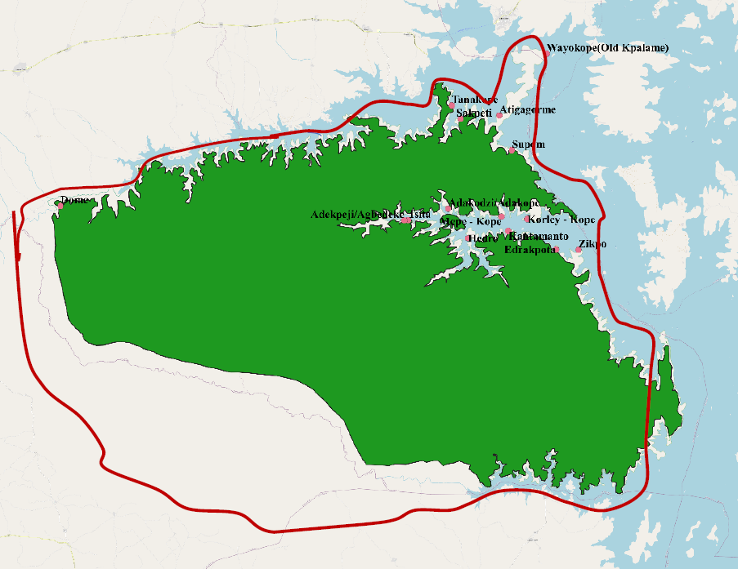
Table 8-2: Settlements Inside Digya National Park (“admitted” / permitted)
SETTLER COMMUNITIES |  | GPS COORDINATES | ESTIMATED POPULATION | STATUS/ COMMENTS | COMMENTS/ ACTIVITIES ENGAGED IN
1 | Dome | 07°33’17’’ N  000° 37’33’’ W | 500 | Admitted | Mostly crop farmers (i.e. Cassava, yam, plantain and vegetables). One major challenge is how to transport their farm products to nearby market center across the Sene River.
2 | Sakpeti | 07°40’04.9’’ N  000°06’20’’ W | 300 | Admitted | Mainly fishermen with backyard livestock rearing. Occasionally engage in illegal charcoal burning, the women also engage in illegal cutting of trees to smoke their fish.
3 | Atigagorme | 07°40’’21.3’ N  000°03’18.5’’ W | 400 | Admitted | Mainly fishermen with backyard livestock rearing. the women also engage in illegal cutting of trees to smoke their fish.
4 | Wayokope (Old kpalame) | 07°45’10’’ N  000°00’23 E | 300 | Admitted | Mainly fishermen with backyard livestock rearing.  -Occasionally front for Fulani herdsmen to graze their cattle in the reserve.  - the women also engage in illegal cutting of trees to smoke their fish.
5 | Supom | 07°37’37.4’’ N  000°02’20’’ W | 200 | Admitted | Mostly crop farming (ie. Cassava and yam). Occasionally bring Fulani herdsmen to graze their cattle. Supom people refused to join their other family members who settled outside the park.
6 | Tanakope | 07°41’07.6’’ N  000°07’02’’ W | 400 | Admitted | Mainly fishermen with backyard livestock rearing. Occasionally bring Fulani herdsmen to graze their cattle , the women also engage in illegal cutting of trees to smoke their fish.
7 | Zikpo | 07°29’ 52.5’’ N  000°02’52.3’’ E | 400 | Admitted | Mainly fishermen with backyard livestock rearing. the women also engage in illegal cutting of trees to smoke their fish.
8 | Edrakpota | 07°30’46’’ N  000° 01’ 01.6’’ E | 300 | Admitted | Mainly fishermen with backyard crop and livestock rearing. the women also engage in illegal cutting of trees to smoke their fish.
9 | Kantamanto | 07°31’ 19.6 N  000°02’36.4W | 300 | Admitted | Mainly fishermen with backyard livestock rearing. the women also engage in illegal cutting of trees to smoke their fish.
10 | Hedzro | 07°30’46’’ N  000°05’45’’ W | 500 | Admitted | Mainly fishermen with backyard livestock rearing. the women also engage in illegal cutting of trees to smoke their fish.
11 | Adakodzi/ Adakope | 07°33’04.1 N  000°07’18.0 W | 300 | Admitted | Mainly fishermen with backyard livestock rearing,  -the women engage in illegal cutting of trees to smoke their fish.
12 | Tsita | 07°32’ 11.1’’ N  000°10’25.9’’ W | 300 | Admitted | - Mainly fishermen with backyard livestock rearing. Occasionally bring Fulani herdsmen to graze their cattle, the women also engage in illegal cutting of trees to smoke their fish.  - engage in cultivation of sugarcane at the river banks for distillation of local Gin (Akpeteshie).
13 | Mepe - Kope | 07°32’16.0 N  000°01’08.2 W | 500 | Admitted | Mainly fishermen with backyard livestock rearing. Occasionally front for Fulani herdsmen to graze their cattle. They also engage in backyard crop farming.  - The women engage in illegal cutting of trees to smoke their fish and sometimes export fuelwood to Volta and Oti Regions.
14 | Korley - Kope | 07°32’20 N  000°02’43.6 W | 450 | Admitted | Mainly fishermen with backyard livestock rearing. The women engage in illegal collection of fuel wood and cutting of trees to smoke their fish.  - Engage in backyard farming.
15 | Adakpeji/Agbedeke | 07°32’10’’ N  000°10’44’’ W | 500 | Admitted | - Mainly fishermen with backyard livestock rearing , the women also engage in illegal cutting of trees to smoke their fish.
TOTAL |  |  | 5,650

Table 8-3: Selected Forest Reserves along the Pra Basin and the Transition Zones
COCOA FOREST LANDSCAPE (PRA RIVER BASIN)
No. | Region | District | Political District | Forest Reserve Within the Project Area | Area (Km2) | Status Management Plans | No. Admitted Farms / settlement | Estimated Total Area of Admitted Farms/settlement (km2) |  | Estimated Total Perimeter of Admitted Farms/settlement (Km)
 |  |  |  |  |  |  |  | Admitted Farm | Settlement
3 | Eastern | Mpreaso | Kwahu South | Southern Scarp | 116.55 | No Management plans | 400 | 29.26 | Nil | 350.14
4 |  |  | Kwahu East | Northern Scarp East | 48.53 | No Management plans | 104 | 15.56 | Nil | 54.82
5 |  |  | Kwahu East | Northern Scarp West | 64.65 | No Management plans | 299 | 2.93 | Nil | 13.83
6 |  | Akim Oda | Asante Akim South | Pra Anum | 132.87 | Written & Published Management Plan | 87 | 3.87 | 4.86 | 51.02
8 | Ashanti | Juaso | Asante Akim South | South Fomangsu | 33.00 | Management Plans preparation is ongoing by FC | 30 | 1.32 | 7.22 | 38.63
9 |  |  |  | Prakaw | 20.14 | No Management plans | 5 | 0.46 |  | 5.74
11 |  | Nkawie | Atwima Mponua | Tano Offin | 402.23 | Written & Published Management Plan | 20 | 0.81 | 5.47 | Unknown
12 |  |  |  | Offin Shelterbelt | 60.23 | No Management plans | 9 | 0.03 | Nil | 2.85
13 |  | Bekwai | Adansi North, Bosome Freho | Fum Headwaters | 85.83 | Written & published Management Plans | 14 | 0.60 | Nil | 11.06
Sub Total |  |  |  |  | 1152.14 |  | 1025 | 63.19 | 17.55 | 593.67

Table 8-3: Savannah Landscape
SAVANNA LANDSCAPE
Bawku | Bawku West | Bazua Bridge | 2.18 | No Management plans | Nil |  | Nil | Nil | Nil
 | Bawku West | Red Volta East | 217.61 | No Management plans | Nil |  | Nil | Nil | Nil
Tumu | Sissala East | Chira Headwaters | 33.67 | No Management plans | Nil |  | Nil | Nil | Nil
Lawra | Wa East | Ambalara | 132.45 | Written & published Management Plans | Nil |  | Nil | Nil | Nil
 | DBI | Kulpawn Tributries | 100.30 | Written & published Management Plans | Nil |  | Nil | Nil | Nil
Sub Total |  |  | 486.20 |  | Nil | Nil |  | Nil | Nil
Total Area |  |  | 1638.34 |  | 1025 | 63.19 |  | 17.55 | 593.67
Source: Forestry Commission, Ghana (FSD)

Consultation with Municipal, District Assemblies and Communities
As part of the project preparatory activities, there has been extensive consultation with project institutions, municipal and district assemblies and communities and the outcome as relevant to restrictions on land use includes the following:
- Participation of affected Communities in the design of project components;
- Determination of measures necessary to achieve the objectives of the ESS, and
- Implementation and monitoring of relevant project activities

Consultation with Municipal and District Assemblies on GLRSSMP

Consultations were held during the period April to July 2020 with MDA’s in the Pra/transitional zone (Eastern, Ashanti and Central regions) and the northern savannah region (Upper West, Upper East, Savannah and North East regions) selected to be enrolled in the GLSSMP. These include the following:

Table 8-4:Municipal and District Assemblies Consulted on GLRSSMP
A | Pra Basin and Transitional Zone | B | Northern Savannah Region
1 | Kwahu South District Assembly | 1 | Wa East District Assembly
2 | Kwahu East District Assembly | 2 | Sawla Tuna Kalba District Assembly
3 | Kwahu Afram Plains South Assembly | 3 | Sissala West District Assembly
4 | Asante Akim South Municipal Assembly | 4 | Sissala East Municipal Assembly
5 | Twifo Atti Morkwa District Assembly | 5 | DaffiemaBussie Issa District Assembly
6 | Assin North District Assembly | 6 | Talensi District Assembly
7 | Adansi South District Assembly | 7 | Bawku West District
8 | Atwima Mponua District Assembly | 8 | West Mamprusi Municipal Assembly
9 | Kwahu West Municipal Assembly

The specific objectives for these consultations were:
- To provide detailed information about the project as a follow up to emails sent to introduce and explain to them in detail project objectives and components
- To solicit their views that could inform the project design
- To collect and find ways of collating data to enrich project design
- To identify other relevant stakeholders within the project area for further engagement

Municipal and district authorities were requested to provide the following documents and information:
- Current Medium-Term Development Plan
- 2020 Annual Operational Plan
- District Maps
- Land Use Maps (if available)
- 2018 annual progress report of the Municipal and District Assemblies
- Grievances redress Mechanism if any
- List of organizations working in the Municipality or District i.e. private companies, NGO’s, CBO’s, farmer associations, etc.
- Cultural/historical sites present that can be develop for ecotourism

These were to assist IA’s to ascertain existing activities, to develop synergies, identify gaps, avoid duplication of activities, mainstream issues and to identify potential risks/impacts that could result from implementation of project activities.

Consultation with Communities on GLRSSMP Activities with potential for restrictions

Consultations were held with three communities each in eight districts in the northern savannah. Some of the communities consulted are in the indicated in the Table 8-5 below.

Table 8-5:Community Consultations in the Northern Savannah Region
No. | Name of Community | Municipality/District | No. of Participants
 |  |  | Male | Female
1. | Kunfusi | Sawla-Tuna-Kalba | 23 | 40
2. | Bujan | Sissala East | 23 | 18
3. | Sakalu | Sissala East | 30 | 20
4. | Tarikom | Bawku West | 16 | 23
5. | Adonsi | Bawku West | 21 | 51
6. | Konsogo | Bawku West | 17 | 34
7. | Sagadugu | West Mamprusi | 15 | 19
8. | Jankori | Wa East | 24 | 39
9. | Naaha | Wa East | 100 | 189

The following activities were proposed by communities for consideration in the implementation of the landscape restoration aspect of the GLSSMP:
- Alternative livelihood activities – shea nut processing, beekeeping, livestock/fowl rearing, cassava and maize processing, small ruminants rearing, pito brewing, rice processing, petty trading
- Cereal/legume rotation SLM technology considered very beneficial and should be intensified
- Provision of water systems i.e. dugouts for dry season farming and for their livestock
- Establishment of fodder banks to feed their livestock
- Cashew cultivation, maize/groundnuts as the major cereals, sweet potatoes/yam (tubers
- Regular provision of chemicals to deal with pests and diseases
- Provision of yam storage facilities
- Tree growing e.g. teak
- Upscaling of the Village Savings and Loan Association (VSLA)
- Training of women in alternative livelihood activities such as soap making, bee keeping, tie and dye, hair dressing etc.
- Training in fire fighting against bushfires

Views, Concerns and Suggestion from Communities and Traditional Authorities

The section below lists some significant potential social impact issues summarized from community consultations and subsequent analysis.

Views, Concerns and Suggestions from Communities and Traditional Authorities
- The extent of destruction caused by sand winnowers was a great worry and queried whether they are issued environmental permit before they commenced the activity
- How the project would handle inputs e.g. fertilizers to ensure that they reach right beneficiaries
- Nananon suggested that they should be consulted to assist in the distribution of inputs
- Need to establish nurseries close to communities
- Nananom lamented on the abrupt end of some previous projects and advise project implemented to ensure sustainability
- Communities and chiefs should be fully involved in al project activities
- The project should enrol only committed communities into the project
- Pollution and sedimentation of major rivers like the Prah
- Suggested the need to create buffer along the prah basin to reduce sedimentation and pollution
- Timely and prompt delivery of inputs
- Requested support from the in respect of farm preparatory activities
- Project should create storage and marketing opportunities for their farm produce

Views, Concerns and Suggestion from Youth, PWDs, etc

Views, Concerns and Suggestions from the Youth, PWD’s etc.
- The project should provide incentives to the youth to garner interest in project activities
- The project should assist PWD’s and other vulnerable groups to form associations to have a voice in decisions to benefit from project activities
- PWD’s should be given the opportunity to partake in project activities to enhance their conditions of living

Concerns and Suggestion from Municipal and District Assemblies

Concerns and suggestions from Municipal and District Assemblies
- Requested more insight into project implementation procedures and their specific roles they will play in the project
- Requested more consultations before the commencement of the project

Even though project coordinators and IA’s through on-line communication have informed municipal/district assemblies and coordinating councils on the project their concerns indicate low level of awareness and limited capacity for implementation. The project design would seek to upgrade their awareness level and scale up their capacities for them to effectively and efficiently play their roles during project implementation.

Table 8-6:Summary of consultations held with EPA Regional Offices
S/N | Name of Regional Office | Name/Position of Officer Consulted | Main Consultation Issues
1 | EPA, Head Office | -Director of EAA Dept.  -Director of Mining Dept | Effective collaboration with MDAs with the EPA and provision of the needed resources to enable the EPA offers her support roles to the MDAs.
2. | EPA, Eastern Region | - Senior Programme Officer | 1. Correspondence with the Assembly in observing E&S safeguards on sub-projects  2. Contribution to the works of EMCs of the assembly
3. | EPA, Ashanti Region | - Senior Programme Officer
3. | EPA, Savannah Region | Senior Programme Officer

Framework for Activity Level Consultations During Project Implementation

Representative consultations should be held regularly as the need arises for GLSSMP related activities at the sub project level. Participants should cut across various focus groups in the selected communities, i.e. traditional leaders, women, youth, etc. Information obtained during consultations can be used to enhance the GLSSMP database and to aid decision making and addressing grievances.
The Safeguards team should closely collaborate with the PCUs to plan consultation meetings at the sub project level. Venue for consultation meetings should be held at community centers and should be interactive, with questions from the communities and answers and explanations from the safeguard team assigned for that purpose. The main issues to be discussed would be related to components of the GLSSMP which may include the following:
- Sensitization on the GLSSMP and WB ESF
- Financial implications of the project
- Selection criteria for beneficiaries
- Safeguards issues at sub-project level
- Training needs of stakeholders at the district and community levels
- Grievance redress mechanism
- Monitoring and supervision of project activities
- Roles of communities in the Implementation of the GLSSMP

Preliminary Eligibility Criteria and Proposed Measures to Assist Affected Persons and Communities

This section describes conditions precedence to benefiting from the subprojects or livelihood schemes proposed for project affected persons. It details the interventions and measures to support these affected persons.

Description of Eligibility Criteria and Plan of Action

This preliminary set of criteria provides guidance on eligible activities and recipients for livelihood restoration assistance. During the project implementation and prior to the introduction of restrictions, the implementing agency in collaboration with the local communities will identify the specific restrictions, measures to be undertaken to assist affected persons, eligibility criteria and arrangements for implementation and monitoring various aspects of implementation, particularly with respect to evaluating the success of livelihood restoration mitigation measures through site-specific community consultations with affected persons and communities.

Consultations on livelihoods impacts and possible mitigation activities will discuss inter alia:
- Identification and ranking of site-specific impacts.
- Criteria and eligibility for livelihood assistance
- The rights of persons who have been legally ‘admitted’ into forest reserves or using forest resources or the associated land to be respected.
- Brief description and identification of available mitigation measures alternatives, taking into account the provisions of applicable local legislation, and the available measures for mitigation actively promoted via project activities and considering any additional sound alternatives, if proposed by the affected persons.

Table 8-7: Preliminary Eligibility criteria and proposed restoration options

Project Interventions | Category of Affected Persons/Communities | Assets | Type of Compensation
Component 3: Investments for Crop and Forest Landscape Management
Subcomponent 3.3. Forest Management Planning and Investments in and around Forest Reserves
Activity 3.3 (a) - improved management of target forest reserves
 | -Communities with restrictions in access to forest reserves | Physical and non- physical assets such as productive lands, farm lands, communal resources, income earning opportunities, and social and cultural networks and activities | -Agricultural inputs and extension to improve productivity of legally held lands  /non encroachment areas;  -Assisted with land preparation;  −Alternative livelihood schemes.
 | -Forest fringe communities.
 | -Admitted settlements and farms
 | -Communities with no legal rights (squatters) to resource. |  | − To be assisted to access alternative resources  − Assisted with  alternative livelihood schemes
 | -Persons without formal legal rights to resource but have claims to property recognized by community leaders. |  | − Restoration of livelihood/ alternative livelihood schemes
 | -Persons with no recognizable legal right or claim to resources. |  | −Assistance to access alternative resources
Activity 3.3. (b) – engagement with Admitted Settlements and Farm Owners to limit their illegal expansion in FRs | − Same as above. | − Same as above. | − Same as above.
Activity 3.3. (c) - livelihoods activities in buffer communities of target FRs | − Same as above. | − Same as above. | − Same as above.
Subcomponent 3.4.: Management of Wildlife Protected Areas and Biological Corridors
Activity 3.4. (a) - improved management of target wildlife protected areas
 | -Communities denied access to protected areas | Physical and non- physical assets such as productive lands, farm lands, communal resources, income earning opportunities, and social and cultural networks and activities | -Agricultural inputs and extension to improve productivity of legally held lands  /non encroachment areas;  -Assisted with land preparation;  −Alternative livelihood schemes.
 | -Forest fringe communities.
 | -Admitted settlements and farms
 | -Communities with no legal rights (squatters) to resource. |  | − To be assisted to access alternative resources  − Assisted with  alternative livelihood schemes
 | -Persons without formal legal rights to resource but have claims to property recognized by community leaders. |  | − Restoration of  livelihood/ alternative livelihood schemes
 | -Persons with no recognizable legal right or claim to resources. |  | −Assistance to access alternative resources
Activity 3.4. (b) – engagement with Admitted Settlements and Farm Owners to limit their illegal expansion in PAs | − Same as above. | − Same as above. | − Same as above.
Activity 3.4. (c) - collaborative resource management around target PAs and in the biological corridors | − Same as above. | − Same as above. | − Same as above.
Activity 3.4. (d) - incentives to communities for sustainable forest management | − Same as above. | − Same as above. | − Same as above.

Livelihood Restoration Measures and Access to Alternative Resources

The potential social impacts to be addressed within the context of this process framework are presented in Table 8-7. The livelihood restoration measures will consider issues such as: (1) income levels of affected communities/persons, (2) other non- monetary sources of livelihood, (3) constraints and opportunities for income generation, (4) number of persons not able to revert to previous occupation, and (5) existing skills and project preferences of affected persons.

In the case of alternative resources, measures will include identification of these resources with the active involvement of the affected persons/ communities and assistance to access these resources.

Project component 3 aims to link improved food production and ecological integrity. The component activities will support sustainable production practices for key food crops; sustainable water and land management interventions supporting silvopastoral and riparian vegetation establishment activities; value chains for key commodity crops including cocoa, cashew, and shea; value-addition for food crops; financial mobilization for sustainability of established interventions; and income generation and income diversification at community level with a view to integrated natural resource management in target savannah and cocoa / forest transition zone landscapes. The component will also include regular monitoring of these interventions.

Administrative and Legal Procedures to Implement Proposed Measures to Assist Affected Persons and Communities

Agreements reached during stakeholder consultations regarding the process approach with relevant administrative jurisdictions and line ministries and administrative and financial responsibilities under the project are presented in Table 8-8 as follows:

Table 8-8:Institutional Framework

No. | Institution | Responsibility –Implementation/Funding | Responsibility -Grievance Redress
1.0 | Forestry Commission | - Overall supervision of the PF and Restoration/Compensation Plans;  - Identification of sub project and preparation of plans for reclamation and plantation development and other sub projects.  - Secure funds for restoration/reclamation related compensation activities.  - Review Plans. | - To assist in resolving issues referred to it by the Regional FSD or RCC through the Project GRM and as may be agreed with affected parties/communities during implementation as outlined in section 11 of this RPF
2.0 | District Assembly | - To assist the FC oversee implementation of plans. | - To assist in resolving issues received directly or referred to it by the District FSD and communities through the Project GRM and as may be agreed with affected parties/communities during implementation as outlined in section 11 of this RPF
3.0 | Community leaders/ CREMA | - To represent community and assist in inventory of affected persons.  - Triger the need the need to re- design sub project  - Confirm restoration/ compensation actions.  - Assist to identify the number of affected persons/communities  - Support implement Plans. | - To receive complaints at community level and liaise with District FSD and DA to resolve issues through the Project GRM and as may be agreed with affected parties/communities during implementation as outlined in section 11 of this RPF

The EPA has the overall responsibility for implementing the PF with World Bank approval. It will ensure that all activities are carried out satisfactorily.

The EPA/MLNR will organize the regional and district orientation and training for the various government departments likely to be involved in the process, to be ready to implement alternative livelihood schemes and the payment of compensation, and other activities in a timely manner. The EPA/MLNR will ensure that progress reports reach the head office regularly. The project administration and restoration planning will run concurrently.

Much of the work will be done at the district levels EPA/MLNR through the District Assembly, which is the local administrative authority, will ensure that:
- communities are properly and adequately informed (timely, and also their rights and options relating to their properties that may be affected by the project;
- coordinate activities between different communities implementing the restoration or compensation plans;
- ensure timely implementation of plans and provision of compensation, in cash and/ or kind;
- attend to any grievances submitted by the affected persons/ communities.

The EPA/MLNR through the community leaders and CREMAs will engage and involve all sections of the community in discussions on the plan. They will:
- schedule open meetings to ensure that all community members are informed, and they are fully aware of their rights and options regarding the reclamation/ restoration activities;
- identify impacts on lands and assets and the members of the community to be affected and to what extent they will be affected.

Procedures for Implementation of Alternative Livelihood Schemes

Participatory plans for mitigation of restriction of community access to resources by provision of alternative livelihoods will consist of the following mechanisms:

Alternative livelihood planning and implementation committee: The committee will comprise the MLNR/EPA/FC representatives of the affected persons/ community (2 persons.), MMDA, LVD, EPA and traditional authorities. The committee will be chaired by the representative of the MMDA.

Consultations: The affected persons/ communities should be engaged in active consultations at the beginning of the project and any planned or proposed access restriction should be well explained in advance. Their input to the process is essential and their cooperation will be forthcoming when the project objective is adequately explained to them. They should have access to the Livelihood Restoration Plan and be encouraged to provide input.

Notification: Affected persons/ communities will be notified through both formal (in writing) and informal (verbal) manner, for example at community meetings called by MMDA.

Documentation: The names and addresses of affected persons in the community will be compiled and kept in a database including claims and assets. The MMDA as well as the RCC will also maintain records of these persons. The records are also important especially for future monitoring activities.

Time Provisions: The affected community or persons may negotiate with the Planning Committee on time frames, but no construction work can begin until the alternative schemes have been fully provided.

Grievance Processes to Addressing Issues Relevant to the Process Framework

Effectively addressing grievances from people impacted by World Bank projects is a core component of managing operational risk. Grievance Redress Mechanism (GRMs) can be an effective tool for early identification, assessment, and resolution of complaints on projects. Understanding when and how a GRM may improve project outcomes can help both project teams and beneficiaries improve results.

The Project adopts a simple procedure for affected persons to be able to follow easily, and which will provide aggrieved people and communities with an avenue for amicable settlement without necessarily opening a court case. Grievance Redress Mechanism which comprehensively responds to both the Resettlement Policy Framework and Process Framework is presented in chapter 11 and Figure 11-1, page 102.

Monitoring Arrangements for the Process Framework and Indicators
The section provides arrangements for participatory monitoring of project activities as they relate to beneficial and adverse impacts on persons within the project impact area, and for monitoring the effectiveness of measures taken to improve (or at minimum restore) incomes, livelihoods and living standards.

Monitoring Plans and Indicators of the Process Framework
The monitoring programme will provide a regular feedback on the implementation of the Process Framework. Monitoring teams at the district and regional FSD levels will be constituted and led by the appointed Focal Point, who will report regularly at the national level EPA/MLNR through the national Focal Point at the FC and EPA. The district team will comprise the DA, District FSD, community groups, and Regional FSD while the regional team will comprise the Regional FSD and DAs, and RCC.

The project will periodically juxtapose the objectives of the restoration plan alongside achievements regarding whether livelihoods and living standards have been restored or enhanced. In case deviations are observed, the project in consultation with affected communities will propose appropriate correcting actions are immediately implemented to fall in line with the original intended results. The scope of monitoring will comprise social and economic considerations as well as technical components, which may further look at any physical infrastructure provided for the affected persons/ community.

The monitoring indicators will cover areas such as: (1) basic information on affected persons’ households, (2) restoration of living standards and livelihoods, (3) levels of affected persons’ satisfaction determined by number of grievances registered, and (4) effectiveness of restoration planning. Some indicators are suggested in Table 8-9 below, which are consistent with provisions within this RPF&PF for the project.

An evaluation programme will be implemented periodically to also check on compliance with policy and provide lessons to amend strategies, especially in the longer term. The evaluation will be based on current WB procedures and also national provisions on access restriction /compensation. It will identify actions which will improve policy and offer higher guarantees of implementation success. The process will be incorporated in the general assessment and review usually undertaken for the project.

Table 8-9:Monitoring indicators and verification means

Potential Impact Issues/ concerns | Indicator | Verification
Maintaining Livelihoods | Key indicators  - Alternatives provided;  - Grievances recorded and resolved.

STAKEHOLDER CONSULTATIONS and disclosure

Public consultation and participation are essential because they afford project stakeholders, including people in project communities, the opportunity to contribute to both the design and implementation of the project activities and reduce the likelihood for conflicts. One key factor that exists in all successful approaches to project development and implementation is participation by all stakeholders and communities in the project.

Stakeholder consultation for the preparation of the RPF&PF was aimed to achieve the following objectives:

- To provide information about the project and its potential impacts to those interested in or affected by the project, and solicit their opinion in that regard
- To manage expectations and reduce misconceptions regarding the project
- To agree on resettlement preferences, if any, and discuss concerns
- To ensure participation and acceptance of the project by the communities

Consultation Meetings

The Project Stakeholder Engagement Plan (SEP) requires that stakeholders are engaged in an inclusive manner throughout the project life cycle. Stakeholder engagement as part of the process for the preparation of this RPF&PF includes relevant government ministries and agencies, local communities including women and the vulnerable, and individuals who have or may have interest or concerns about the project and/or are impacted by it. The project team and consultant conducted several field visits, both separate from and during Bank identification missions, to selected project districts and communities prior to the COVID-19 pandemic and national lockdowns. Other stakeholder consultations for preparation of the RPF&PF took place during the national lockdown, particularly when restrictions were relaxed from April to July 2020. These consultations were guided by the government mandated national prevention protocols and international best practices including the World Bank’s Technical Note on Public Consultations and Stakeholder Engagement in World Bank-supported operations when there are constraints on conducting public meetings. Since the COVID-19 pandemic did not permit frequent face-to-face meetings with the various stakeholder groups, the meetings were held via zoom, phone calls, WhatsApp messages, and email correspondence to collect the needed information for the preparation of the RPF&PF. The consultations focused on:
- Assessing the views and understandings of the MDAs on the GLRSSMP, identifying and assessing environmental and social impacts of the project
- Proposed activities that would be implemented under the GLRSSMP
- Reviewing the status of compliance and enforcement of environmental regulations
- Identifying capacity building needs and relevant regulatory institutions and recommending actions to strengthen roles of various institutions involved in project implementation to ensure sustained environmental and social compliance and monitoring.

The meetings were held to provide information and to receive feedback and concerns to inform the design and implementation of the GLRSSMP and to obtain relevant documents that could provide the necessary baseline information. Concerns and feedback from these consultations were incorporated in the design of the project and the RPF. Pictures of Stakeholder Consultations are presented in Annex 2A.

So far consultations have been held with following:

Ministries:
- Ministry of Land and Natural Resources (MLNR)
- Ministry of Environment, Science, Technology and Innovation (MESTI)
- Ministry of Local Government and Rural Development (MLGRD)
- Ministry of Food and Agriculture (MoFA)

Relevant Government Agencies:
- Minerals Commission (MC)
- Environmental Protection Agency (EPA)
- Lands Commission
- Forestry Commission (FC)
- Forest Services Division of FC
- Wildlife Division of the FC
- Ghana Cocoa Board (COCOBOD)
- Water Resources Commission (WRC)
- Ghana Geological Survey Authority (GGSA)
- Lands Commission
- Land Use and Spatial Planning Authority (LUSPA)
- University of Mines and Technology (UMaT)
- Centre for Remote Sensing and Geographic Information Services (CERSGIS)
- Kwame Nkrumah University of Science and Technology (KNUST) and University of Development Studies (UDS)

Other Relevant Stakeholders:
- Precious Minerals Marketing Company (PMMC)
- Ghana National Association of Small-Scale Miners (GNASSM)
- The Ghana Chamber of Mines
- Ghana Water Company Limited (GWCL)
- Traditional Authorities
- Farmers (Cocoa Farmers and Small-Scale Farmers)

Consultation process will continue and secondary stakeholder institutions, agencies, organisations etc. will also be engaged as needed throughout project implementation.

Summary of Consultation Views and Suggestions

Natural Resource Issues

The key natural resources issues that emerged from the consultations covered the following:

- What concerns the FC is mining in productive forest reserves which are given to Large Scale Mining companies
- The FC plant trees, so where tree planting issues come up then it is their mandate.
- If the Mineral Commission is giving out concessions, they need to work out the restoration plan.
- Under the MMIP they used part of the rehabilitation fund which was distributed for livelihoods at Ayamfuri and also raised large palm seedlings.
- The Forestry Commission comes in where rehabilitation of degraded land has to be done.
- No small-scale mining is supposed to take place in forest reserves so livelihoods restoration issues don’t arise here.
- In the future, the Forestry Commission will need safeguards support in terms of environmental engineering for the construction civil works as part of land restoration measures.
- Under the FIP, it was recommended that only reserved areas should be restored. When you move to off-reserve areas there will be ownership issues after the reclamation and restoration.
- After reclamation of off-reserved areas by government, it shall remain the property of the land owners.
- Under the Forestry Investment Programme (FIP), the Forestry Commission (FC) has tried to stay out of this controversy that will arise if government has to reclaim off-reserve areas.

Economic and Livelihood Issues

The views of some stakeholders on economic and livelihood issues are as follows:
- One key livelihood area to consider is water. Using water to wash gold is a major social issue for the communities. This situation is very alarming in Tontokrom.
- Small scale miners should create their own water system. The excessive use and competition for water in some mining communities has made the price of water higher than fuel. If Ghana should begin to import water into the country it will be problematic.
- Treating heavy metals-polluted water is a threatening danger to the communities.
- Currently the FC allows 2% of forest reserves for mining. Seventeen (17) companies have been given the right to prospect but only five (5) are operating now.
- Small scale mining should never be allowed in forest reserves.
- The forests provide micro climate for survival of wildlife and serves as sources of food.
- There is the need for stricter measures. The small-scale miners mainly think of money and they don’t think about the environment.
- The behavior of small-scale miners cannot be controlled. Considering allowing them in forest reserves is not the way to go.
- It is very important to think of the value of our forests and biodiversity and not readily think of mining in the forest areas with the hope that a better technology will be a solution. There is the need to set priorities right.
- The gold ASM sector is a valuable sector.
- There is the need for legislation and enforcement in the sector.
- Capacity building is needed about traceability, record keeping and data gathering
- Funding support from government is needed just like it is done for the cocoa sector for gold pricing to support foreign exchange.
- The need to create more job opportunities by providing more alternative livelihood opportunities.
- Women are generally dependent on men because the men have the dominant access to and use of the main factor of production, land and this limits their economic empowerment.
- Training in livelihood activities like bee keeping, small ruminant rearing, etc.
- The need for development of water harvesting systems like dugouts or weirs especially in the savannah zone.

Socio-Cultural Issues

The following are some key socio-cultural issues:
- There is a general demand for forest lands for farming/settlement expansion as the farmers believe that forest lands are fertile and produce good yields of food/cash crops and they need not incur any fertilizer cost.
- Forest fringe communities believe that land for farming and other uses is becoming limited, mainly due to population increase and settlement expansion and hence the motivation to go into the forest.
- Food security is a concern because of the emphasis on forestation/afforestation, conservation and not food production.
- There should be compensation arrangements for affected cocoa tress should number of shade trees be increased in existing cocoa farms.
- Socio-cultural and traditional norms and customs do affect women access and right to tenure and ownership of land and natural resources.

Disclosure Requirements for the Resettlement Policy Framework and Process Framework
The World Bank ESS 10 requires that the project make publicly available project reports to project affected groups, local NGOs, and the public at large.

The PCUs of EPA and MLNR will disclose the RPF&PF and other instruments (RAP/ARAP or others that as may be required) on their website during implementation when sites are identified. The MLNR and EPA will make available copies of the RPF&PF and disclosable versions of the RAP/ARAP in selected public places as required by law for information and comments. Public notice in the media could also be done.
The notification should be made through newspaper or radio announcement or both. The notification should provide:
- a brief description of the Project;
- a list of venues where the RFP&PF /RAPs/ARAPs are on display and available for viewing;
- duration of the display period; and
- contact information for comments.

To decentralize the disclosure, process all implementing agencies with websites will be made to disclose the RPF&PF on their websites. In addition, all MDAs participating in the GLRSSMP will also be given hard copies of these reports for reference purposes.

IMPLEMENTATION ARRANGEMENTS
The EPA and MLNR are the two institutions responsible for the overall implementation of the project. The two Ministries will provide overall oversight for the development and implementation of the RAP/ARAP. The census will commence immediately after the cut-off date has been declared. The draft RAP will be prepared and submitted to the World Bank for review and clearance and disclosed in-country by project using the agreed methods of public consultation. After its finalization, the RAP will be submitted to the World Bank for disclosure on its external website for wider circulation.

Roles and Responsibilities

The success of the GLRSSMP in general, and the Resettlement Policy Framework and Process Framework, will depend largely on the key stakeholder institutions who will drive the implementation of the project. The coordinating ministries, EPA/MLNR have the required capacities to manage the Resettlement Policy Framework and Process Framework implementation. However, there is the need for capacity building covering ESS5 requirements for GLRSSM-PCU staff, staff of Municipal Assemblies in the project areas and Community Leaders/Representatives. The main institutions that would be involved in the implementation of the Resettlement Policy Framework and Process Framework and their responsibilities are shown in Table 10-1 below:

Table 10-1:Summary of Implementation Institutions and Responsibilities
No. | Institution | Responsibility
1. | MLNR/EPA/GLRSSMP PCUs | Overall responsibility for ensuring that all participating MDA’s apply procedures and standards outlined in the RPF and ESMF (screening tool of sites for risks and impacts) throughout the life of the project  - Coordinate identification and screening of project sites  - Coordinate the preparation of ToRs for RAP preparation  - Liaising with World Bank on resettlement and livelihood restoration issues and for the necessary approvals/clearances.  - Coordinate and support RAP/ARAP/LRP preparation and reviews prior to submitting to World Bank’s and implementation  - Monitoring IA’s to adhere to laid down procedures and standards for RPF/RAP implementation  - Appoint E&S SpecialistsCoordinate screening process and inventory of affected persons and assets and implement plan.  - Preparation and Disclosure of RPF&PF/RAP/ARAP
 | World Bank | - Review and give No Objection to the RPF&PF/RAP/ARAP, etc.  - Disclose the approved report on World Bank External Website  - Conduct periodic site visits/monitoring and audits as needed to check compliance
 | Ministry of Finance | - The Ministry responsible for the provision of funds for compensation payments to PAPs on behalf of the Government of Ghana.
2. | IAs (MC, EPA, FC, GGSA) /DMCs  FC (FSD and WD)  EPA | - Assist in grievance redress matters relating to crop and livestock production (e.g., education and capacity building)  - Assist in screening of sub-projects and identification of PAPs  - Assist with compensation negotiations (in kind) where necessary  - Assist in grievance redress matters relating to forestry and wildlife (e.g., education and capacity building  - Assist in screening of sub-projects and identification of PAPs  - Assist in community awareness creation, notification and support in the inventory of affected persons and compensation related issues.  - Review screening reports and advise on level of environmental assessment if required  - Assist in the training and capacity building of other institutions  - Issue environmental permits per the requirements of the LI 1652  - Monitor for environmental compliance
4. | DMCs | - Participate in the Screening and design of projects  - Assist in grievance redress matters relating to Crop and livestock production (e.g. education and capacity building)  - Assist in screening of sub-projects and identification of PAP’s  - Assist with compensation negotiations (in kind) where necessary
5. | MC | - Responsible for coordinating activities and managing issues relating to ASM  - Assist in community awareness creation, notification and support in the inventory of affected persons and compensation related issues.
6 | Land Valuation Division of the Lands Commission | - To assist in the valuation and compensations payment process and reporting  - Vetting of request for compulsory acquisition of land, oversight of land expropriation and land issuance of titles to PAPs as required.
7. | Safeguards Specialists | - Assist in the preparation of the RPF&PF and RAPs  - Screening of sub-projects  - Monitoring of RPF&PF implementation procedures and standards
8. | MDAs | - Assist in the screening of sub-projects and identification of PAP’s  - Assist in grievance redress matters
9. | GRM committees | - GRM committees will be established and will responsible for resolving all grievances promptly and in a fair and transparent manner under the project  - Following up to ensure remediation of any complaints and grievances and responding to them
10. | Traditional Authorities/ DMCs | - Assist in identification of PAP’s and grievance redress matters
11. | Consultants/ Project Staff | - Preparation of RF&PF, RAP/ARAP and other documents
12. | NGOs | - Assist in capacity building and community sensitization
14. | Supervising Consultants | - Provide technical support services such as supervise civil works and be responsible for organizing site meetings to discuss and address quality of reinstatement of PAPs properties among others as needed.
15. | Contractor | - Contractor engaged by the project shall be responsible for reinstatement of affected properties for which cash or direct compensation was not made to the PAP.

Technical support and capacity building
The project will conduct capacity building of both Project Coordinating Units and Project implementing Agencies at the national and regional and district levels on the ESF and training on the RPF&PF and other relevant safeguard tools to make the work of the implementing team more effective. Compliance with World Bank’s ESF will require some level of capacity building on the ESS.

Grievance REDRESS Mechanism

The World Bank is committed to enhancing opportunities for grievance redress, collaborative problem solving, and alternative dispute resolution on the projects it supports. Effectively addressing grievances from people impacted by World Bank projects is a core component of managing operational risk. Grievance Redress Mechanisms (GRMs) can be an effective tool for early identification, assessment, and resolution of complaints about projects. Understanding when and how a GRM may improve project outcomes can help both project teams and beneficiaries improve results.

The Bank is supporting more effective approaches to problem solving to help strengthen its performance and development outcomes. This strengthened corporate approach focuses on a preventive approach to identify, track and resolve grievances early; and offering lower-cost, rapid citizen redress at the project and country level through mediation, facilitation or other problem-solving processes where it is most needed.

The approach proposes three interlinked steps: (i) a risk-based assessment of potential grievances, disputes or conflicts that may arise during project preparation and implementation; (ii) identification of the client’s existing capacity for grievance redress; and (iii) an action plan that identifies priority areas for strengthening grievance capacity, or if necessary, establishing new mechanisms at the project level. Where applicable, dedicated resources should be allocated for realization of the action plan.

General Grievance/Disputes Anticipated
Many people in the project areas depend on land and other natural resources for their livelihoods which may be impacted by the project activities. Grievances and disputes may arise due to one or more of the following situations:
- disagreement on land or property boundaries;
- disagreement on plot/property valuation and valuation rates applied;
- mistakes in inventorying or valuing properties;
- disputed ownership of a given asset (two or more people claiming ownership of an affected property);
- successions, divorces, and other family issues resulting in disputed ownership or disputed shares between inheritors or family members;
- disagreement on resettlement package (e.g., location of resettlement site not being suitable to them, proposed housing or resettlement plot characteristics/agricultural potential not adequate or suitable);
- disputed ownership of businesses and business-related assets (e.g., owner and operator of a business may be distinct individuals, which gives rise to disputes in the event of compensation);
- complaint about adverse impacts of a particular activity thereby creating health hazards, environmental pollution or nuisance;
- exclusion from the PAP list;
- non-response to complaints; and
- siting/location of subproject activities.
Other potential sources of grievance could be delays in compensation payment or corruption and elite capture which can expose the project to undue social risks and possible legal challenges during implementation.

Objectives of the GRM
The objectives of the grievance process are to:
- provide affected people with avenues for registering their complaint or resolving any dispute that may arise during the course of the implementation of GLRSSMP activities or projects;
- ensure that appropriate and mutually acceptable redress actions are identified and implemented to the satisfaction of complainants; and
- avoid the need to resort to expensive and time-consuming judicial proceedings.

Court cases are known to be cumbersome and take a long time before settlements are reached and usually one party is still not satisfied. It is therefore proposed to adopt a simple procedure for affected persons to be able to follow easily, and which will provide aggrieved people with an avenue for amicable settlement without necessarily opening a court case.

Proposed Grievance Management and Redress Mechanism
The Dispute Resolution Mechanism (DRM), the processes and procedures outlined for the GLRSSMP will be used in addressing disputes and conflicts arising from resettlement and compensation related issues. The DRM also proposes amicable settlement/mediation as a first option, which is in line with the stated above objectives under this RPF.

In compensation and resettlement operations, it often appears that many grievances derive from misunderstandings of project policy and procedures, land/asset valuations, property demarcations and boundaries among others as mentioned above, which can usually be solved through adequate mediation using customary rules and some mediation. This is why a first instance of dispute handling will be set up with the aim of settling disputes amicably. The proposed DRM for the GLRSSMP is provided in Figure 12-1 below.

The proposed DRM recommends four key steps as follows:
- Receive and register grievances or complaints;
- Acknowledge, assess and assign (acknowledge receipt of grievance, outline how grievance will be processed, assess eligibility of the complainant and assign responsibility);
- There might be the need to undertake some investigation and arrange meeting between parties before responding.
- propose response;
Agreement on response;
- If agreement is reached, implement agreement,
- If agreement is not reached, review case and if no agreement is reached under the review process, then the case can be referred to a higher lever dispute resolution bodies before finally the law courts.
- Storage and achieving all case history and resolution and closure.
- Complete the dispute resolution Form 8

The proposed DRM also recommends various levels of institutional arrangements in addressing the disputes/grievance and these include:

Options 1: Resolve disputes/ grievance
  - Community level (Community Resource Management Centres (CRMCs)
  - District level (District Dispute Resolution Team)
  - Regional level (Regional Dispute Resolution Team)
  - National level (National Dispute Resolution Team)

Option 2: refer to outside bodies
- Use or delegate functions to Alternative Dispute Resolution (ADR) centres (National and District)

Details of the grievance resolution process, institutional arrangements, composition, and capacity needs requirements for all the levels (community, district, regional and national) are all provided in the DRM which will be the basic document for addressing grievances and disputes under the GLRSSMP.

Dissatisfaction and Alternative Actions

Courts of law will be an option, which in principle should only be triggered where first instance amicable mechanisms and review processes have failed to settle the grievance/dispute. However, the Constitution allows any aggrieved person the right of access to court of law.

Documentation and Tracing

Annex 7 presents a template form for the grievance reporting. The Grievance Redress Management team at each level (i.e. community, district or national) will file the completed form appropriately as part of data keeping/documentation and for future reference to confirm resolution of grievance. It is also advised that photocopies of these documented resolved cases be collated on a quarterly basis into a database held at the GLRSSMP PCUs

Financing

The entire GRM process will be financed by the Ministry of Lands and Natural Resources (MLNR) in collaboration with the Environmental Protection Agency (EPA) under the project budget.

Timeframe for Grievance Redress

Table 11-1 below presents recommended timeframes for addressing grievance or disputes related to resettlement, compensation and other complaints. It is envisaged that resettlement/compensation disputes and environmental, health and nuisance complaints could be resolved at the community or district levels.

Table 11-1:Suggested Time Frame for Grievance Redress
Step | Process | Time frame
1 | Receive and register grievance | within 5 Days
2 | Investigate complaint or dispute, acknowledge, assess grievance and assign responsibility | within 7 Days
3 | Consultation and development of response | within 14 Days
4 | Implementation of response if agreement is reached | within 1 Month
5 | Close grievance | within 7 Days
6 | Initiate grievance referral or review process if no agreement is reached at the lower level | within 1 Month
7 | Implement agreement/recommendation reached at higher or review stage. | within 2 Months
8 | Grievance taken to court by complainant after unsuccessful higher lever consultation or review. | -

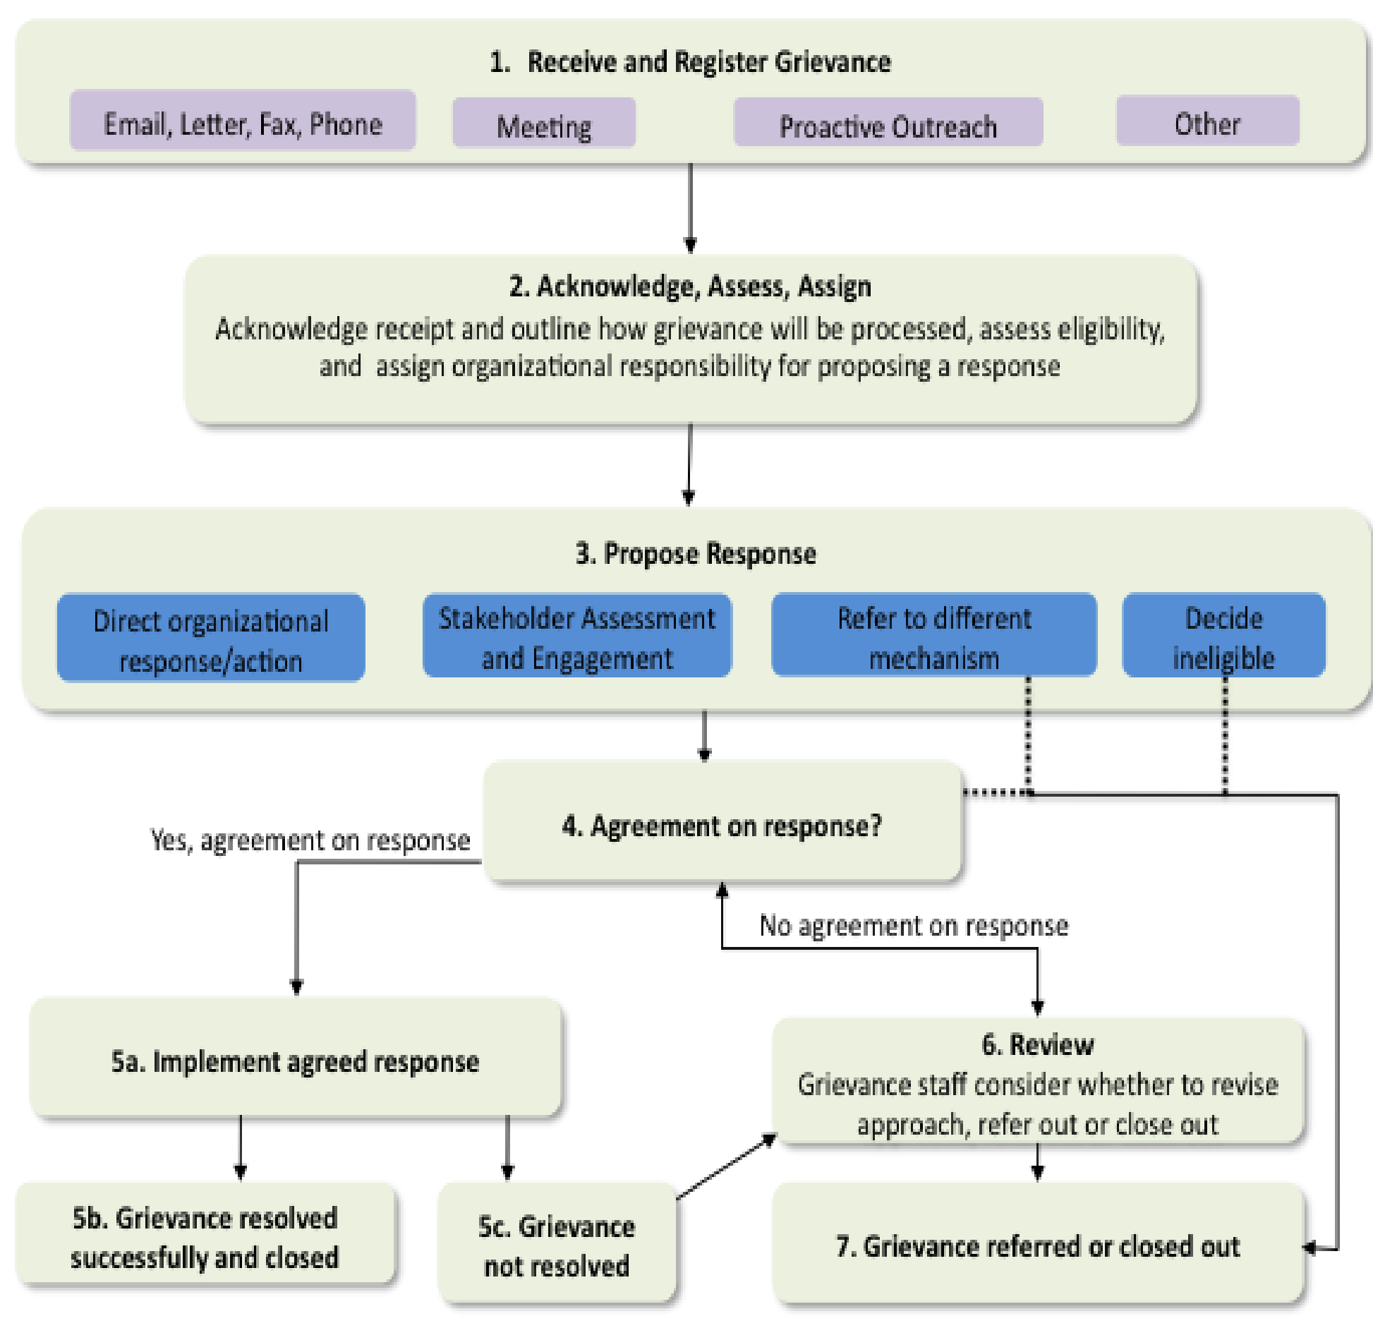
Figure 11-1:Grievance Redress Mechanism

MONITORING AND EVaLUATION of the RPF and process framework

Monitoring and Evaluation (M&E) are key component of the RPF and RF. The objective of monitoring is to identify implementation problems and opportunities early, so that implementation arrangements can be adjusted. Monitoring aims to correct implementation schedules during the course of the project, as required, while evaluation is intended at checking whether standards and policies have been complied with and providing lessons learnt for amending strategies and implementation in a longer-term perspective.
Monitoring and Evaluation is a vital component of this RPF. The general objectives are to:
Monitor specific situations or difficulties arising from implementation activities, and compliance with actions and plans set out in this RPF;Evaluate the impacts of the Resettlement/Compensation Actions on PAPs’ livelihood, environment, local capacities, on socio-economic development of the project area of operation.

Scope and Indicators for Monitoring

Monitoring will focus on establishing progress and compliance on the RPF and RF implementation, documenting and sharing feedback with stakeholders, and providing implementation support when needed. The specific objectives are to:
- Ensure compliance to requirements and plans set out in this RPF and RF, and implementation of activities;
- Document progress on the implementation of the RPF and RF and share with stakeholders.

Reporting and Documenting
All activities to be implemented through this RPF and RF shall be documented, and records kept appropriately. Key documents will include minutes of meeting, field monitoring report, screening reports, RAPs/ARAPs, records on grievance and others.

The GLRSSMP, among other indicators, will check the following regularly:
- Numbers of households/individuals/farmers affected by GLRSSMP activities,
- Numbers of households/individuals/farmers displaced or lost assets or restrict access and use to their assets Project
- Type and number of assets affected
- Amounts of compensation paid
- Number of grievances registered, and number resolved

A semi-annual monitoring report will be developed by the safeguards team to determine actual output as against expected output and variances.

Table 12-1:Monitoring Indicators and Means of Verification
Potential Impact issues/Concerns | Monitoring Indicators | Means of Verification
Land tenure and ownership | Key Indicators:  - Proper documentation available;  - PAPs paid compensation  - Disputes registered;  - Grievances recorded and resolved; | - Field inspections  - Site reports  - Special audits by project units  - Third party audits  - Annual monitoring by Environmental and Social Safeguards Focal Person
Maintaining Livelihoods | Key Indicators:  - Alternatives provided;  - Support and incentives available;  - Number of PAPs receiving livelihood restoration  - Proper and acceptable results documented;  - Grievances recorded and resolved.
Affected person/Communities’ rights | Key Indicators:  - Participation in projects design;  - Local customary land rights respected;  - Grievances documented and resolved;
Cultural Heritage | Key Indicators:  - Cultural rites agreed and documented

Evaluation of Resettlement Policy Framework and Process Framework

As part of efforts to improve learning and properly achieve the outcome of this RPF and RF, the project will carry out both midterm and end of project evaluation on the compliance and implementation of actions and activities prescribed in this RPF and RF. An internal resettlement completion report would be prepared after completion of resettlement activities.

Reference documentation for the evaluation will be the following:
- This Resettlement Policy framework and Process Framework;
- The Ghanaian laws and regulations as described in this document;
- The World Bank requirements for “Involuntary Resettlement” as outlined in ESS5; and
- Compensation and GRM reports and Resettlement actions prepared for the GLRSSMP activities.

Evaluation has the following specific objectives:
- General assessment of the compliance of the implementation of resettlement activities with objectives and methods as set out in this RPF;
- Assessment of the compliance of the implementation of resettlement activities with requisite laws regulations and safeguard policies;
- Assessment of resettlement and compensation procedures as they have been implemented;
- Evaluation of the impact of the resettlement and compensation programs on incomes and standard of living of PAPs to ensure that their living conditions are improved and not becoming worse off;
- Identification of actions to take as part of the on-going monitoring to improve the positive impacts of the programme and mitigate its possible negative impacts.

Several indicators will be used to measure these impacts. These will include but not limited to the following:
- Comparison of income levels before-and-after the RAP;
- Access to livelihoods and employment and other alternative incomes;
- changes in standards of living/housing conditions of PAPs;
- Number of grievances and their status, time and quality of resolution;
- Number of vulnerable groups identified and assisted, and impact of resettlement assistance provided on them;
- Number of demolitions after giving notice if any, and
- Number of PAPs paid in a given period in comparison with what was planned.

Evaluation of resettlement and compensation activities will be part of general assessment and review activities undertaken for GLRSSMP activities in an integrated manner by IAs.

BUDGET AND FUNDING ARRANGEMENTs

Budgetary Provisions
The implementation of the RPF and PF would have budget implications in terms of awareness creation, capacity building and enhancement, and training of PCU, IA staff, MDA staff and community representatives as well as dissemination of RPF information to key stakeholders. Cost for the preparation and implementation of the ARAP/ RAP will be derived from expenditures relating to (1) the preparation of the resettlement instrument, (2) relocation and transfer, (3) income losses and livelihood restoration plan, and (4) administrative costs. The estimated total budget of TwoHundred and Ninety-Five Thousand United States Dollars (USD 295,000.00) and its breakdown for the year one is shown in Table 13-1 below:

Table 13-1:Indicative Budget for Implementation
No | Item | Unit/  Frequency |  | Unit Cost (USD) | Total  (USD)
1 | Training, Capacity Building &Enhancement in RPF and GRM
 | Training and capacity building and enhancement for PCU members and IA staff | 2  2 |  | 10,000.00 | 40,000.00
 | Training and capacity building of MDAs and community representatives, Contractors, NGO’s etc. | 3  3 |  | 10,000.00 | 60.000.00
 | Sensitization of project communities to be spearheaded by GLRSSMP | 2  2 |  | 10,000.00 | 40,000.00
2 | Preparation of RAPs/ARAPs | 8 |  | 5,000.00 | 40,000.00
3. | Monitoring and Evaluation
 | Safeguard component for M&E | 40 |  | 2,000.00 | 80,000.00
4. | RPF&PF Disclosure
 | Disclosure of RPF&PF- Advertisements i.e., national dailies | Lump sum |  |  | 5,000.00
 | Disclosure of RPF&PF- Hard and soft copies to all relevant stakeholders | Lump sum |  |  | 5,000.00
5, | Completion Audit | Lump sum |  |  | 25,000.00
 | Grand Total |  |  |  | 295,000.00

  - Budget Template for preparation and implementation of ARAPs/ RAPs
The budget for RAP/ARAP preparation will be developed based on site specific screening or social assessment reports and required mitigation/livelihood restoration measures to be developed when sites are identified. The cost will be derived from expenditures relating to these areas.
- the preparation of the resettlement instrument;
- relocation and transfer,
- Income losses and livelihood restoration plan(s) and
- Administrative costs.

The cost centres for the areas are provide as follows:

- Preparation of resettlement instrument (e.g., ARAP or RAP)
  - Cost of survey of affected persons, valuation and inventory of assets
  - Compensation payments for affected assets. This is the responsibility of the Government of Ghana (GoG).
  - Fees for Consultants/NGO to be engaged
- Relocation Issues, if relevant
  - Cost of moving and transporting items
  - Cost of site and infrastructure development and services
  - Subsistence allowance during transition
  - Cost of replacement of businesses and downtime
- Income and means of livelihood restoration plans
  - Cost of estimating income losses
  - Cost of livelihood assistance
- Administrative costs
  - Operation and support staff
  - Training and monitoring
  - Technical assistance
  - Independent external monitoring and audit

Table 13-2 presents a sample budget template to guide the preparation of resettlement plans when cash compensation is required and no resettlement housing is involved.

Table 13-2:Itemization of budget
No. | ITEM | GHS
1.0 | PREPARATORY PHASE COST
1.1 | Inventory of affected persons, assets and livelihoods
1.2 | Valuation fees (LVD or private valuer)
1.3 | Preparation of resettlement plans or compensation reports
1.4 | Subtotal 1 (Preparatory phase cost)
2.0 | COMPENSATION COST
2.1 | Compensation for permanent acquisition of land
2.2 | Compensation for temporary occupation of land
2.3 | Compensation for destruction of crops
2.4 | Compensation for destruction of permanent immoveable structures
2.5 | Compensation for temporary displacement of moveable structures
2.6 | Subtotal 2 (Compensation cost)
3.0 | LIVELIHOOD RESTORATION /MITIGATION MEASURES COST
3.1 | Compensation for PAPs loss of income
3.2 | Compensation for business persons loss of income
3.3 | Cost of special assistance to vulnerable persons
3.4 | Subtotal 3 (Livelihood restoration/mitigation cost)
4.0 | CAPACITY BUILDING & IMPLEMENTATION COST
4.1 | Capacity building for key stakeholders
4.2 | Disclosure of resettlement instrument
4.3 | Logistical support and engagement of Safeguard Officers
4.4 | Cost for compensation disbursement/grievance redress/monitoring & evaluation activities
4.5 | Legal fees (in case of court dispute)
4.6 | Subtotal 4 (Capacity building & implementation cost)
5.0 | CULTURAL RESOURCES MEASURES COST
5.1 | Cost of removing cultural properties ( if any is encountered)
5.2 | Subtotal
6.0 | TOTAL COST (addition of all subtotals)
7.0 | CONTINGENCY (5%-10% OF TOTAL COST)
8.0 | GRAND TOTAL COST (Total Cost + Contingency)

  - Sources and Funding Arrangement
Compensation, land acquisition and resettlement related issues will be funded by the Government of Ghana through the Ministry of Finance. The Ministry of Finance is expected to make funds available to the Project for the payment of compensation. All compensation payments will have to be completed prior to start of respective activities that require involuntary resettlement.

REFERENCES

- Environmental Protection Agency, state of Environment Report 2016, EPA, Accra, Ghana
- Forestry Commission of Ghana. (November 2018), Resettlement Policy Framework (RPF). Ghana Cocoa Forest REDD + Emissions Reduction Program. Ministry of Lands and Natural Resources
- Ghana: Concept Note for funding of the Ghana Landscape Restoration Project, Draft October, 2019
- Ghana: GLRSSMP, World Bank Preparation Mission, Aide Memoire, January 20-31, 2020
- Ministry of Education (April 2019), Resettlement Policy Framework, Ghana Accountability for Learning Outcomes (GALOP),
- Ministry of Finance, (April 2019), Resettlement Policy Framework, Ghana Economic Transformation Project
- Republic of Ghana (1994): Environmental Protection Agency Act, 1994 (Act 490)
- Republic of Ghana (1999): Environmental Assessment Regulations 1999 (LI 1652)
- World Bank, Environmental and Social Framework (ESF) for Investment Project Financing, October 2018
- Ghana Landscape Restoration and Small-Scale Mining Project (GLRSSMP) Project Appraisal Document
- Ministry of Lands and Natural Resource (MLNR), Multi-Sectoral Mining Integrated Project (MMIP), 2017
- IFC, Doing Better Business Through Effective Public Consultation and Disclosure, A Good Practice Manual
- Minerals Commission, Artisanal and Small-scale Mining Framework, Ministry of Lands and Natural Resources
- Handbook for Preparing a Resettlement Action Plan, International Finance Corporation
- FIP-Process Framework, Nov 2018

APPENDICES

Appendix 1: Screening Checklist for Identifying Cases of Involuntary Resettlement

A. Details of Person Designated to Fill out This Form:

Completed by
(Name): …………………………………………………………………………………
Contact Details: ………………………………………………………………………………….……..
Job Title/ Designation: …………………………………………………………………………………
Date: …………..……………………………………………………………………………………….
Signature: …………..……………………………………………………………..……………………
B. ACTIVITY DESCRIPTION
Name of Project: ………………………………………………………………………………………..
Name of Project Execution Entity/Organization: ……………………………………………………….
Location of the Project: …………………………………………………………………………………
Type of the Project: ….…………………………………………………………………...……………...
Approximate size of the Project in land area: ……...……………………………………………...……...
Location of the project: Region: ………………………………………………. District: …….…………….…….……………... Town/Community: ………...…………………………………………...…………….…………………...
C. THE CHECKLIST
Please fill in the checklist below by ticking applicable answer (Yes or No):
i. Will the Project lead to permanent acquisition of the land? Yes ……….…/ No…………
ii. Will the project lead to temporary occupation of the land or use of the land for a limited time frame? Yes…….../No…………
iii. Based on available sources, consultations with local community/ authorities, local knowledge and / or observations, could the project alter any cultural heritage site? Yes……../No……….if yes, describe [………………………..]
iv. Will the project result in the physical displacement of people? Yes………../No……….
v. Will the project result in the permanent removal or damage or demolition of structures or buildings? Yes…..…../No……….If yes estimate # [ ]
vi. Will the project result in the temporary removal or relocation of structures? Yes………/No……….
If yes, estimate # [ ]
vii. Will the project affect or block access to homes, organizations, farms, forest or any assets in general? Yes…………/No……………
viii. Will the project result in the permanent or temporary loss or damage to standing crops, fruit or economic trees? Yes…………../No………….
ix. Will the project result in the loss of income of affected farmer or business person? Yes………./No…………
x. Will the project affect farmlands that have been cleared but not cultivated? Yes…………./No………….. How many persons are impacted by the project? -----------------
D. PROPOSED ACTION
If all the above answers are ‘NO’ except for the permanent land acquisition only or temporary land occupation only or both, please follow the requirements in the RPF to address any compensation issue.
If there is permanent land acquisition or temporary land occupation or no land acquisition and there is one or more of the above answers as YES, there is need for further action. The number of affected persons need to be investigated further to determine which resettlement instrument to be prepared in line with the RPF to address the resettlement and compensation related issues. Actions to address to address compensation issues
• RAP will be prepared where more than 200 individuals are displaced. ARAP will be prepared where less than 200 individuals are displaced. The preparation of the RAP/ARAP will involve the flowing key activities:
• Consultation of stakeholders on the subproject
• Census of Affected Persons & Assets/ Socio-economic baseline to identify the persons/assets/livelihood that will be affected by the sub-project., ensuring the eligibility criteria.
• Valuation of land or affected properties.
• Elaboration of the RAP/ARAP report.
• Consultation and disclosure of the RAP/ARAP documents.
• Compensation payment.
• RAP/ARAPs will need World Bank approval prior to commencing resettlement activities. Resettlement activities must be completed before commencing GLRSSMP activities on the fields.
E. COMMENTS BY PERSON FILLING THIS FORM …………………………………………………………………………………………………………… …………………………………………………………………………………………………………… …………………………………………………………………………………………………………… …………………………………………………………………………………………………………… ………………………………………………………………………………………………………..…..
F. COMMENTS BY THE GLRSSMP SAFEGUARDS OFFICER OR PC (The PCU should sign off this form and attach copy to the activity proposal) …………………………………………………………………………………………………………… …………………………………………………………………………………………………………… …………………………………………………………………………………………………………… ……………………………………………………………………………………………………………
Name:
Date:
Signature:

Appendix 2A Stakeholder Consultations

No | STATEHOLDER COMMENTS/CONCERNS AND SUGGESTIONS
1 | MINERALS COMMISSION (MC), 22.05.2020
 | Persons Consulted: Christopher Kwasi Anokye, Head, Smalll-Scale & Industrial Minerals (SSIM)
Minerals Commission perspective of the status of the Small-Scale & Industrial Minerals Sector:
- There are currently two (2) pilot areas in Kyebi and Prestea
- There are social issues of employment
- Engaging in the jobs for their livelihoods
- Use of women, under aged children. This has to be investigated
- There are about 1m people engaged in this small scale and illegal mining
- About 1300 licenses have been issued. Some might have expired by now
- Government set up the Inter-Ministerial Taskforce Mining Committee. Only about 450 of the small-scale mining companies have valid licenses
Small-Scale Mining License Acquisition Process:
- The process is not supposed to be long; it involves the following:

- Depending on the area where the applicant is, the applicant will approach the District Office. Currently the MC has 11 offices from the previous number of 9). The District Offices are 1. Wa District 2. Bolga-District 3. Konoggo 4. Akim Oda 5. Tarkwa 6. Asankangua 7. Bibiani 8. Dunkwa/Obuasi 9. Assin Fosu
- District office will ascertain the site
- Request the applicant to do a survey
- Applicant will buy an application Form
- Add Map to application and send it to the District Office
- Application is forwarded by the District Office to the Head Office in Accra
- Checks are done, recommendations made and fees paid
- Agreements are made and signed.

Before the license is granted EPA does its check in addition to the checks done by the Minerals Commission

Involvement of the Ghana Geological Survey Authority (GGSA):
The Small-scale miners have the challenge of not knowing the ore grade. The surest way to address this problem is to ensure the involvement of the Geological Survey Authority (GSA) to do the survey before parcels of say 25 acres are allocated to prospective applicants.
Issues of Reclamation:
Issues of reclamation rests with EPA. Reclamation bonds are posted by the large mining companies but not sure what happens with the small-scale mining companies
Agencies Coordination Including the DMCs:
The political Districts should be superimposed on the Mining Districts and ensure that the political Districts and DCEs are held by KPIs with respect to environmental stewardship
Funding of DMCs:
There should be a funding scheme set-up for the DMCs where various stakeholders will contribute into the fund.
Stakeholders vital to the Success of GLRSSMP:
- DCEs should be involved and given KPIs.
- The President should be made to hold the DCEs to KPIs in sustainable mining.
- The chiefs also need to be involved.
The most Vulnerable:
- Women, children and the community people are the most vulnerable.
- There is the need to entice them to move out of small-scale mining by education.
- License issuance must ensure or an undertaking be made that there will be no engagement of children
Existence of Penalties MC Laws and how they are enforced:
- The penalties pertain mainly to the foreigners.
- There is the need to look at the law and make recommendations.
- There must be clear sanctions in the law for specific offences aside sanctions relating to failing to do reclamation.
Potential Supporters and Opponents of the changes the project will bring:
- Small-scale license owners will oppose this project due to the burden of responsible mining places on them.
- They will think returns might not be adequate enough to do reclamation.
- The general public will support the change.
- Small scale mining companies contribute about 42% of Gold production in Ghana.
Baseline performance indicator the MC-SSIM will used as the basis to assess the performance of the GLRSSMP:
- The baseline or performance indicator to be used by the MC-SSIM to assess the performance of the GLRSSMP is the quality of water bodies in the mining areas.
2 | ENVIRONMENTAL PROTECTION AGENCY (EPA) 22.05.2020
 | Persons Consulted: Ing. Michael S. Ali (Director/Mining), Isaac Owusu (Senior Program Officer, Mining Department)
EPA’s view on the GLRSSMP:
- ASM to the EPA was already Formalized under the PNDC Law
- The Formalization only needs to fall in place because the formalization has already been done
- The GLRSSMP seems to be an attack on the Large-Scale Miners
- Government needs to get land for the Small-scale miners and assign it to them
- There is a thin line between small-scale miners and the large-scale miners
- There is the need to dedicate ore areas for the small-scale miners to operate
- There is the need to consider the licensing procedures of the Minerals Commission vis-à-vis the EPA Permitting Procedures.

EPA’s role in Small-Scale Mining:
- The EPA has an office in Damongo (Bole), Prestea (Tarkwa Office), Kyebi (EPA Eastern Regional Office), Tontokrom -Amasie South (Obuasi or Kumasi Office of EPA)
- EPA would want to enforce bonding in the Small-scale mining sector.
Small-Scale Mining Permitting Process by EPA:
The Permitting process involves:
1) Acquisition of Lease from the Mineral Commission
2) Issuance of Environmental Permit through the completion of SMM1 Form
3) Digging License/Permit issued by the Minerals Commission.

Preliminary Environmental Report (PER) is prepared if the application is for a contiguous concession.

- In Ghana, Gold extraction with mercury amalgamation from concentrates is one of the major sources of emissions and releases of mercury into the natural environment.
- In keeping with her efforts of supporting International efforts to address international environmental challenges, Ghana joined the rest of the World to negotiate the Minamata Convention on Mercury which was initiated in 2009 by the United Nations Environment Programme (UN Environment) Governing Council, and finally agreed after a series of intergovernmental negotiations meetings, by one hundred and forty-seven (147) Governments on January 19, 2013 in Geneva, Switzerland.
- Ghana became a signatory to the Convention on 24th September 2014 and ratified it on 23rd March 2017. Ghana’s ratification was achieved through collaboration with the United Nations Institute for Training and Research (UNITAR) and funding from Government of Switzerland.
- The Minamata Initial Assessment Report on mercury use, sources and releases in Ghana represents the collective efforts of several actors. It is a positive demonstration of the commitment of the Government of Ghana to fully implement its obligations as a party to the convention
- The Convention prohibits the production and trade of a range of products containing mercury
- In accordance with Article 20, Ghana intends to use this initial assessment to develop and execute an implementation plan, taking into account the country’s domestic circumstances, for meeting the obligations under Minamata Convention.
- Gold buyers are a problem to the environment in the process of Gold melting
- PMMC buy the Gold from Small-scale miners
- One of the challenges of the small-scale miners is finance. Support can be given to them in the form of equipment and then pay back through the gold sale proceeds
- EPA are doing the costing of the reclamation under the GLRSSMP
- Degraded small scale mining sites to be costed
- Dealing with infractions, EPA charges penalties. Small scale miners fee is GHC6000
3 | FORESTRY COMMISSION (FC), 27.05.2020
 | Persons Consulted: Mr Oppon Sasu (Executive Director, FSD), Dr, S.A Mintah (Director, ICT), Mrs. Edith Abruqauh (Director of Operations, FC-FSD), Luri Kanton (Ag. DOP/WD), Christian F.Naseh (Operations Manager, WD/FC), Ricahrd Gyimah (Ag Dir/WD), John Appah (Manager, FSD), David k.Galley (RS Officer) Sharon Asomaning (CPME,FC), Joe Appiah Gyapong (Director/PM), Godwin P. Cudjoe (DR/P), Cudjoe Awudi (Dir CPME), Joyce Ofori Kwafo (Head, CAMPU), Kenneth Mbroh (CPME/FC), Roselyn F. Adjei (Director, Climate Change/FC) and Kofi Awadwo Frimpong (DR/P,FC)
The Role of the Forestry Commission in relation to the GLRSSMP:
- The Forestry Commission is responsible for the regulation of utilization of forest and wildlife resources, the conservation and management of those resources and the coordination of policies related to them.
- The Forestry Commission is aware of the Ghana Landscape Restoration and Small-Scale Mining Project and the Ghana Artisanal Small-scale Mining Formalization Project (GLRSSMP).
- The FC finds it necessary to bring on board these projects the Safeguard Officers of the Commission.
- The Forestry Commission welcomes the project and the purpose of the stakeholder engagement
- The FC sees a lot of synergies between these projects and the operations of the Forestry Commission, particularly relating to these projects: The Sustainable Land and Water Management Project, Ghana Forest Investment Project (Engaging Local Community), Ghana Cocoa Forest REDD+ Project by AfDB, and Enhancing Natural Forest and Agroforestry Landscapes Project
- The FC would want the project to be looked at in the multi-faceted approach. How are existing projects being undertaken will be affected or contributed to these projects
- There is the need for reduction of poverty in the communities. The FC is currently running some projects in the communities. It is good the ESMF/RF Consultant understands these projects.
- The FC is also working on the FIP

Safeguard issues relating to the FIP:
- The FIP is to restore degraded lands hence there weren’t many concerns. The project involves the rehabilitation of mining sites. Possible sites have been identified for the restoration.
- Clearly, there were positive impacts trying to repair what has been damaged.
- The FIP is mainly located in the Brong Ahafo and Western Regions. In Prestea there weren’t much degradation. In Tarkwa trees were planted.
- The FIP started in 2010 and should have ended December 2020 but has been extended to 2023

The FC’s perspective of land reclamation and rehabilitation under the GLRSSMP and ownership of reclaimed and rehabilitated land:
- Under the FIP, the Consultant recommended only reserved areas. When you move to off-reserve areas there will be issues.
- After reclamation of off-reserved areas by government it shall remain the property of the land owners.
- Under the FIP, the FC has tried to stay off this controversy that will arise if government has to reclaim off-reserve areas

Some key concerns of the Forestry Commission:
- What concerns the FC is mining in productive forest reserves which are given to Large Scale Mining companies
- The FC plant trees, so where tree planting issues come up then it is their mandate.
- If the Mineral Commission is giving out concessions, they need to work out the restoration plan.
- Under the MMIP they used part of the rehabilitation fund which was distributed for livelihood at Ayamfuri and also raised large palm seedlings.
- The FC Comes In where rehabilitation has to be done
- No Small-scale mining supposed to take place in forest reserves so livelihoods restoration issues don’t arise here.
- In the future, the FC will need the safeguards support in terms of environmental engineering for the construction civil works as part of land restoration measures.

The Forestry Commission’s experience under the FC-GhREDD Project:
- The GhREDD+Climate change mitigation plan started in 2008. ESMF and RPF were done for this project
- The safeguard instruments helped streamline consultation and participation with government agencies, NGOs etc
- The safeguards instruments also helped to reduce displacement.
- The programme is designed for 10 years
- What are the transitions?
- How to reduce grievances
- Participation of both sexes (gender aspects)
- Plan for vulnerable groups
- On the environmental side, mixed plantation to help in the restoration efforts
- Cocoa and share programs
- How riverine or water courses are treated considering water quality and treatment
- Habitat loss in the forest areas
- How benefits are shared to ensure whoever has performed is rewarded
- Safeguard information system and harmonization
- The project is in cocoa growing areas, Northern Savanah, Mangrove, Transition Belt and High Forest Zones.
- Biodiversity Conservation is the Oti Region
- GhREDD+ has a whole institutional arrangement working with decentralization
- Climate change enhancement to account for carbon reduction.
- There are plantations on the ground

The Forestry Commission’s experience under the Sustainable Land and Water Management Project:
- The Sustainable Land and Water Management Project is being implemented by MESTI, MOFA, EPA and FSD and WD of the FC
- The project involves forest restoration, wildlife protection, provision of boreholes etc. Environmental and Social Safeguard instruments were prepared for this project.
- The project is supposed to end in November 2020 but have been extended for six (6) months.
- This project will be replaced by the GLRSSMP.
- Under an IDA funding, the project will cover the Northern and Transition areas
- There is an ongoing discussion to integrate the GLRSSMP with the GLRSSMP.

The Forestry Commissions experience with the Bole Landscape:
- Bole Landscape: Under the Bui Project, Environmental and Social Safeguard Instruments were done. The Bole Landscape has mining issues. There is also the Bui National Park in the area being managed by the Wild Life Division of the FC. It is appropriate that the GLRSSMP ESMF/RPF pays attention to issues under the Bole Landscape.

The Forestry Commission’s perspective on Baseline indicators with respect to the impacts of small-scale mining:
- Small-scale mining is not allowed in forest reserves. Their operations are in off-reserves, which are under the Minerals Commission.
- From the perspective of the FC, the baseline is zero. Generally, such miners use shovels and do not cause major impacts unless recently they began to use excavators.
- Better statistics can be obtained from Minerals Commission. Data on emissions contribution to mining could also be obtained as well as threats to forest reserves and biodiversity.
- Some of the mining pits are in the forest reserves
- NREG has done some work on this and can be obtained from Mr Richard Afenu.

The Forestry Commission’s view on review of mining legislation in forest reserves:
- If we say we will allow small scale mining in forest reserves we will not have forest in Ghana.
- If we have large scale mining in forest reserves the FC can restrict them. For small scale mining of 25 acres, they will be too many.
- Small scale mining should never be allowed in forest reserves.
- The forests also provide and micro climate and serves as sources of food.
- We need to put in stricter measures. The small-scale miners mainly think of money and they don’t think about the environment.
- The behaviour of small-scale miners cannot be controlled. Considering of allowing them in forest reserves is not the way to go
- It is very important to think of the value of our forests and biodiversity and not readily think of mining in the forest areas with the hope that a better technology will be a solution. There is the need to set out priorities right.
The Forestry Commission’s view on some social impacts from small scale mining and mitigation measures:
- One key livelihood area to consider is water. Using water to wash gold is major social issue for the communities. This situation is very alarming in Tontokrom.
- Small scale miners should create their own water system. The price of water is higher than fuel. If we should begin to import water in the country it will be problematic.
- Treating heavy metals polluted water is a threatening danger to the communities.
- Currently the FC allows 2% of forest reserves for mining. Seventeen (17) companies have been given the right to prospect but only five (5) are operating now.

4 | GHANA WATER COMPANY LTD (GWCL), 27.05.2020
 | Persons Consulted: Mrs Margaret Macaulley (CM-WQA), John E. Kwofie (Manager, Operations), Hanson Mensah Akuetteh (Manager), Mark Ayertey (WQAO)
GWCL operations and views on impacts from Small-Scale mining on their operations:
- The GWCL was happy with the step taken by Messrs EEMC to engage the GWCL
- There is nowhere in the country where the GWCL source of water for their operations is not being affected
- GWCL treatment plants and systems are designed based on a specific water quality so when the raw water quality is bad if it affects the GWCL operations and systems
- GWCL operations are based on Ghana Standard Board Water Quality
- Most of the sources where the GWCL gets its raw water have poor turbidity issues
- All over the country the operations of GWCL are being affected by the activities of small-scale mining activities
- Public health is more affected when water of good quality is not available and they have to resort to other sources of water.
- GWCL experiences damage to treatment installations, breakdown of mechanical aspects with associated costs
- High raw water turbidity affects the GWCL water pumps. The pumps have to be regularly replaced. A typical example is the GWCL Water Treatment plant at Nchaban which serves the Central Region.
- Every year the GWCL Daboase plant is affected.
- The Obosoase plant which serves Sekondi-Takoradi. This plant is always down and the GWCL is compelled to buy new pumps.
- The Osino plant in the Eastern Region has been forced to shut down as result of poor raw water quality challenges. The GWCL had to undertake dredging. Other areas such as Kyebi, Bonsu, Odaso, Osino, etc., are seriously affected.
- The GWCL have made several complains and reports to the Regional Ministers and Commanders but their support haven’t been satisfactory.
- The GWCL thinks there is a poor enforcement of existing laws hence the rampant small-scale mining activities leading to the pollution of water bodies.

5 | PRECIOUS MINERALS MARKETING COMPANY LTD (PMMC), 28.05.2020
 | Persons Consulted: Mr. Venance Dey (DMD, PMMC), Ernest Asiedu Ode (Director, Corporate Planning, PMMC), Donatus Asusko (Teleweal, PMMC)
The Operations of PMMC:
- The brief made by the team on the GLRSSMP project is well noted by the PMMC
- PMMC, who are we?
- It is a new PMMC which came int being from a Ministerial Instrument for National Assaying. Buying of diamond and gold for export.
- The PMMC is in charge of all fiscal transactions
- Helps to develop policies to improve the sector and the country
- The sole role of buying and selling of gold was taken from the PMMC and given to the Private Sector. PMMC no longer buy and sell gold through export.
- These changes took place in 2016.
- PMMC only does assaying, testing quality and certifying the quality of gold.
- Following the Mining Act 2006, all the legislative instruments in the sector had to cease. This act annulled the PMMC Act.
- From the Mining Act 2006anything regarding the buying and selling of gold had to be done by the Minister of Lands and Natural Resources (MLNR)
- The Minerals Commission are mainly concerned with issues of regulation in the large and small-scale mining sectors
- The actual activity of transacting in gold is done by private companies.
- Anybody dealing in gold has to obtain license from the Minerals Commission.
- The PMMC issues license to companies for buying and selling of gold but cannot export the gold.

The Terms, Conditions and Requirements for Licensing by PMMC:
Every gold that leaves the country has to pass through the PMMC. The following are the conditions for licensing:
- Every month the private company must supply 500g of gold as a buyer
- Companies are not allowed to use the license to export gold
- PMMC requests the personal details of the company owners
- Police screening report from the Ghana Police Headquarters have to submitted by the applicant as part of the requirements

The systems the PMMC have in place to ensure that the companies that are licensed buy gold from permitted sources and such sources can be verified:
A: There used to be a traceability concept but was not successful:
- With the inception of the Taskforce in the mining sector, traceability is a big issue in the country. Sources of Gold in the country cannot be traced.
- Since time immemorial a gold from a mine does not have a specific code. This has now brought the traceability concept to the PMMC and the PMMC is trying to pursue it.
- The PMMC intends to ensure that every miner has a record of every gold that is produced.
- Agents will also be required to have records of where they buy their gold from, the quality of the gold and the quantity level to ensure the traceability of the source.
- Exporters will also have to create a record of the source, quality and quantity of gold they deal in.
- PMMC is going to ensure this in terms what activity they engage in to come out with a code. When this is done, the traceability as well as issues of taxes in the gold sector will be resolved.
- The other issues have to do with those who are engaged in the mining sector: children, women, illegal persons etc.
- PMMC and MC and other stakeholders are involved in the process to establish the legal status of the gold miners as part of the processes of establishing the traceability chain.

The Status of traceability Concept being pursued by the PMMC:
There is no documentation currently:
- The MMIP is going to address this problem. The World BANK is going to fund this from the technology aspects, data collection on various miners, personal data which will be kept at PMMC. The data will also help the PMMC to establish trends.
- The PMMC will need people who will go around to undertake the field work regarding the traceability concept,
- PMMC will need vehicles and other logistics support to enable staffs go to all the mining communities
- PMMC will have to undertake an extensive education and awareness creating campaign.
- Tentatively, by September 2020, the PMMC expects some activities to commence on the traceability concept.

Lessons being drawn from other areas by PMMC such as Diamond Traceability and Fish Traceability Concepts:
The PMMC has been in charge of the Kimberly Process for diamond tracing in Ghana:
- There is a system for diamond traceability in Ghana. Any diamond obtained in Ghana is brought to the PMMC, tested, valued and certified.
- PMMC will extend the same system to the gold sector.
- Diamond can easily be identified differently but gold is not like that hence the difficulty in tracing it.
- It is a bit more difficult for the gold sector considering the market and people that are involved with lots of monetary influences.
- Institutionally, PMMC need to be strengthen in the assaying processes and extend their control upstream to control gold coming from the various mining areas.
- There will be the need for legislation review in this area
- The control authority of the PMMC upstream in the gold sector must be strengthen.
- PMMC started assaying the large mining companies from 2018. This followed engagement with the Chamber of Mines.
- Currently, gold from large mines are assayed at the Kotoka International Airport.
- PMMC staffs are also present in all the large-scale mines in the country to ensure that quality and quantities of gold are monitored.
- At the airport, representatives from immigration service and PMMC meet to cross check what quantity of gold signed at the mines. Samples are also taken for testing.
- Now PMMC is able to effectively monitor what is going on in the exporting of gold from Ghana.
- The Gold Refinery currently being constructed as a partnership between the PMMC and the Private Sector will further enhance the effectiveness and efficiency of the PMMC
- There is a Policy that 30% of gold production will be retained in Ghana for refining and use in Ghana and for export of value-added gold jewellery. This policy target will gradually be increased to 100%

Legislation empowering the PMMC regarding assaying:
The PMMC is only currently undertaking the assaying based on Ministerial Directive.
- There is the need for a legal backing to make the PMMC the sole assayer of gold in the country. The Mining Act 2006 says the Minister can appoint an assayer. PMMC was appointed because the PMMC have the laboratory and the facilities.
- MCs operations are mainly upstream, licensing. However, the Act does not empower them on the gold buying control.
- PMMC needs support and the mandate to regulate, monitor and control the gold mines.
- There is a strong weakness on the side of MC in the area of control of gold production and selling at the mines level. PMMC could be made the regulator in this sector at the mines level. If this is done, the traceability concept being proposed by the PMMC will be strengthened.

Financial Support for ASMs from the perspective of the PMMC:
MMIP has earmarked PMMC to play a role in providing financial support for ASMs.
- PMMC has the structures and the goodwill and internationally known so PMMC is to secure investment (loan) to support recipient miners (agents buying gold) to be identified.
- PMMC is going to provide capital for the buyers and miners to set up co-operatives.
- PMMC is being tasked to look for funds for the supporting of ASMs
Some recommendations from PMMC:
Concluding remarks by the DMD:
- The gold ASM sector is a valuable sector
- There is the need for legislation and enforcement in the sector
- Capacity building is needed about traceability, record keeping and data gathering
- Funding support from government is needed just like it is done for the Cocoa sector for gold pricing to support foreign exchange

Some assessment baseline criteria the PMMC would consider to assess the performance of the GLRSSMP:
The PMMC considers the following baseline criteria for performance assessment as relevant:
- Availability of data
- Data on agents who were licensed
- Increase in quantity of gold production in the country
- Increase in gold value addition
- Economic empowerment of women in the local communities and areas where gold mining is done
- Reduction in the degradation of land and water quality
- Enforcement of existing laws.
6 | WATER RESOURCES COMMISSION (WRC), 01/06/2020
 | Persons Consulted: Ben Ampomah (Executive Secretary, WRC), Adwoa Paintsil (Director-EQ/WRC)
What the WRC knows about the GLRSSMP:
The WRC has been part of the Inter-Ministerial Committee and have been involved in the workshops and preparation of workplans for the project since its inception.
The Role of WRC under the GLRSSMP:
Issues of permitting, implementation of the buffer zone policy to engage the small-scale mining activities, regulations and monitoring.
- The above are currently being done by the WRC as part of the WRC day to day activities. WRC expects to increase the monitoring for the smooth operation of the project in the Western Region where the main mining activities are.
- WRC has plans to increase the number of monitoring stations to 81 from 41 and monitor for more parameter such as trace metals like mercury, sediments analysis and quality.

The main issues and challenges confronting the WRC arising from the ASMs activities:
- The main problems arising from the operations of ASMs are:
- Pollution of water bodies arising from the operation of ASMs
- Degradation of land leading to pollution of water quality
- High turbidity levels leading to siltation
- Poor sanitation and waste management issues
- Main pollution parameters are turbidity and colour. There are other pollutants that you cannot see physically.
- Oil spillage from fuel storage
- Mercury
- The WRC have a system of monitoring water bodies. Currently there are 41 river sampling stations on various water bodies
- The WRC does sample in the raining season and the dry seasons during the year. Osino is one of the sampling sites in the Eastern Region
- Sampling is done twice in the year.

Difference between the WRC Sampling Stations and Gauging Stations:
These stations are for water quality monitoring whilst the gauging stations are mainly for monitoring water levels.
- For the designated mining areas under the GLRSSMP, namely Prestea, Kyebi, Tontokrom and Bole, the following are the WRC sampling stations in these designated mining areas:
  - Osino Station for Kyebi
  - Prestea station for Prestea
  - Offin and Barekese Stations for Tontokrom
  - Bamboi Station for Bole
- Suggested that for the baseline studies and information required under the ESMF and RPF for the GLRSSMP, the Basins in the designated areas should be considered for a holistic view. The requisite Basins in the designated mining areas are:
  - Birim
  - Ankobra
  - Offin
  - Black Volta

The Scope of Water Permit Issuance by WRC and coverage of Small-Scale Mining Companies:
Yes, the ASM are not collecting the permits because of the strict conditions that the permits will impose on them.
WRC comfortability on insisting that water permit collection is made as part of the safeguard requirements for permitting small-scale mining companies:
: No. Otherwise the applicants will violate the regulation.
- A simplified arrangement and period for the permit for 3 years is being proposed.
- A one-off payment is also being proposed for the permit.
- Another alternative measure is to allow the applicants to make contact with the Water Basins without them coming to Accra
- WRC Basin officers will be involved

The Buffer Zone Policy:
The policy is a policy if it is not legal. However, it is being used by the regulatory agencies to make it legal. Example EPA, Land Use Policy etc:
- When water use permit are issued the buffer policy is included
- Currently an LI is being developed to cover the accepted activities that will be allowed.
- Proponents are not supposed to wash into the water bodies
- The legal issues are addressed in the permit issuance
- There is a draft LI that has gone through consultation but there is an issue of land acquisition for the creation of the buffer. It is not likely to be done this year but perhaps next year.

Between 1996 and now, when the WRC Act was passed, how adequate does the provisions in the Act addresses mining issues, which are emerging? Would the Act be reviewed?
The WRC was fortunate with regards to that because the WRC broadly captures that.
- The main gap is to do with grey areas in the Water Sector such as bore hole systems that are not regulated.

Steps involved in the WRC Permitting Process:
The proponent puts in an application
- Application form is obtained online, completed and submitted
- Pay processing fee which depends on the use such as drinking water or for mining activity, etc
- In the acknowledgement, a site visit is scheduled and a site visit report is done
- If there are issues, the applicant is asked to address them.
- A Water Management Plan, EIA Permit may be required
- If everything is okay, a permit is issued with a schedule and conditions.
- Sometimes it takes time. The act stipulates the time frame of about 3 months.
The WRC experience with Small-Scale Mining Operators:
- Currently the small-scale mining companies are applying for water permit.
- WRC insists the applicants have mining lease before their applications are considered.

The problem areas from the perspective of the WRC:
The problem areas are:
- Fanteakwa are in Kyebi- mianly social conflict with community and opinion leaders
- There are also the so-called big mining companies who are having clashes with the small-scale mining companies

WRC experience on successful engagement with communities:
Sometimes it is difficult. When a party is found guilty, communities now report to appropriate quarters
7 | THE GHANA CHAMBER OF MINES (GCM), 22.06.2020
 | Persons Consulted:
8 | GHANA GEOLOGICAL SURVEY AUTHORITY (GGSA),23.06.2020
 | Persons Consulted:
9 | GHANA ASSOCIATION OF SMALL-SCALE MINERS, 02.07.2020
 | Persons Consulted:
10 | MINISTRY OF LOCAL GOVERNMENT AND RURAL DEVELOPMENT (MLGRD), 09.07.2020
 | Persons Consulted:
11 | MINISTRY OF ENVIRONMENT, SCIENCE, TECHNOLOGY AND INNOVATION (MESTI)

Appendix 2B Stakeholder Consultation Pictures
Minerals Commission-Small-scale & Industrial Minerals (MC-SSIM) Head Office, Accra
Photographs
Stakeholder Engagement in ‘Action’ 1, 22/05/2020
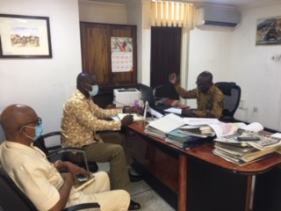
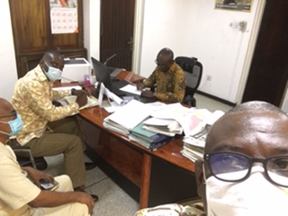
View over Stakeholder Engagement Location (including stakeholders)
Supportive of project and happy to engage further.
Name | Organisation | Position | Telephone | Email
Christopher Kwasi Anokye | MC-SSIM | Head | 0558707053 | Christopher.anokye@mincom.gov,gh
Dr. William Ahorttor | EEMC | Environmental Expert | 00243970263 | billahor@yahoo.com
Kofi Agbogah | EEMC | Environmental Specialist | 0266031882 | Kofi.agbogah@gmail.com
Dyson Jumpah | EEMC | ESS Consultant | 0244649873 | dyson.jumpah@gmail.com

Environmental Protection Agency (EPA) Head Office, Accra
Photographs
Stakeholder Engagement in ‘Action’ 1, 22/05/2020
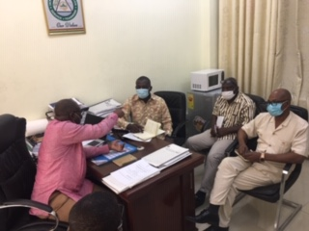
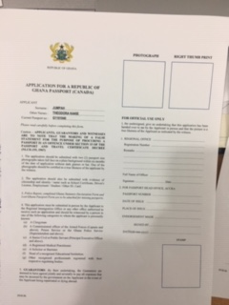
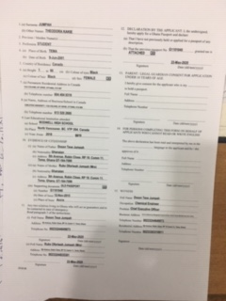
View over Stakeholder Engagement Location (including stakeholders)
Supportive of project and happy to engage further.
Follow-up, documents provided, miscellaneous

- Small Scale Mining Registration Form SS1M
- MINAMATA Convention on Mercury Initial Assessment Report, August 2018
- Ghana State of the Environment Report 2016
Name | Organisation | Position | Telephone | Email
Ing. Michael S. Ali | EPA | Director/Mining | 0244604048 | Masadow96@gmail.com
Isaac Owusu | EPA | SPO | 0244544332 | Isaac.owusu@epa.gov.gh
Dr. William Ahorttor | EEMC | Environmental Expert | 00243970263 | billahor@yahoo.com
Kofi Agbogah | EEMC | Environmental Specialist | 0266031882 | Kofi.agbogah@gmail.com
Dyson Jumpah | EEMC | ESS Consultant | 0244649873 | dyson.jumpah@gmail.com

Forestry Commission- Head Office, Near GIMPA Junction, Accra
Photographs
Stakeholder Engagement in ‘Action’ 1, 27/05/2020
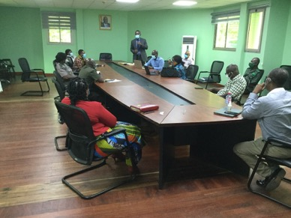
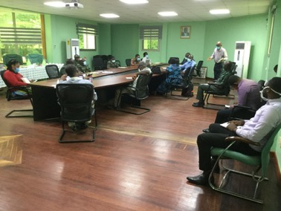
View over Stakeholder Engagement Location (including stakeholders)
Supportive of project and happy to engage further.
Follow-up, documents provided, miscellaneous

- Forestry Commission, Ghana Forestry Plantation Strategy, Biennial Report 2017 &2018
Name | Organisation | Position | Telephone | Email
Dr. S.A Mintah | FC | Director ICT | 0244233143 | Jmintah.hq@fcghana.org
Oppon Sasu | Executive Director | FSD | 0244367851 | sasuoppon@yahoo.com
Edith Abruquah | FC-FSD | Director of Operations | 0208199409 | Edith022@hotmail.com
Luri Kanton | WD/FC | Ag DOP/WD | 0246719592 | lurikunton@fcghana.org
Christian F. Naseh | Operations Manager | WD/FC | 0244434299 | fumeyo7108@itc,nl
Richard Gyimah | Ag Dir/WD | WD/FC | 0246420261 | Yawgyimah1968@gmail.com
John Appah | Manager/FSD | FSD/FC | 0244290398 | ebosmiths@yahoo.com
David K. Galley | R/S Officer | FC | 054059220 | Galleyd6@gamil.com
Sharon Asomaning | CPME | FC | 0249726039 | asomaning@yahoo.com
Joe Appiah Gyapong | Director/PM | FC | 0208126825 | Appiah.gyapong@yahoo.com
Godwin P. Cudjoe | DR/P | FC | 0242726732 | Godwin.cudjoe@outlook.com
Nathan Sika | Social Safeguards | EEMC | 0264729563 | padiafro@yahoo.com
Cudjoe Awudi | Dir CPME | FC | 0244234885 | Awudi.hq@fcghana.com
Joyce Ofori Kwafo | Head,CAMPU | FC | 0244643780 | Oforikwafo2000@yahoo.com
Kenneth Mbroh | CPME | FC | 0244231277 | kennethmbroh@gmail.com
Alice Addai-Yeboah | Social Development Expert | EEMC | 0244571474 | Ewiaba2001@yahoo.com
Eben Anum-Tetteh | Comms Specialist | GASMFP | 0244885342 | ebenanumtetteh@gmail.com
Roselyn F. Adjei | Director, Climate Change | FC | 0244535772ya | fossy@yahoo.com
Kofi Awadwo Frimpong | DR/P | FC | 0244036764 | cofyfr@gmail.com
Dr. William Ahorttor | EEMC | Environmental Expert | 00243970263 | billahor@yahoo.com
Kofi Agbogah | EEMC | Environmental Specialist | 0266031882 | Kofi.agbogah@gmail.com
Dyson Jumpah | EEMC | ESS Consultant | 0244649873 | dyson.jumpah@gmail.com

GWCL, Head Office Accra

Photographs
Stakeholder Engagement in ‘Action’ 1, 27/05/2020
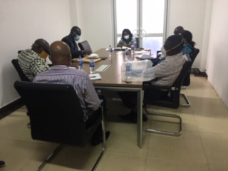
View over Stakeholder Engagement Location (including stakeholders)
Supportive of project and happy to engage further.
Follow-up, documents provided, miscellaneous

- Messrs EEMC to followup to request for Water Quality Data from GWCL
Name | Organisation | Position | Telephone | Email
Margaret Macaulley | GWCL | CM-WQA | 0277808829 | mnmacauley@gmail.com
John E. Kwofie | GWCL | Manager Ops | 0243283078 | jkwofie@gwcl.com.gh
Hanson Mensah Akuetteh | GWCL | Mgr | 0244841331 | hakuetteh@gmail.com
Mark Ayertey | GWCL | WQAO | 0242223837 | mayertey@gwcl.comgh
Nathan Sika | Social Safeguards | EEMC | 0264729563 | padiafro@yahoo.com
Alice Addai-Yeboah | Social Development Expert | EEMC | 0244571474 | Ewiaba2001@yahoo.com
Dr. William Ahorttor | EEMC | Environmental Expert | 00243970263 | billahor@yahoo.com
Kofi Agbogah | EEMC | Environmental Specialist | 0266031882 | Kofi.agbogah@gmail.com
Dyson Jumpah | EEMC | ESS Consultant | 0244649873 | dyson.jumpah@gmail.com

Precious Minerals Marketing Company (PMMC)
Photographs
Stakeholder Engagement in ‘Action’ 1. 28/05/2020
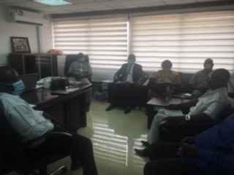
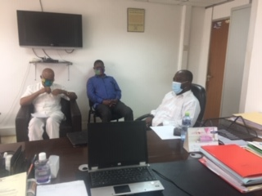
View over Stakeholder Engagement Location (including stakeholders)
- Supportive of project and happy to engage further.
- The RPF Consultant to put in application to request for the following:
- for gold production records and other relevant baseline information for 2015, 2016, 2017, 2018, 2019
- to further discuss the traceability concept and request PMMC to make available the concept proposal to the Consultant
- Capacity building, training and budget for the traceability concept proposal.
Name | Organisation | Position | Telephone | Email
Venance Dey | PMMC | DMD | 0248693431 | venancedey@yahoo.com
Ernest Asiedu Ode | PMMC | Director Corporate Planning | 0541393935 | asieduvval@yahoo.com
Donatus Asusko | Teleweal | PMMC | 0244689148
Dr. William Ahorttor | EEMC | Environmental Expert | 00243970263 | billahor@yahoo.com
Kofi Agbogah | EEMC | Environmental Specialist | 0266031882 | Kofi.agbogah@gmail.com
Dyson Jumpah | EEMC | ESS Consultant | 0244649873 | dyson.jumpah@gmail.com

Water Resources Commission (WRC)
Photographs
Stakeholder Engagement in ‘Action’ 1, 01/06/2020
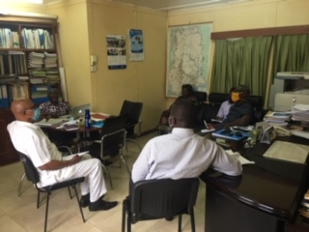
View over Stakeholder Engagement Location (including stakeholders)
Supportive of project and happy to engage further.
Follow-up, documents provided, miscellaneous
- Messrs EEMC to follow-up to request for Water Quality Data from GWCL
Name | Organisation | Position | Telephone | Email
Adwoa Paintsil | WRC | Director-EQ | 0244227972 | himapaintsil@yahoo.com
Ben Ampomah | WRC | Executive Secretary | 0244374138 | byampomah@yahoo.com
Nathan Sika | Social Safeguards | EEMC | 0264729563 | padiafro@yahoo.com
Dr. William Ahorttor | EEMC | Environmental Expert | 00243970263 | billahor@yahoo.com
Kofi Agbogah | EEMC | Environmental Specialist | 0266031882 | Kofi.agbogah@gmail.com
Dyson Jumpah | EEMC | ESS Consultant | 0244649873 | dyson.jumpah@gmail.com

Appendix 2C: Stakeholder Consultation Pictures

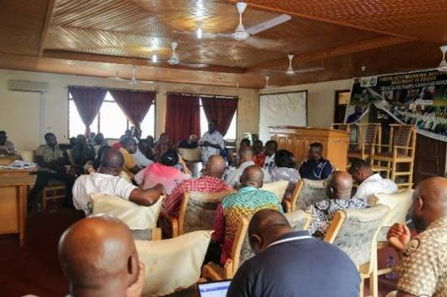
Stakeholder engagement at Twifo/Atti-Morkwa District Assembly

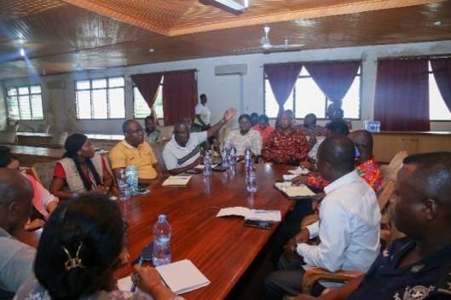
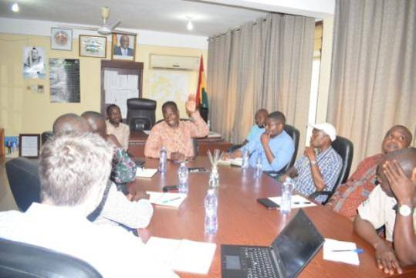
Stakeholder engagement with officers of Kwahu South District Assembly

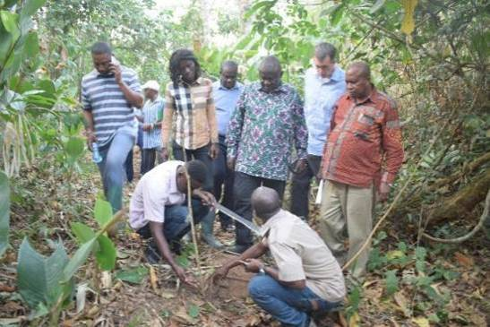
Field Interaction with Forest staff at Kwahu South

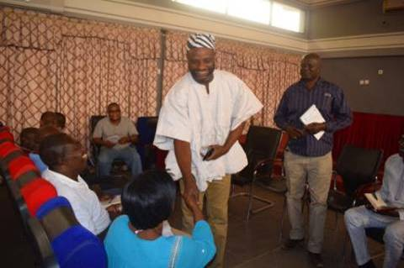
Stakeholder Consultation at West Mamprusi Municipality

Stakeholder Consultation at Kwahu West District Assembly

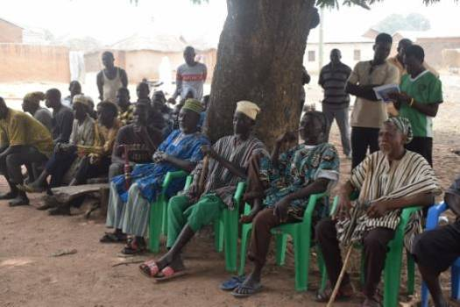
Community Engagement at Takorayiri community - West Mamprusi Municipal, North East Region

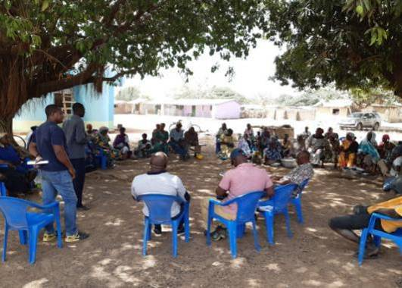
Community Engagement at Goyiri community in STK District, Savannah Region
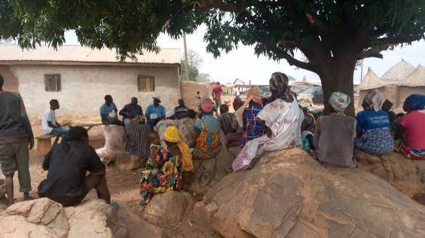
Community engagement at Sagadugu community in the West Mamprusi Municipal, North East Region

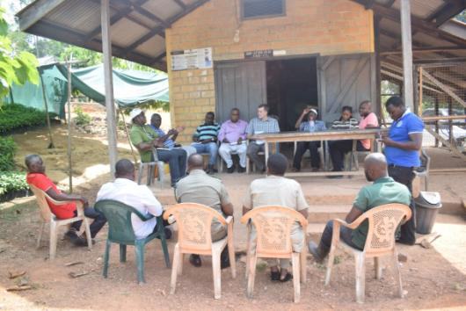
Interaction with officers of the Seed Production Unit in Juaso (COCOBOD)

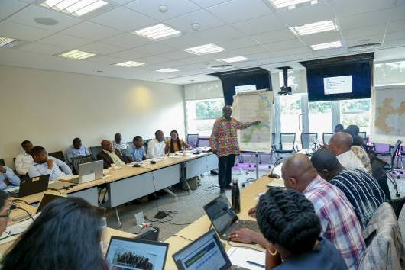
Consultation with IAs and World Bank
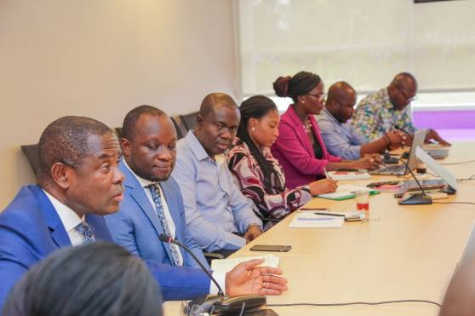
Joint consultation with IAs, WB, COCOBOD, FIP, etc.

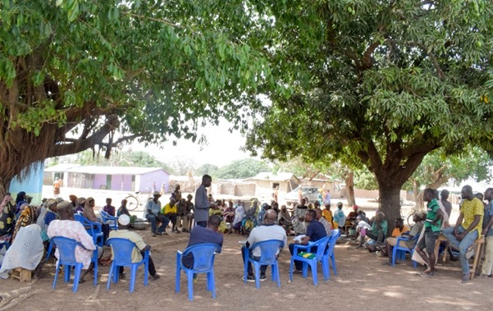
Community engagement at Goyiri community, Sawla Tuna-Kalba District - Savannah Region

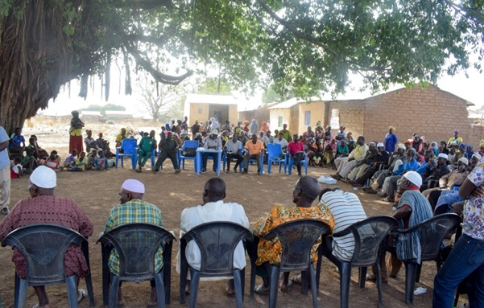
Community consultation at Naaha Community, Wa East District - Upper West Region

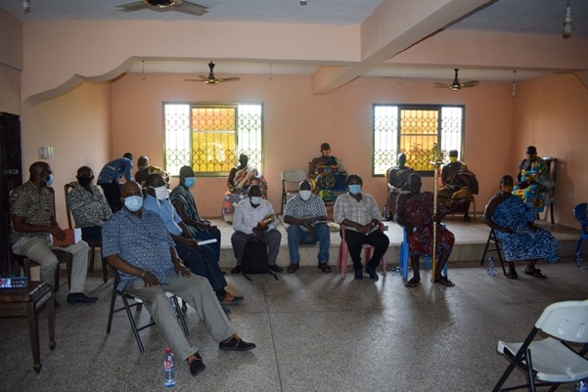
Courtesy call on the Traditional Authority and Elders of Twifo Ati Morkwa District
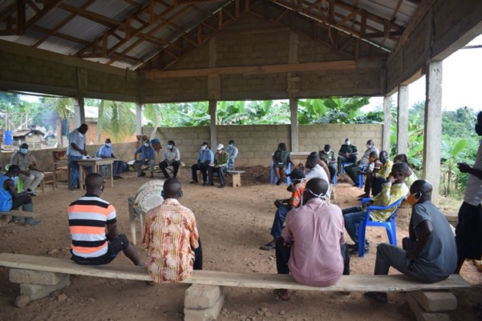
Community consultation at Kwame Adu Community, Adansi South District

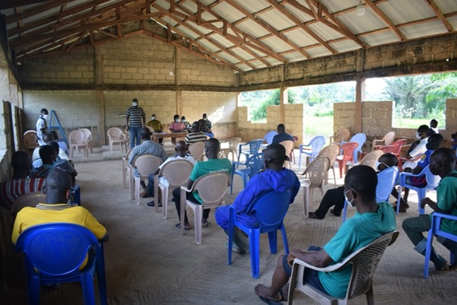

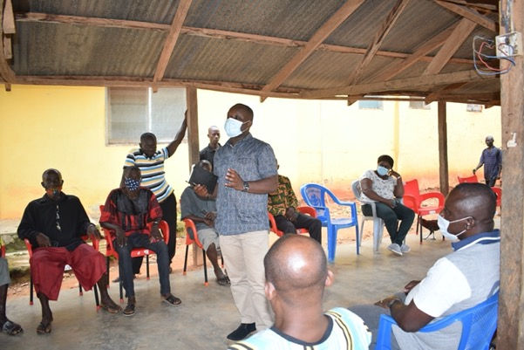
Community consultation at Adansi Praso Community, Adansi South District

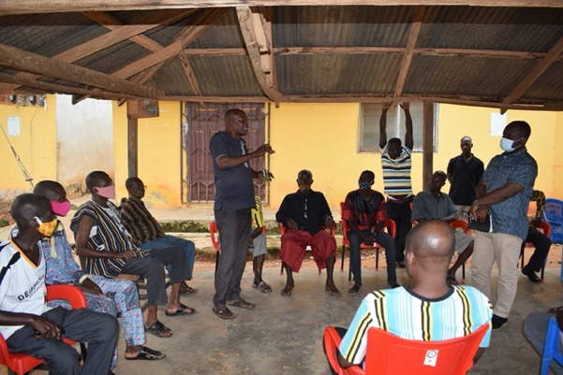
Community consultation at Adansi Praso Community, Adansi South District

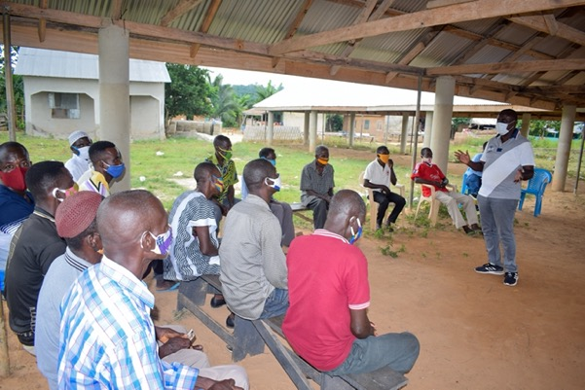
Community consultation at Subritwe community, Kwahu West District
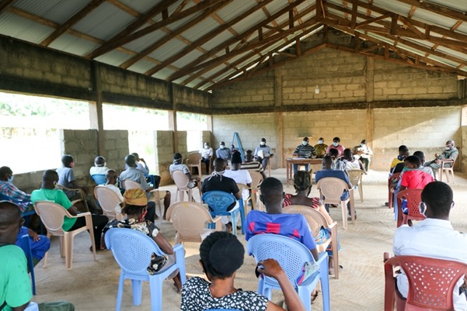

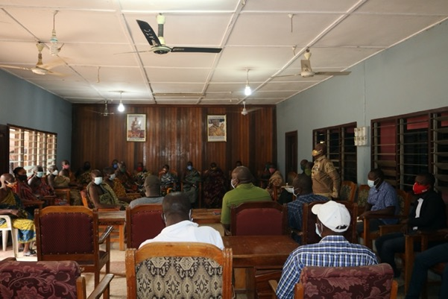
Courtesy call on the Adansi Traditional Council – Adansi Formena

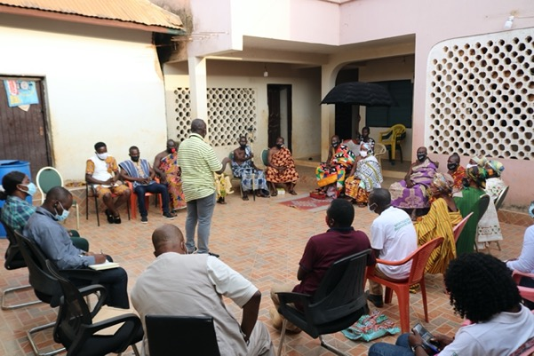
Community engagement with Chiefs and people of Mpasaaso, Nkawie District

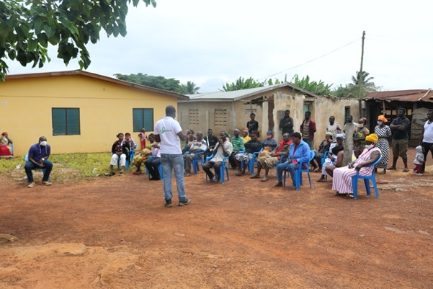
Community engagement at Nteso Community, Mpraeso
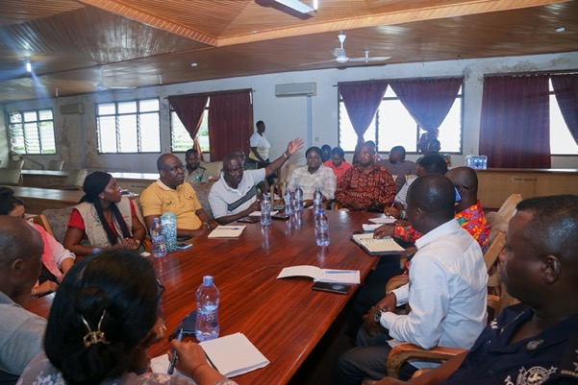
Consultation with the Twifo Atti Morkwah District Assembly

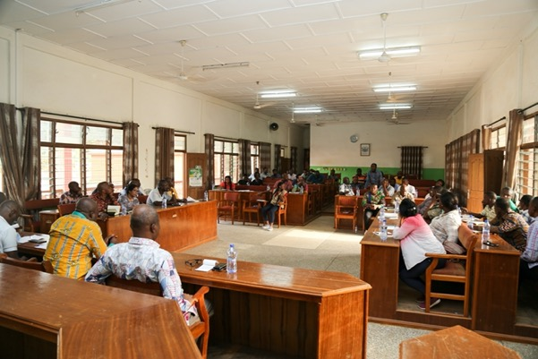
Consultation engagement with the Adansi South District Assembly

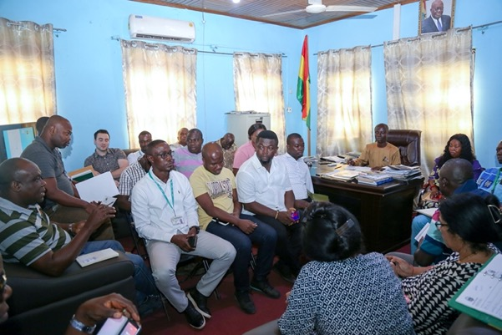
Stakeholder engagement with the Atwima Mponua District Assembly

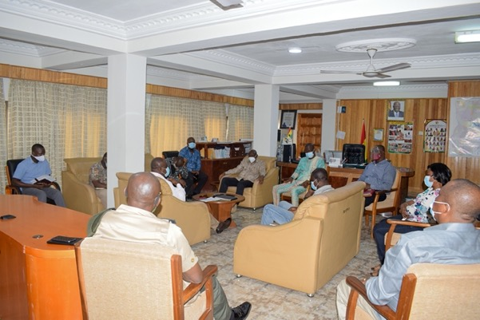
Consultation with the Eastern Regional Minister and the Coordinating Council, Eastern Region

Appendix 3: Sample Asset Valuation Survey Form

FRAMEWORK FOR THE CENSUS OF AFFECTED ASSETS AND AFFECTED PEOPLE
AFFECTED PLOT OR LAND SHEET
Reference/GPS Coordinates:
Location: Region: District: Community/ Village:
Surface: Description of soil:
Perennial | 1 | Owner:
 | 2 | Owner:
Annual | 1 | Owner:
 | 2 | Owner:
Trees | 1 | Owner:
 | 2 | Owner:
Structures: Owner
Channels: Owner:
Anti-erosive structures: Owner:
Buildings: Owner:
Users: User 1: Surface used: Regime of tenure:
User 2: Surface used: Regime of tenure:
User 3: Surface used: Regime of tenure:
User 4: Surface used: Regime of tenure:
Valuation proposal (details of calculation on attached sheet):
Crops:
Structures:
Proposed distribution of compensation:
User 1:
User 2:
User 3:
User 4:
Date: Prepared By:
AFFECTED BUILDING SHEET
Reference/ GPS Coordinates/Photograph number
Location: Region/District/Community/Village
Owner: Address:

Description:
Permanent Non-permanent
Surface: Number of rooms:
Walls: Material Condition
Roof: Material Condition
Floor: Material Condition
Annexes outside: Latrine: Bathroom: Kitchen: Others:
Additional features:
Permanently Inhabited: By: Regime of occupation:
Periodically Inhabited: By: Regime of occupation:
Valuation proposal (details of calculation on attached sheet):
Proposed distribution of compensation:
User 1:
User 2:
User 3:
User 4:
Date: Prepared By:
AFFECTED HOUSEHOLD SHEET
Household Reference:
Location: Region: District: Village:
Photograph numbers for each household member
Reference of Affected Asset:
Type: Structure Plot Crop
Reference of Affected Asset Sheet:
Location: Zone: Region:
Household Information:
Head of Household: Name: Age:
Sex:
Humber | Name | Relationship with household head | Sex | Age

Identity Document: Type: Number

Composition of Household:
Socio-Economic Information:
Occupations:
Head of Household:
Other members of Household:
Number: Occupation:
Number: Occupation:
Total Estimated Household Cash Income:
Education level of Household Members:
Project Impact:
Assessment of the Impact of the Loss of the Affected Asset on Household’s Livelihood:
Proposed Compensation or Resettlement Package
Household’s Wishes
Proposed Package
Proposed Livelihood Restoration or Assistance Package:
Household’s Wishes
Proposed Package Date:
Prepared By:

ANNEX 4: Compensation Claim and Commitment Form
COMPENSATION CLAIM & COMMITMENT FORM
Affected Person Information:
Name of claimant: ……….…………………………… Sex: …….….………. Age: ………….………
Name of Representative/Contact Person……….………………………………………………………
Region: ………………………........ Town: ………………………..…… Community/Suburb: .............
Affected property: ………………………………………………………………………………………
Total Compensation Due:
Affected Property Value (GHS) | Disturbance (GHS) | Livelihood Assistance (GHS) | Other  Supplementary Assistance as necessary (GHS) | Total Compensation (GHS)

Compensation Payment Commitment:
I, …………………………………………………………………………….., having received the above total compensation amount for the land required/structures/crop(s) at the project site in question on ………………………………..…………………………….(i.e. date of compensation payment), have agreed in principle to vacate or release the said land(s), for which compensation has been paid for the crops/structures/land thereon, on ……………………………………………………………(agreed date when PAP should vacate or release the land).
Signature or Thumb print of claimant /recipient: …………............................................... Date: ……...
Name of Administrator (MOFA/Project Representative): ………………………………………...……
Signature of Administrator: …………………………………………..……………… Date: …………
Contact of Administrator: ……………………………………………………..
Name of Witness: …………………………………………… Signature of Witness …………………
Contact of Witness: …………………………………….……………….

Appendix 5: Annotated Outline – Resettlement Action Plan (RAP)

1. Description of the sub-project and of its potential land impacts
1.1 General description of the project and identification of the project area
1.2 Potential impacts. Identification of
1.2.1 Project component or activities that give rise to resettlement;
1.2.2 Zone of impact of such component or activities;
1.2.3 Alternatives considered to avoid or minimize resettlement; and
1.2.4 Mechanisms established to minimize resettlement, to the extent possible, during project implementation.
2. Objectives. The main objectives of the resettlement program
3. Socio-economic studies and census of affected assets and affected livelihoods. The findings of socioeconomic studies and census to be conducted with the involvement of potentially displaced people include:
3.1 Standard characteristics of displaced households, including a description of production systems, labour, and household organization; and baseline information on livelihoods (including, as relevant, production levels and income derived from both formal and informal economic activities) and standards of living (including health status) of the displaced population;
3.2 The magnitude of the expected loss—total or partial—of assets, and the extent of displacement, physical or economic.
3.3 Information on vulnerable groups or persons as provided for in ESS5
3.4 Provisions to update information on the displaced people's livelihoods and standards of living at regular intervals so that the latest information is available at the time of their displacement.
3.5 Other studies describing the following
3.5.1 Land tenure and transfer systems, including an inventory of common property natural resources from which people derive their livelihoods and sustenance, non-title-based usufruct systems (including fishing, grazing, or use of forest areas) governed by local recognized land allocation mechanisms, and any issues raised by different tenure systems in the project area;
3.5.2 The patterns of social interaction in the affected communities, including social networks and social support systems, and how they will be affected by the project;
3.5.3 Public infrastructure and social services that will be affected; and
3.5.4 Social and cultural characteristics of displaced communities, including a description of formal and informal institutions (e.g., community organizations, ritual groups, nongovernmental organizations (NGOs)) that may be relevant to the consultation strategy and to designing and implementing the resettlement activities.
4. Legal and Institutional Framework.
4.1 Summary of the information included in this RPF
4.2 Local legal specificities if any
4.3 Local institutional specificities
4.3.1 Identification of agencies locally responsible for resettlement activities and NGOs that may have a role in project implementation;
4.3.2 Assessment of the institutional capacity of such agencies and NGOs; and
5. Eligibility and entitlements. Based on the definitions and categorization in this RPF (see entitlement matrix), definition of displaced persons and criteria for determining their eligibility for compensation and other resettlement assistance, including relevant cut-off dates.
6. Valuation of and compensation for losses. The methodology to be used in valuing losses to determine their replacement cost; and a description of the proposed types and levels of compensation under local law and such supplementary measures as are necessary to achieve replacement cost for lost assets.
7. Resettlement measures:
7.1 Description of the packages of compensation and other resettlement measures that will assist each category of eligible displaced persons to achieve the objectives of the policy (see WB requirements in ESS5).
7.2 Site selection, site preparation, and relocation. Alternative relocation sites considered and explanation of those selected.
7.3 Legal arrangements for regularizing tenure and transferring titles to resettlers.
7.4 Housing, infrastructure, and social services.
7.5 Environmental protection and management.
7.6 Community participation. Involvement of resettlers and host communities
7.7 Integration with host populations. Measures to mitigate the impact of resettlement on any host communities
7.8 Specific assistance measures intended for vulnerable people, to be identified for instance amongst those listed in section 5.4 the RPF
8. Grievance procedures. Based on the principle mechanisms described in this RPF, description of affordable and accessible procedures for third-party settlement of disputes arising from resettlement; such grievance mechanisms should consider the availability of judicial recourse and community and traditional dispute settlement mechanisms.
9. Organizational responsibilities. The organizational framework for implementing resettlement, including identification of agencies responsible for delivery of resettlement measures and provision of services; arrangements to ensure appropriate coordination between agencies and jurisdictions involved in implementation; and any measures (including technical assistance) needed to strengthen the implementing agencies' capacity to design and carry out resettlement activities; provisions for the transfer to local authorities or resettlers themselves of responsibility for managing facilities and services provided under the project and for transferring other such responsibilities from the resettlement implementing agencies, when appropriate.
10. Implementation schedule. Based on the template presented in the RPF, present an implementation schedule covering all resettlement activities from preparation through implementation, including target dates for the achievement of expected benefits to resettlers and hosts and terminating the various forms of assistance. The schedule should indicate how the resettlement activities are linked to the implementation of the overall project.
11. Costs and budget. Tables showing itemized cost estimates for all resettlement activities (see Section 13 of this RPF), including special assistance to vulnerable persons and other contingencies.
12. Monitoring and evaluation. Arrangements for monitoring of resettlement activities by the implementing agency, supplemented by independent monitors as considered appropriate by the Bank, to ensure complete and objective information; performance monitoring indicators to measure inputs, outputs, and outcomes for resettlement activities; involvement of the displaced persons in the monitoring process; evaluation of the impact of resettlement for a reasonable period after all resettlement and related development activities have been completed; using the results of resettlement monitoring to guide subsequent implementation.

Appendix 6: Outline – Abbreviated Resettlement Action Plans (ARAP)
Depending on the magnitude of the displacement, an Abbreviated Resettlement Action Plan (ARAP). .
1.Brief Description of the Sub-Project
1.1. Sub-Project Land Needs
1.2. Land Needs Justification and Minimization
2.Census Survey of Displaced Persons and Valuation of Assets
2.1. Methodology
2.2. Results
3.Affected Assets
4.Socio-Economic Features and Affected People’s Livelihoods
5.Description of Compensation and other Resettlement Assistance
6.Consultation with Displaced People
7. Procedures for Grievance Redress
8.Monitoring and Evaluation
9.Institutional Responsibilities and Arrangements for Implementation
10. Timetable, Budget and Funding Arrangements

Appendix 7: Model Complaint Registration & Resolution Form (GRM)
Name (Complainant): …………………………………………………………………………………
ID Number (PAPs ID number if any): ……………………………………………………………….
Contact Information (house number/ mobile phone) ……………………………………………….
Nature of Grievance or Complaint: ………………………………………………….…………………………………...
Details of Grievance: ………………………………………………………………………………………………… ………………………………………………………………………………………………… ………………………………………………………………………………………………… ………………………………………………………………………………………………………………………………………………………………………………………………………………………………………………………………………………………………………
Name (Receiver): ……………………………………………………. Signature:……………..………..
Date……………………....
Name (Filer): ………………...……………………………………… Signature……………………….
Date…………………………
Relationship to Complainant (if different from Complainant): ……………….……………………… ---------------------------------------------------------------------------------------------------------------------------
Review/Resolution Level 1 (MMDA) Level 2 (MDA) Level 3 (PCU)
Date of Conciliation Session: …………………………………………………………………………………………………
Was Filer/Complainant Present? Yes/ No
Was field verification of complaint conducted? Yes/ No
Findings of field investigation……………………………………………………………………… …………………………………………………………………………………………………
Summary of Conciliation Session Discussion…………………………………………...………….. Issues………………………………………………………………………………………………………………………………………………………………………………………………
Was agreement reached on the issues? Yes No If agreement was reached, detail the agreement………………………………………...……………… …………………………………………………………………………………………………
If agreement was not reached, specify the points of disagreement…………………………………… ……………………………………………………………………………………………………………………………………………………………………………………………………
Signed (Conciliator): ……………………………. Signed (Filer/Complainant): …………………………………...
Signed: ………………………………………………………………
(Independent Observer e.g. Assembly Member/Opinion Leader)
Date: ………………………………………………………………
Implementation of Agreement
Date of implementation: …………………………………………………………………………………………………………… . Feedback from Filer/Complainant: Satisfied /Not Satisfied
If satisfied, sign off & date………………………………………………… ………………………..
(Filer/Complainant) (Mediator)
If not satisfied, recommendation/way forward ……………………………………………………………………………………..…………... ………………………………………………………………..……………………………………………………………………………………………………………………………………………………… ………………………………………………………………………… ………………………………... ………………………………………..
(Signature & date of Filer/Complainant) ………………………………………………………………………………….
(Signature & date of Mediator) …………………………………………………………………………………………

https://eros.usgs.gov/westafrica/land-cover/deforestation-upper-guinean-forest
https://cocobod.gh/weakly_purchase.php
https://cocoainitiative.org/news-media-post/cocoa-farmers-in-ghana-experience-poverty-and-economic-vulnerability/
GSS (2016) 2015 Labour Force Report, the Ghana Statistical Service (GSS) – December 2016. http://statsghana.gov.gh/gssmain/fileUpload/Demography/LFS%20REPORT_fianl_21-3-17.pdf.
Ghana Country Environmental Analysis, World Bank 2020.
Mantey, Jones, Kwabena Nyarko, and Frederick Owusu-Nimo. 2016. Costed Reclamation and Decommissioning Strategy for Galamsey Operations in 11 Selected MDAs of the Western Region, Ghana. S-33205-GHA-1. London: International Growth Centre.
Delve, www.delvedatabase.org.
Minerals Commission, 2018.
https://en.wikipedia.org/wiki/Ashanti_Region
https://en.wikipedia.org/wiki/Central_Region_(Ghana)
https://en.wikipedia.org/wiki/Eastern_Region_(Ghana)
https://en.wikipedia.org/wiki/Western_Region_(Ghana)
https://en.wikipedia.org/wiki/North_East_Region,_Ghana
https://en.wikipedia.org/wiki/Savannah_Region
https://en.wikipedia.org/wiki/Upper_East_Region
https://en.wikipedia.org/wiki/Upper_West_Region
There is going to be a new Land Act, presently with the Presidency for assent, that seeks to consolidate or codify most of the Acts relating to land in Ghana.
Ref footnote 9 of ESS5: This ESS does not apply to restrictions of access to natural resources under community-based natural resource management projects, i.e., where the community using the resources collectively decides to restrict access to these resources, provided that an assessment satisfactory to the Bank establishes that the community decision-making process is adequate and reflects voluntary, informed consensus, and that appropriate measures have been agreed and put in place to mitigate adverse impacts, if any, on the vulnerable members of the community.
These are “farmers or cultivators who had their farms in forest reserve areas before their designation as reserves and they are entitled to continue to farm in designated areas” (Handbook for Paralegals in Ghana, CEPIL, 2009). Boundaries of these farms are well established and recorded in the Reserve Settlements Commissioner’s reports.

